SMART HOTEL LAB

[Update Before the HOL - Line-of-business application migration.md](https://github.com/microsoft/MCW-Line-of-business-application-migration/commit/26452482b655f26f686bebc622e2a2b93df6f740)

<https://github.com/microsoft/MCW-Line-of-business-application-migration/blob/master/Hands-on%20lab/Before%20the%20HOL%20-%20Line-of-business%20application%20migration.md>

**Task 1: Deploy the on-premises environment**

1. Deploy the template **SmartHotelHost.json** to a new resource group. This template deploys a virtual machine running nested Hyper-V, with 4 nested VMs. This comprises the 'on-premises' environment which you will assess and migrate during this lab.

You can deploy the template by selecting the 'Deploy to Azure' button below. You will need to create a new resource group. The suggested resource group name to use is **SmartHotelHostRG**. You will also need to select a location close to you to deploy the template to. Then choose **Review + create** followed by **Create**.

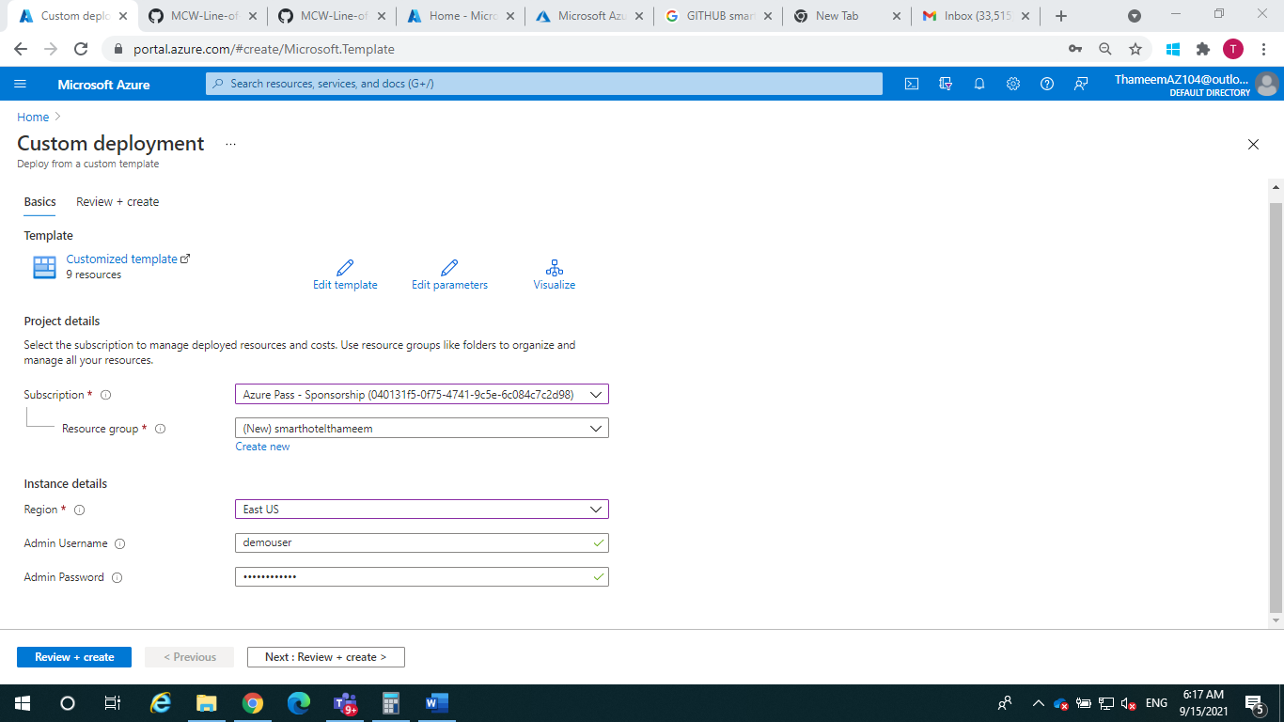

**Task 2: Verify the on-premises environment**

1. Navigate to the **SmartHotelHost** VM that was deployed by the template in the previous step.
2. Make a note of the public IP address.
3. Open a browser tab and navigate to **http://<SmartHotelHostIP-Address>**.

<http://smarthotelhost-nywy.eastus.cloudapp.azure.com> or <http://40.114.105.95>

You should see the SmartHotel application, which is running on nested VMs within Hyper-V on the SmartHotelHost. (The application doesn't do much: you can refresh the page to see the list of guests or select 'CheckIn' or 'CheckOut' to toggle their status.)

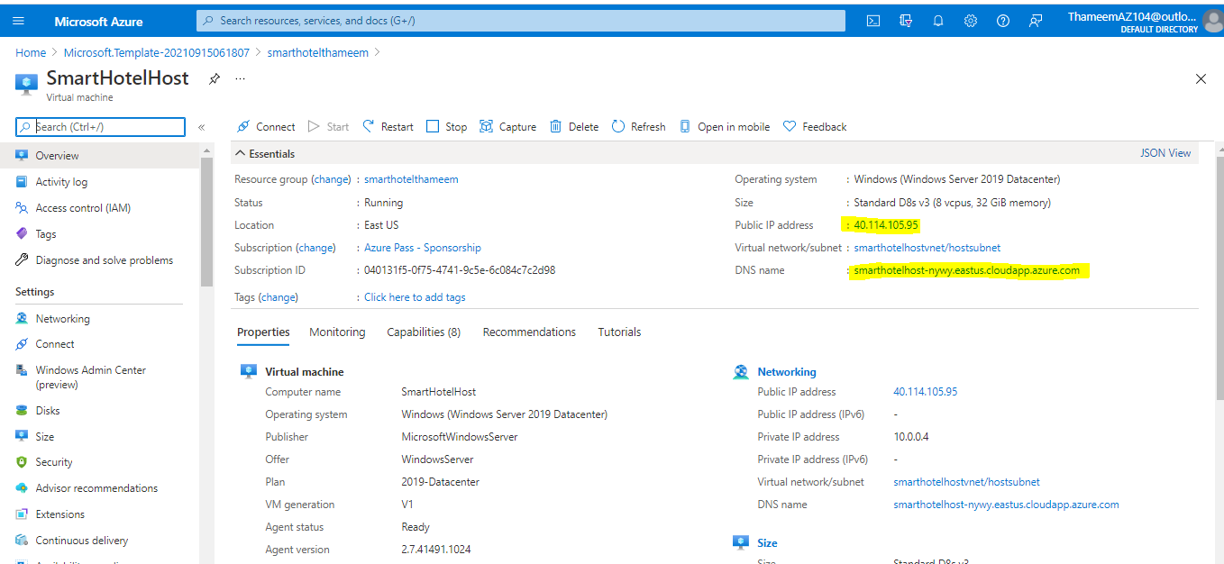

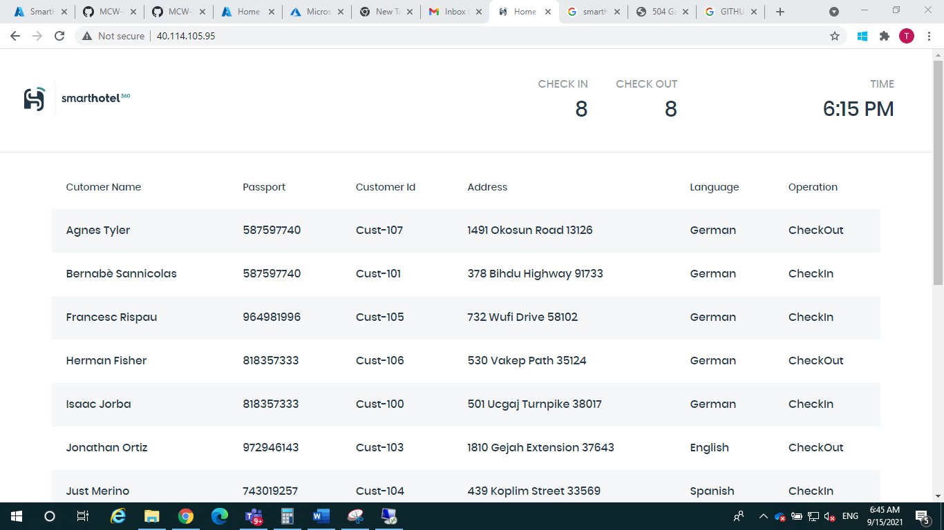

[Moving manual Discover import note higher up](https://github.com/microsoft/MCW-Line-of-business-application-migration/commit/46a7040bc2f5f45eda2e66f229055f597657a9ee)

<https://github.com/microsoft/MCW-Line-of-business-application-migration/blob/master/Hands-on%20lab/HOL%20step-by%20step%20-%20Line-of-business%20application%20migration.md#line-of-business-application-migration-hands-on-lab-step-by-step>

# **Line-of-business application migration hands-on lab step-by-step**

## **Solution architecture**

The SmartHotel application comprises 4 VMs hosted in Hyper-V:

* **Database tier** Hosted on the smarthotelSQL1 VM, which is running Windows Server 2016 and SQL Server 2017.
* **Application tier** Hosted on the smarthotelweb2 VM, which is running Windows Server 2012R2.
* **Web tier** Hosted on the smarthotelweb1 VM, which is running Windows Server 2012R2.
* **Web proxy** Hosted on the UbuntuWAF VM, which is running Nginx on Ubuntu 18.04 LTS.

For simplicity, there is no redundancy in any of the tiers.

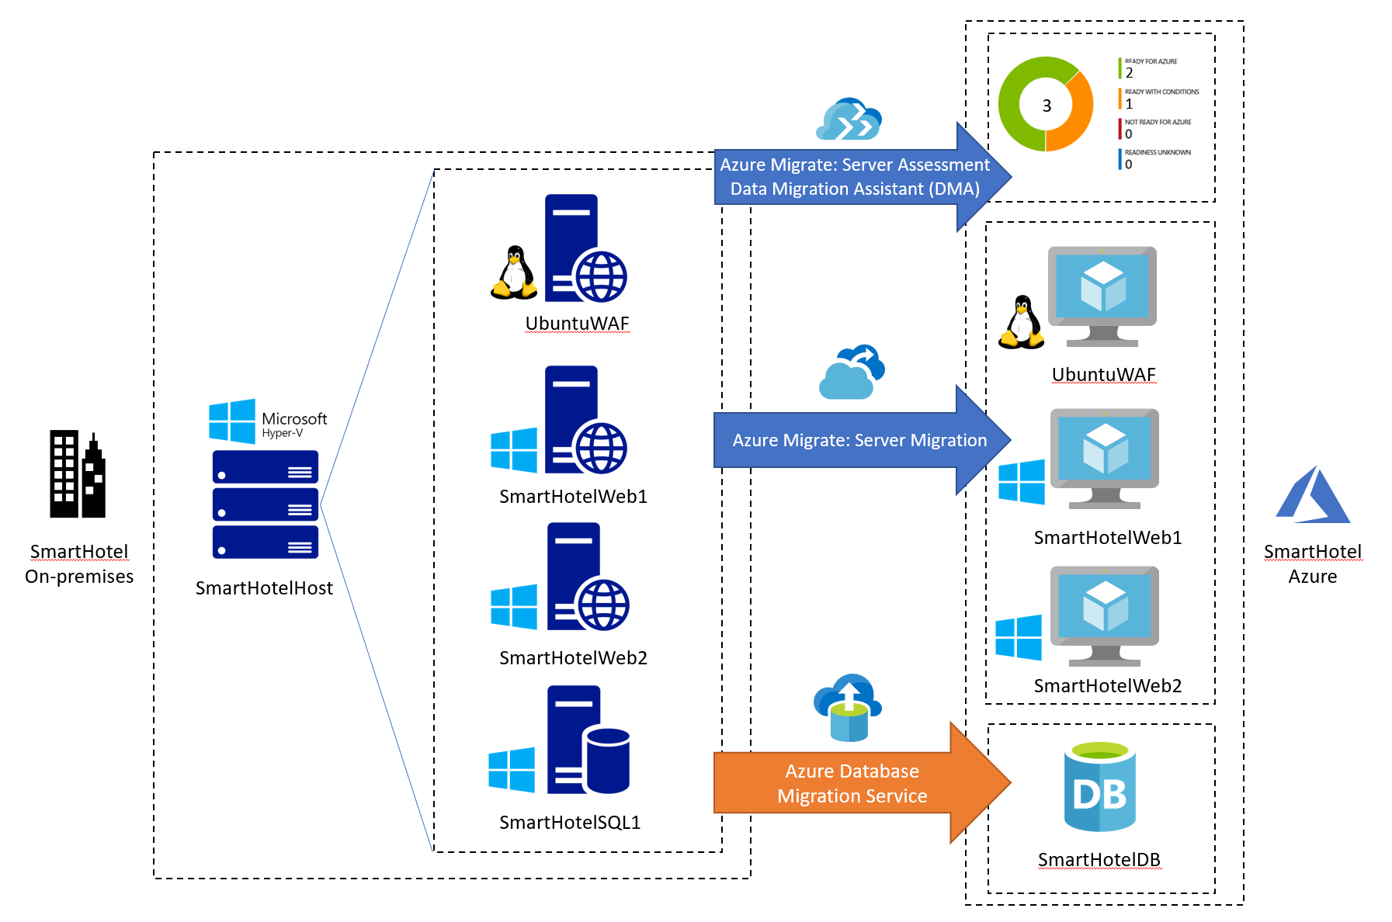

**Contents**

* [Line-of-business application migration hands-on lab step-by-step](https://github.com/microsoft/MCW-Line-of-business-application-migration/blob/master/Hands-on%20lab/HOL%20step-by%20step%20-%20Line-of-business%20application%20migration.md#line-of-business-application-migration-hands-on-lab-step-by-step)
  + [Abstract and learning objectives](https://github.com/microsoft/MCW-Line-of-business-application-migration/blob/master/Hands-on%20lab/HOL%20step-by%20step%20-%20Line-of-business%20application%20migration.md#abstract-and-learning-objectives)
  + [Overview](https://github.com/microsoft/MCW-Line-of-business-application-migration/blob/master/Hands-on%20lab/HOL%20step-by%20step%20-%20Line-of-business%20application%20migration.md#overview)
  + [Solution architecture](https://github.com/microsoft/MCW-Line-of-business-application-migration/blob/master/Hands-on%20lab/HOL%20step-by%20step%20-%20Line-of-business%20application%20migration.md#solution-architecture)
  + [Requirements](https://github.com/microsoft/MCW-Line-of-business-application-migration/blob/master/Hands-on%20lab/HOL%20step-by%20step%20-%20Line-of-business%20application%20migration.md#requirements)
  + [Before the hands-on lab](https://github.com/microsoft/MCW-Line-of-business-application-migration/blob/master/Hands-on%20lab/HOL%20step-by%20step%20-%20Line-of-business%20application%20migration.md#before-the-hands-on-lab)
  + [Exercise 1: Discover and assess the on-premises environment](https://github.com/microsoft/MCW-Line-of-business-application-migration/blob/master/Hands-on%20lab/HOL%20step-by%20step%20-%20Line-of-business%20application%20migration.md#exercise-1-discover-and-assess-the-on-premises-environment)
    - [Task 1: Create the Azure Migrate project and add assessment and migration tools](https://github.com/microsoft/MCW-Line-of-business-application-migration/blob/master/Hands-on%20lab/HOL%20step-by%20step%20-%20Line-of-business%20application%20migration.md#task-1-create-the-azure-migrate-project-and-add-assessment-and-migration-tools)
    - [Task 2: Deploy the Azure Migrate appliance](https://github.com/microsoft/MCW-Line-of-business-application-migration/blob/master/Hands-on%20lab/HOL%20step-by%20step%20-%20Line-of-business%20application%20migration.md#task-2-deploy-the-azure-migrate-appliance)
    - [Task 3: Configure the Azure Migrate appliance](https://github.com/microsoft/MCW-Line-of-business-application-migration/blob/master/Hands-on%20lab/HOL%20step-by%20step%20-%20Line-of-business%20application%20migration.md#task-3-configure-the-azure-migrate-appliance)
    - [Task 4: Create a migration assessment](https://github.com/microsoft/MCW-Line-of-business-application-migration/blob/master/Hands-on%20lab/HOL%20step-by%20step%20-%20Line-of-business%20application%20migration.md#task-4-create-a-migration-assessment)
    - [Task 5: Configure dependency visualization](https://github.com/microsoft/MCW-Line-of-business-application-migration/blob/master/Hands-on%20lab/HOL%20step-by%20step%20-%20Line-of-business%20application%20migration.md#task-5-configure-dependency-visualization)
    - [Task 6: Explore dependency visualization](https://github.com/microsoft/MCW-Line-of-business-application-migration/blob/master/Hands-on%20lab/HOL%20step-by%20step%20-%20Line-of-business%20application%20migration.md#task-6-explore-dependency-visualization)
  + [Exercise 2: Migrate the Application Database](https://github.com/microsoft/MCW-Line-of-business-application-migration/blob/master/Hands-on%20lab/HOL%20step-by%20step%20-%20Line-of-business%20application%20migration.md#exercise-2-migrate-the-application-database)
    - [Task 1: Register the Microsoft.DataMigration resource provider](https://github.com/microsoft/MCW-Line-of-business-application-migration/blob/master/Hands-on%20lab/HOL%20step-by%20step%20-%20Line-of-business%20application%20migration.md#task-1-register-the-microsoftdatamigration-resource-provider)
    - [Task 2: Create an Azure SQL Database](https://github.com/microsoft/MCW-Line-of-business-application-migration/blob/master/Hands-on%20lab/HOL%20step-by%20step%20-%20Line-of-business%20application%20migration.md#task-2-create-an-azure-sql-database)
    - [Task 3: Create the Database Migration Service](https://github.com/microsoft/MCW-Line-of-business-application-migration/blob/master/Hands-on%20lab/HOL%20step-by%20step%20-%20Line-of-business%20application%20migration.md#task-3-create-the-database-migration-service)
    - [Task 4: Assess the on-premises database using Data Migration Assistant](https://github.com/microsoft/MCW-Line-of-business-application-migration/blob/master/Hands-on%20lab/HOL%20step-by%20step%20-%20Line-of-business%20application%20migration.md#task-4-assess-the-on-premises-database-using-data-migration-assistant)
    - [Task 5: Create a DMS migration project](https://github.com/microsoft/MCW-Line-of-business-application-migration/blob/master/Hands-on%20lab/HOL%20step-by%20step%20-%20Line-of-business%20application%20migration.md#task-5-create-a-dms-migration-project)
    - [Task 6: Migrate the database schema](https://github.com/microsoft/MCW-Line-of-business-application-migration/blob/master/Hands-on%20lab/HOL%20step-by%20step%20-%20Line-of-business%20application%20migration.md#task-6-migrate-the-database-schema)
    - [Task 7: Migrate the on-premises data](https://github.com/microsoft/MCW-Line-of-business-application-migration/blob/master/Hands-on%20lab/HOL%20step-by%20step%20-%20Line-of-business%20application%20migration.md#task-7-migrate-the-on-premises-data)
  + [Exercise 3: Migrate the application and web tiers using Azure Migrate: Server Migration](https://github.com/microsoft/MCW-Line-of-business-application-migration/blob/master/Hands-on%20lab/HOL%20step-by%20step%20-%20Line-of-business%20application%20migration.md#exercise-3-migrate-the-application-and-web-tiers-using-azure-migrate-server-migration)
    - [Task 1: Create a Storage Account](https://github.com/microsoft/MCW-Line-of-business-application-migration/blob/master/Hands-on%20lab/HOL%20step-by%20step%20-%20Line-of-business%20application%20migration.md#task-1-create-a-storage-account)
    - [Task 2: Create a Virtual Network](https://github.com/microsoft/MCW-Line-of-business-application-migration/blob/master/Hands-on%20lab/HOL%20step-by%20step%20-%20Line-of-business%20application%20migration.md#task-2-create-a-virtual-network)
    - [Task 3: Register the Hyper-V Host with Azure Migrate: Server Migration](https://github.com/microsoft/MCW-Line-of-business-application-migration/blob/master/Hands-on%20lab/HOL%20step-by%20step%20-%20Line-of-business%20application%20migration.md#task-3-register-the-hyper-v-host-with-azure-migrate-server-migration)
    - [Task 4: Enable Replication from Hyper-V to Azure Migrate](https://github.com/microsoft/MCW-Line-of-business-application-migration/blob/master/Hands-on%20lab/HOL%20step-by%20step%20-%20Line-of-business%20application%20migration.md#task-4-enable-replication-from-hyper-v-to-azure-migrate)
    - [Task 5: Configure static internal IP addresses for each VM](https://github.com/microsoft/MCW-Line-of-business-application-migration/blob/master/Hands-on%20lab/HOL%20step-by%20step%20-%20Line-of-business%20application%20migration.md#task-5-configure-static-internal-ip-addresses-for-each-vm)
    - [Task 6: Server migration](https://github.com/microsoft/MCW-Line-of-business-application-migration/blob/master/Hands-on%20lab/HOL%20step-by%20step%20-%20Line-of-business%20application%20migration.md#task-6-server-migration)
    - [Task 7: Enable Azure Bastion](https://github.com/microsoft/MCW-Line-of-business-application-migration/blob/master/Hands-on%20lab/HOL%20step-by%20step%20-%20Line-of-business%20application%20migration.md#task-7-enable-azure-bastion)
    - [Task 8: Configure the database connection](https://github.com/microsoft/MCW-Line-of-business-application-migration/blob/master/Hands-on%20lab/HOL%20step-by%20step%20-%20Line-of-business%20application%20migration.md#task-8-configure-the-database-connection)
    - [Task 9: Configure the public IP address and test the SmartHotel application](https://github.com/microsoft/MCW-Line-of-business-application-migration/blob/master/Hands-on%20lab/HOL%20step-by%20step%20-%20Line-of-business%20application%20migration.md#task-9-configure-the-public-ip-address-and-test-the-smarthotel-application)
    - [Task 10: Post-migration steps](https://github.com/microsoft/MCW-Line-of-business-application-migration/blob/master/Hands-on%20lab/HOL%20step-by%20step%20-%20Line-of-business%20application%20migration.md#task-10-post-migration-steps)
  + [After the hands-on lab](https://github.com/microsoft/MCW-Line-of-business-application-migration/blob/master/Hands-on%20lab/HOL%20step-by%20step%20-%20Line-of-business%20application%20migration.md#after-the-hands-on-lab)
    - [Task 1: Clean up resources](https://github.com/microsoft/MCW-Line-of-business-application-migration/blob/master/Hands-on%20lab/HOL%20step-by%20step%20-%20Line-of-business%20application%20migration.md#task-1-clean-up-resources)

**Exercise 1**

* + [Exercise 1: Discover and assess the on-premises environment](https://github.com/microsoft/MCW-Line-of-business-application-migration/blob/master/Hands-on%20lab/HOL%20step-by%20step%20-%20Line-of-business%20application%20migration.md#exercise-1-discover-and-assess-the-on-premises-environment)
    - [Task 1: Create the Azure Migrate project and add assessment and migration tools](https://github.com/microsoft/MCW-Line-of-business-application-migration/blob/master/Hands-on%20lab/HOL%20step-by%20step%20-%20Line-of-business%20application%20migration.md#task-1-create-the-azure-migrate-project-and-add-assessment-and-migration-tools)
    - [Task 2: Deploy the Azure Migrate appliance](https://github.com/microsoft/MCW-Line-of-business-application-migration/blob/master/Hands-on%20lab/HOL%20step-by%20step%20-%20Line-of-business%20application%20migration.md#task-2-deploy-the-azure-migrate-appliance)
    - [Task 3: Configure the Azure Migrate appliance](https://github.com/microsoft/MCW-Line-of-business-application-migration/blob/master/Hands-on%20lab/HOL%20step-by%20step%20-%20Line-of-business%20application%20migration.md#task-3-configure-the-azure-migrate-appliance)
    - [Task 4: Create a migration assessment](https://github.com/microsoft/MCW-Line-of-business-application-migration/blob/master/Hands-on%20lab/HOL%20step-by%20step%20-%20Line-of-business%20application%20migration.md#task-4-create-a-migration-assessment)
    - [Task 5: Configure dependency visualization](https://github.com/microsoft/MCW-Line-of-business-application-migration/blob/master/Hands-on%20lab/HOL%20step-by%20step%20-%20Line-of-business%20application%20migration.md#task-5-configure-dependency-visualization)
    - [Task 6: Explore dependency visualization](https://github.com/microsoft/MCW-Line-of-business-application-migration/blob/master/Hands-on%20lab/HOL%20step-by%20step%20-%20Line-of-business%20application%20migration.md#task-6-explore-dependency-visualization)

[Task 1: Create the Azure Migrate project and add assessment and migration tools](https://github.com/microsoft/MCW-Line-of-business-application-migration/blob/master/Hands-on%20lab/HOL%20step-by%20step%20-%20Line-of-business%20application%20migration.md#task-1-create-the-azure-migrate-project-and-add-assessment-and-migration-tools)

* Open your browser, navigate to [**https://portal.azure.com**](https://portal.azure.com/), and log in with your Azure subscription credentials.
* Select **All services** in the portal's left navigation, then search for and select **Azure Migrate** to open the Azure Migrate Overview blade, shown below.

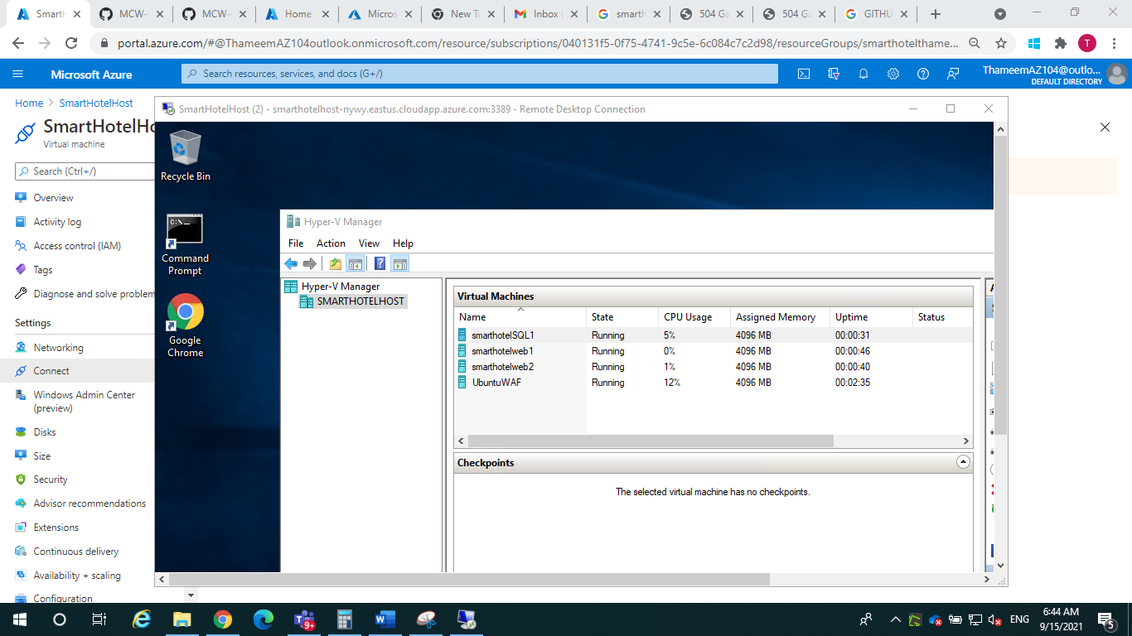

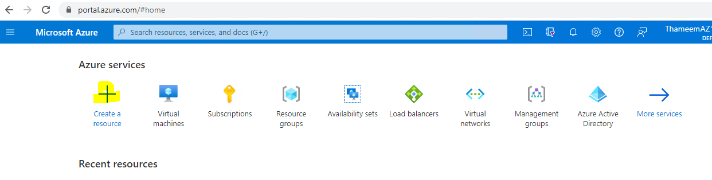

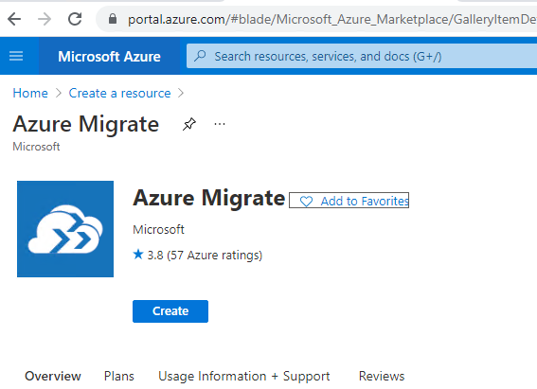

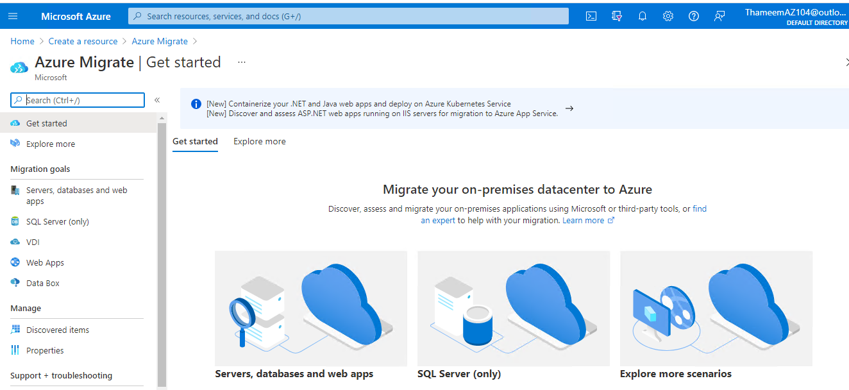

Select **Assess and migrate servers**, then **Create project**. Select your subscription and create a new resource group named **AzureMigrateRG**. Enter **SmartHotelMigration** as the Migrate project name, and choose a geography close to you to store the migration assessment data. Then select **Create**.

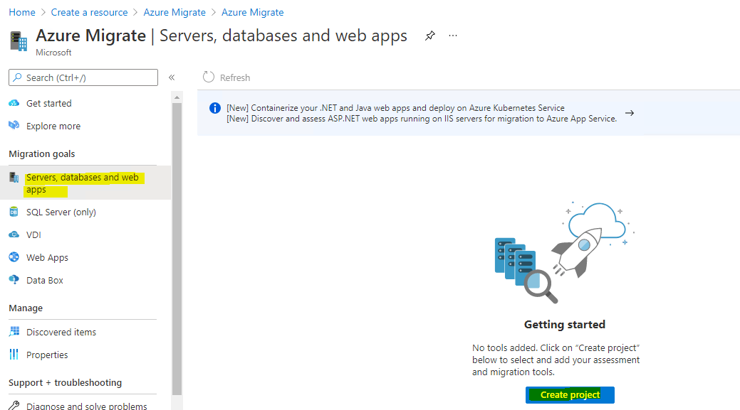

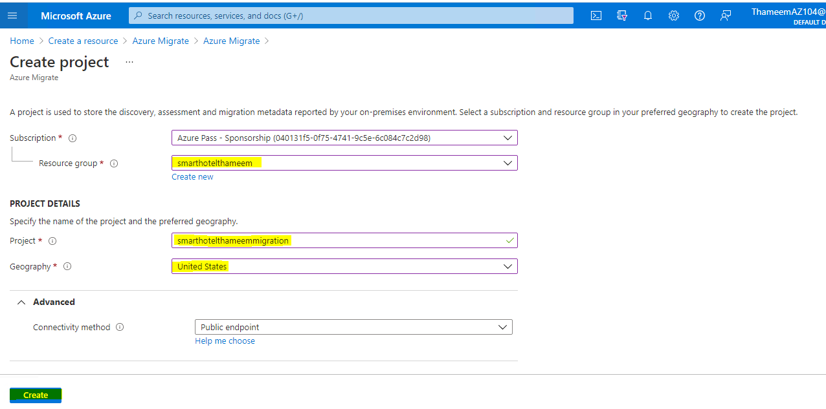

The Azure Migrate deployment will start. Once it has completed, you should see the **Azure Migrate: Discovery and assessment** and **Azure Migrate: Server Migration** panels for the current migration project, as shown below.

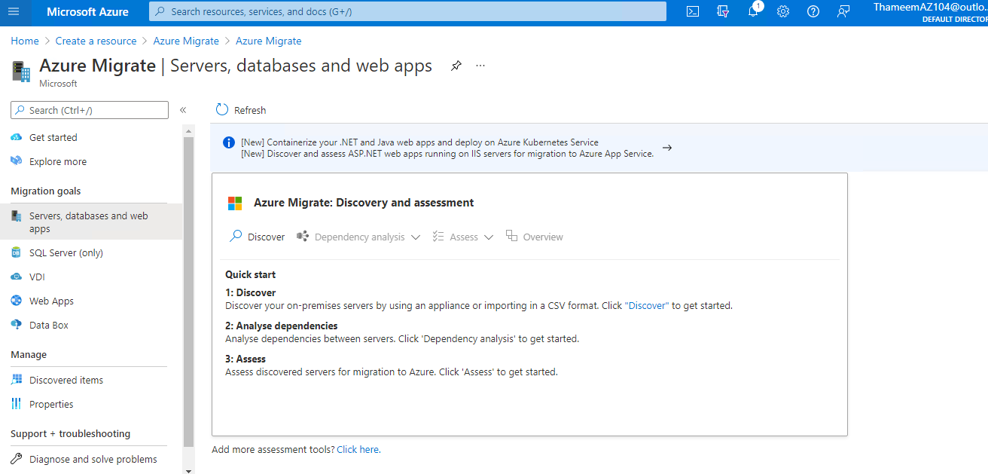

### Task 2: Deploy the Azure Migrate appliance

In this task, you will deploy and configure the Azure Migrate appliance in the on-premises Hyper-V environment. This appliance communicates with the Hyper-V server to gather configuration and performance data about your on-premises VMs, and returns that data to your Azure Migrate project.

1. Under **Azure Migrate: Server Assessment**, select **Discover** to open the **Discover machines** blade. Under **Are your machines virtualized?**, select **Yes, with Hyper-V**.

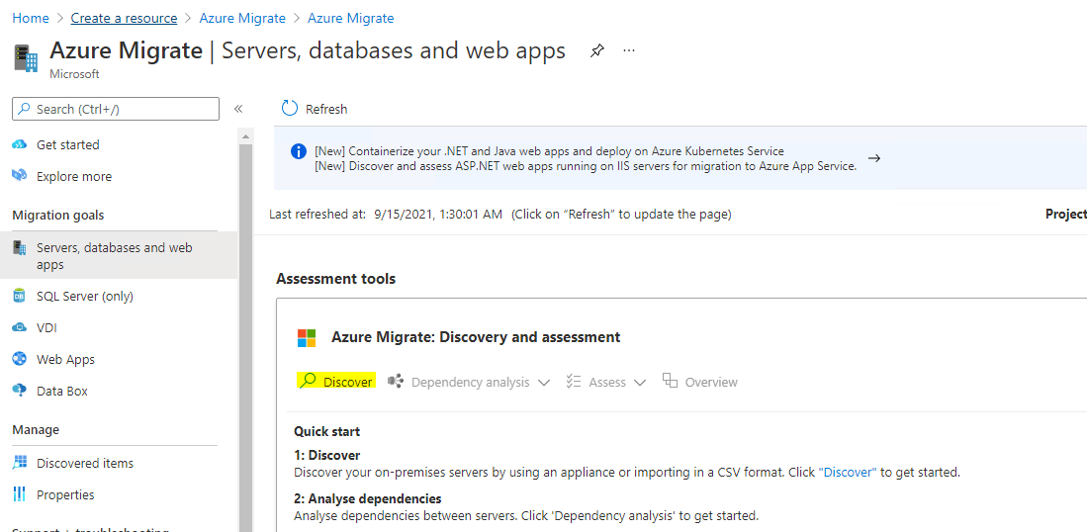

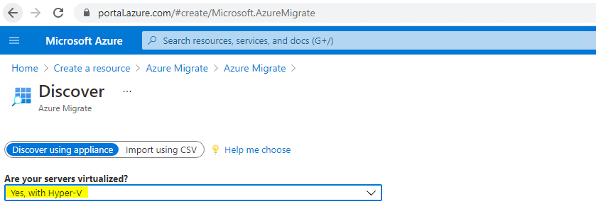

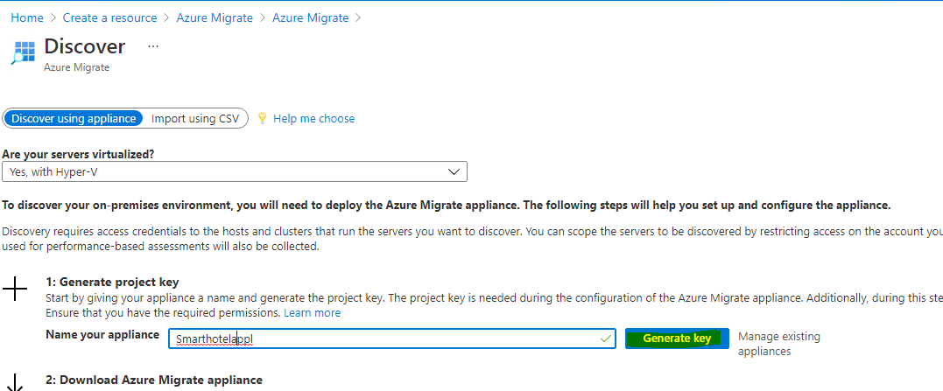

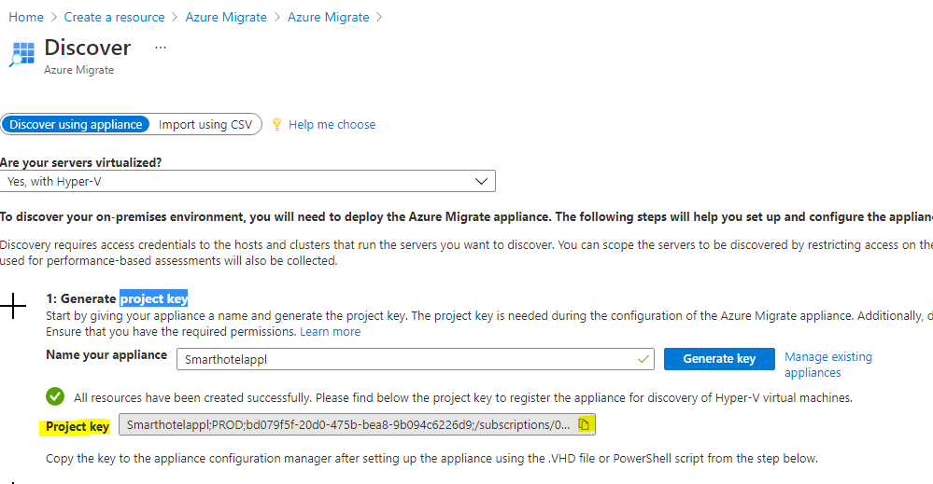

**project key**

Smarthotelappl;PROD;bd079f5f-20d0-475b-bea8-9b094c6226d9;/subscriptions/040131f5-0f75-4741-9c5e-6c084c7c2d98/resourceGroups/smarthotelthameem/providers/Microsoft.Migrate/MigrateProjects/smarthotelthameemmigration

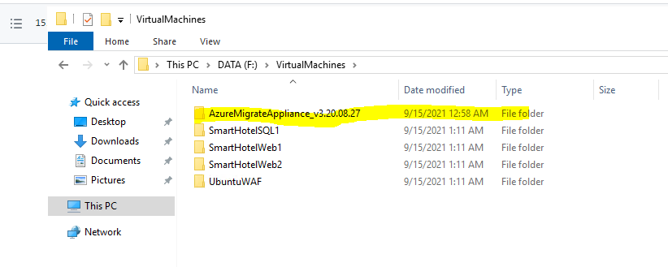

In Server Manager, select **Tools**, then **Hyper-V Manager** (if Server Manager does not open automatically, open it by selecting **Start**, then **Server Manager**). In Hyper-V Manager, select **SMARTHOTELHOST**. You should now see a list of the four VMs that comprise the on-premises SmartHotel application.

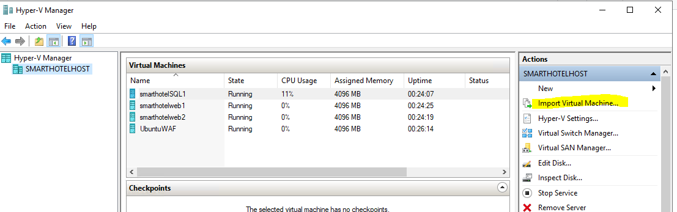

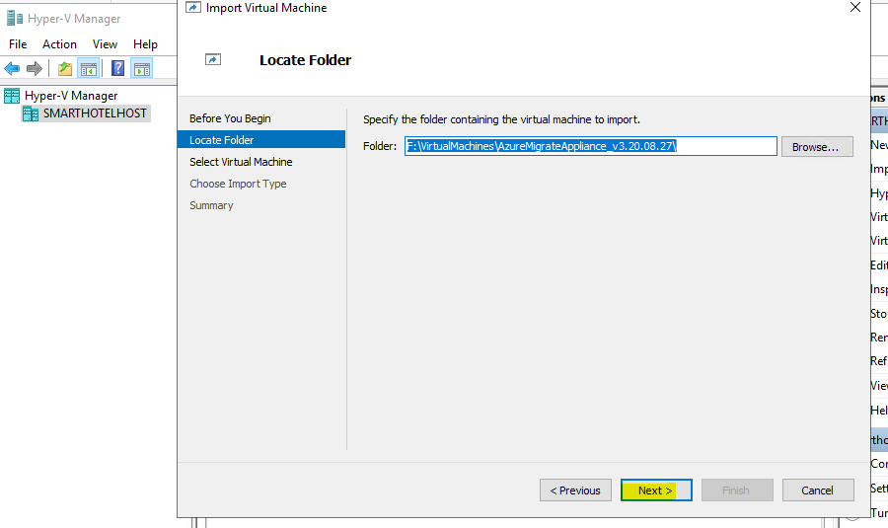

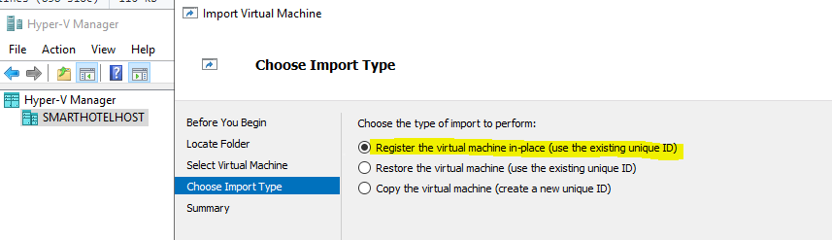

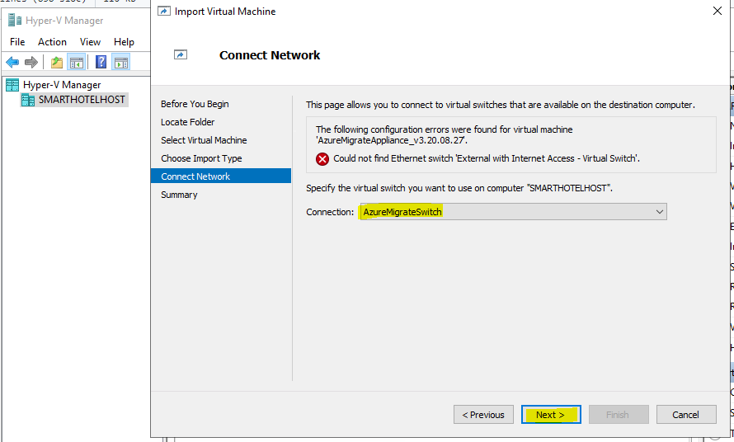

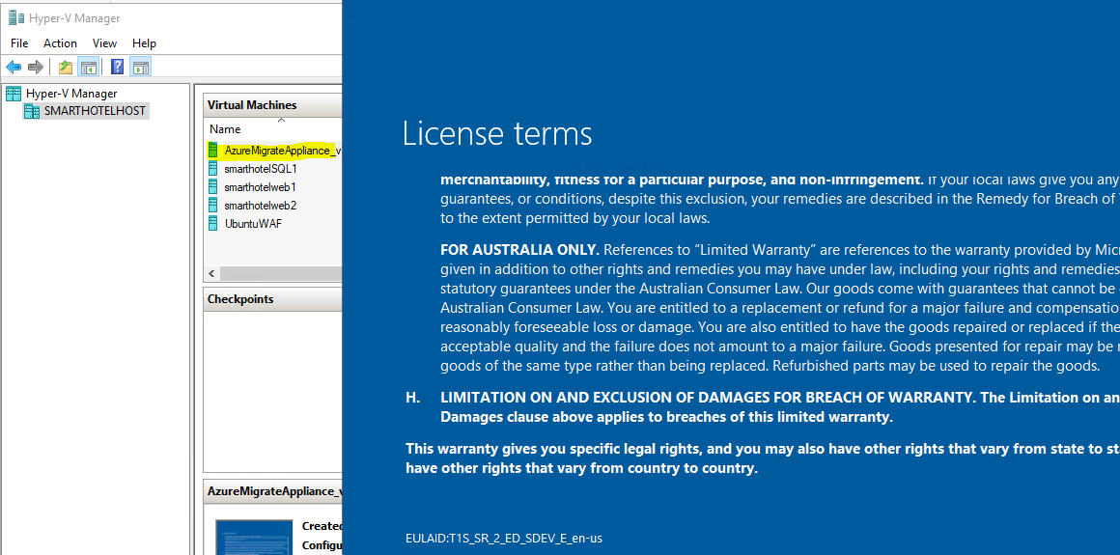

Set password demo!pass123

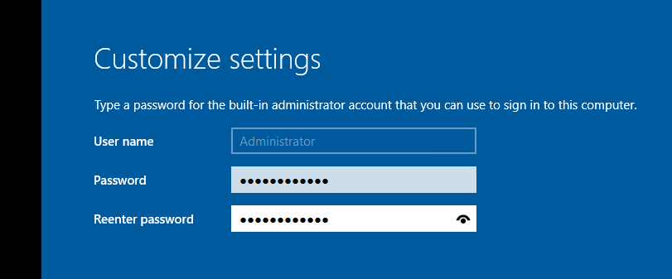

**Wait.** After a minute or two, the browser will open showing the Azure Migrate appliance configuration wizard (it can also be launched from the desktop shortcut).

On opening of the appliance configuration wizard, a pop-up with the license terms will appear. Accept the terms by selecting **I agree**.

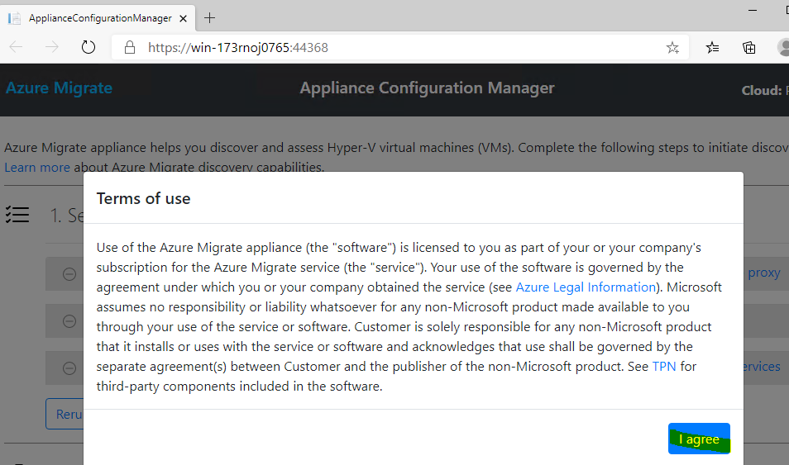

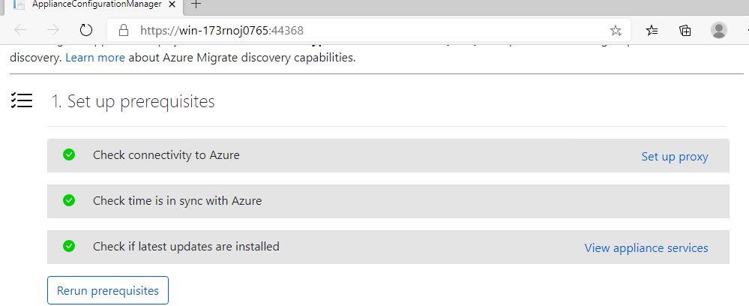

Smarthotelappl;PROD;bd079f5f-20d0-475b-bea8-9b094c6226d9;/subscriptions/040131f5-0f75-4741-9c5e-6c084c7c2d98/resourceGroups/smarthotelthameem/providers/Microsoft.Migrate/MigrateProjects/smarthotelthameemmigration

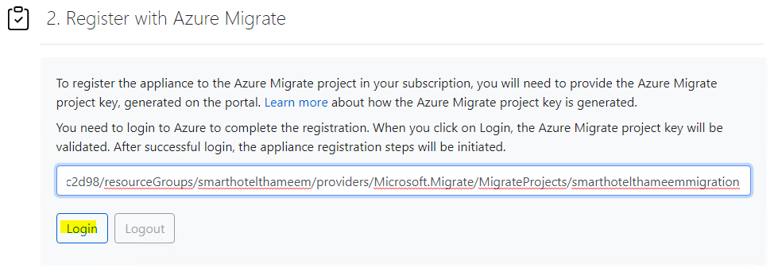

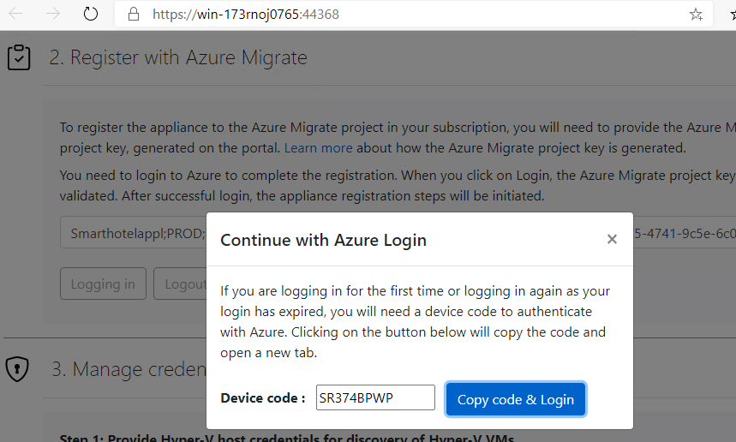

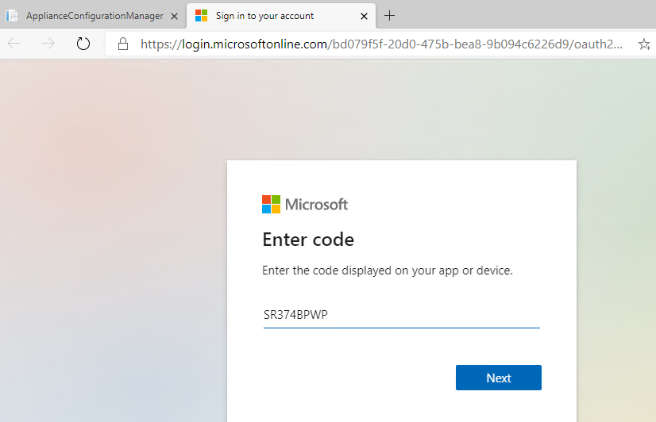

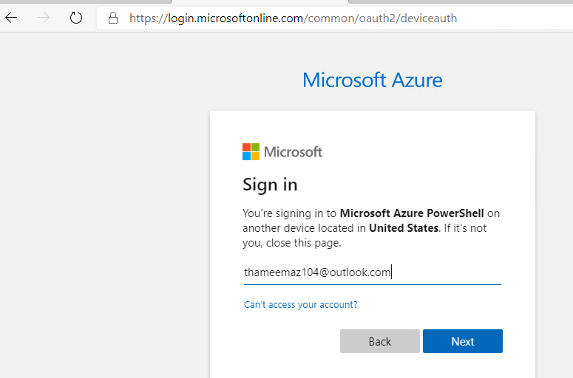

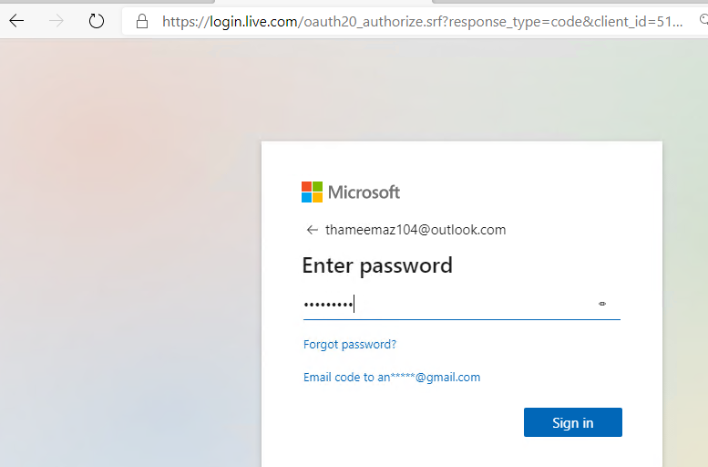

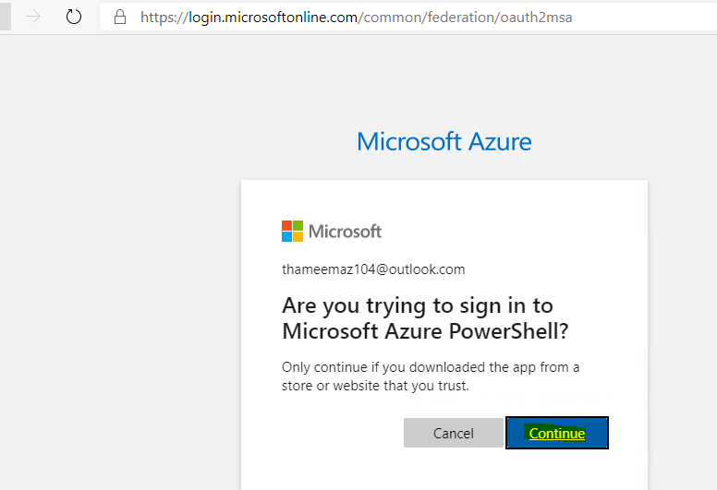

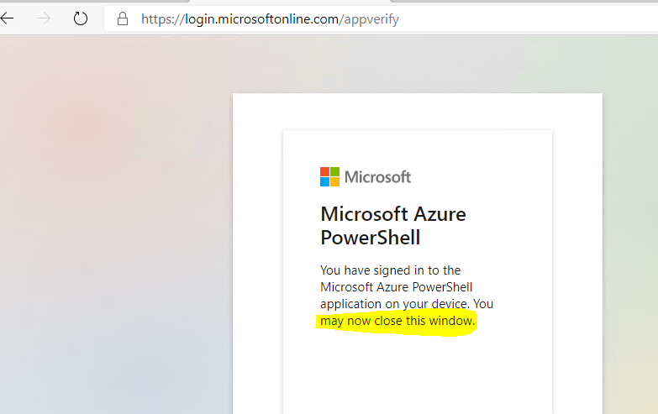

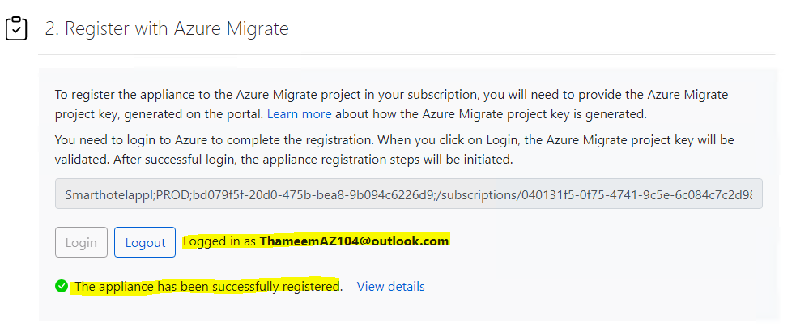

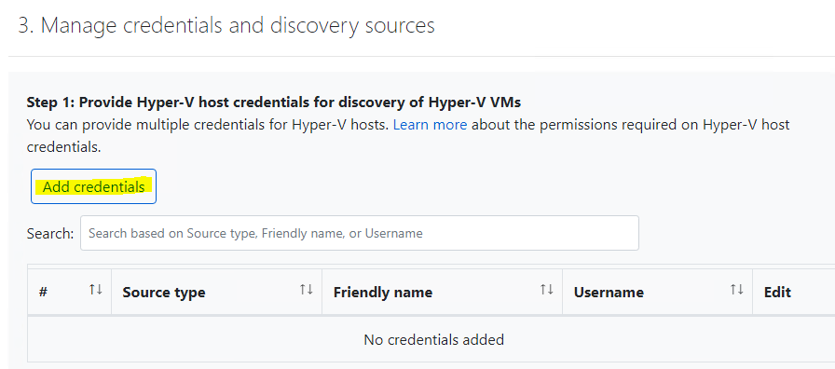

In **Step 1: Provide Hyper-V host credentials**, select **Add credentials**.

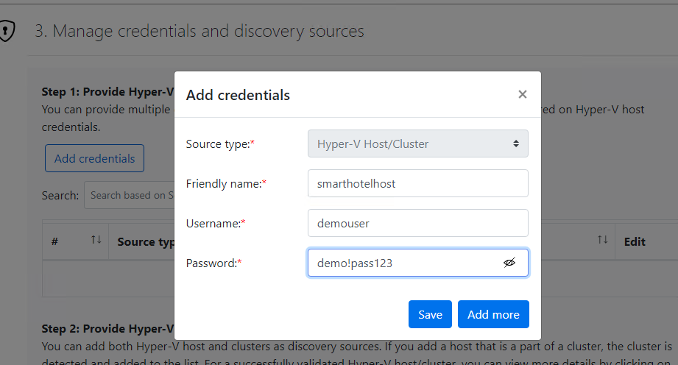

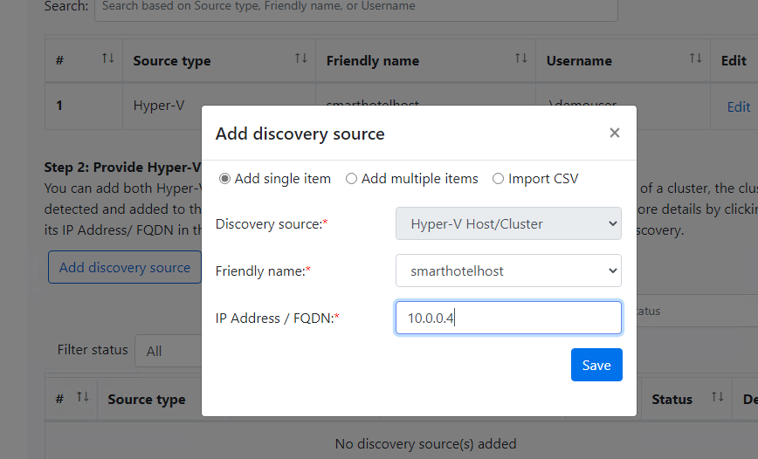

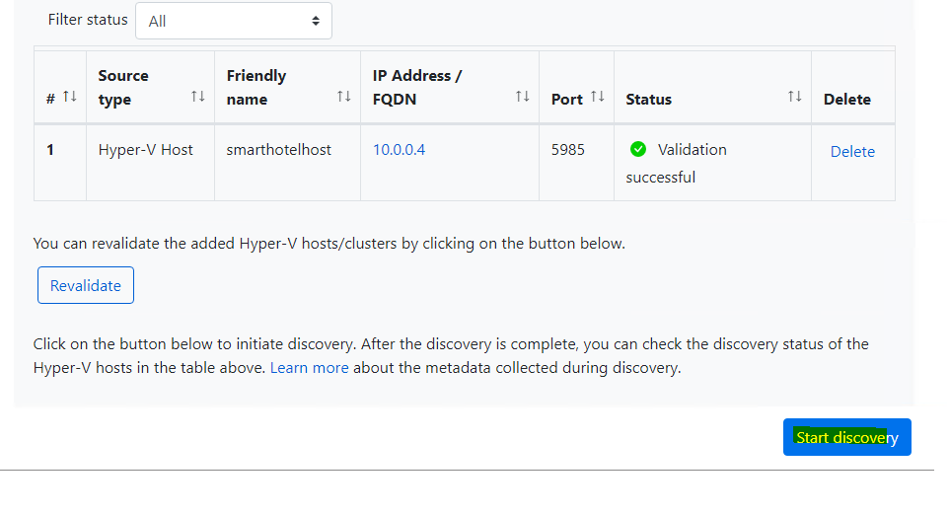

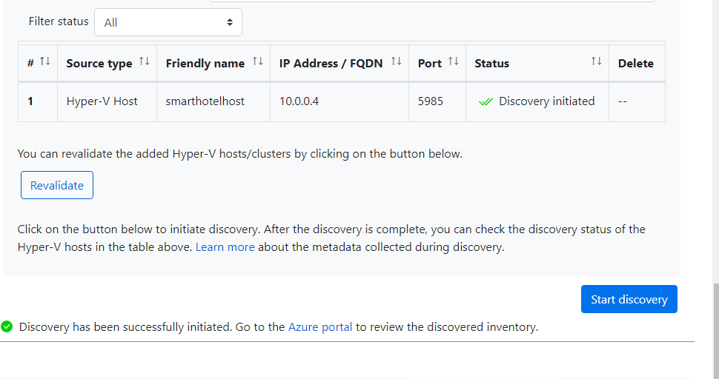

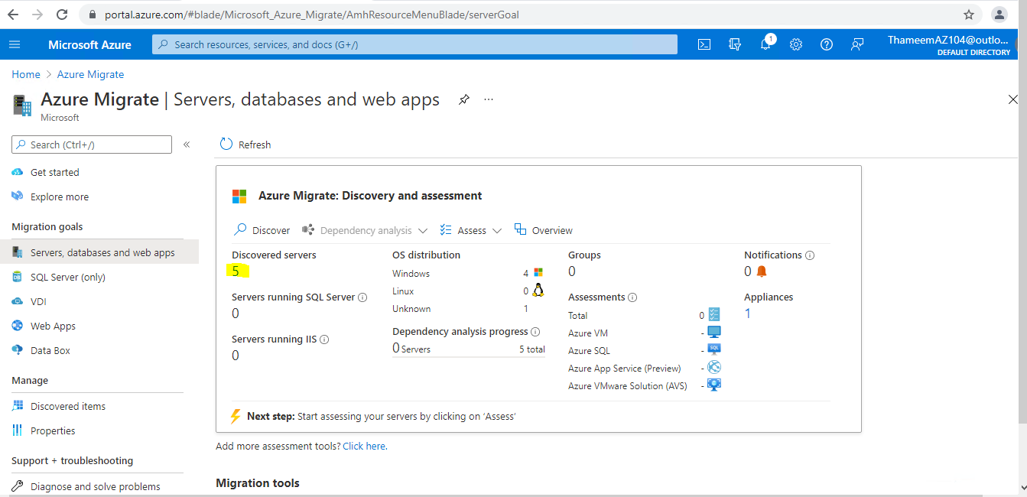

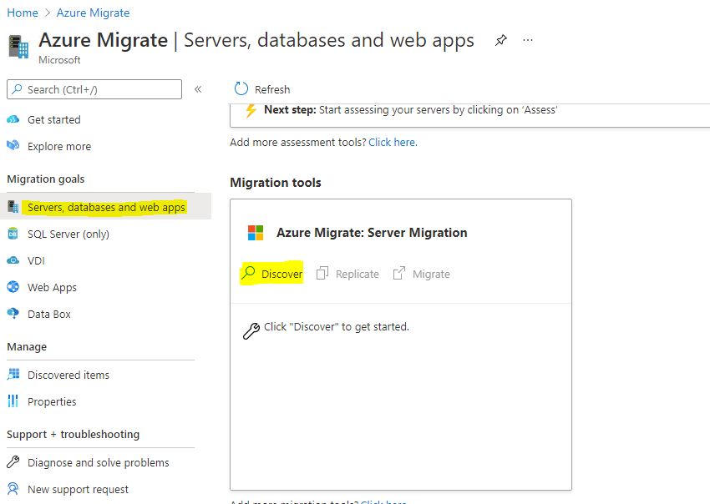

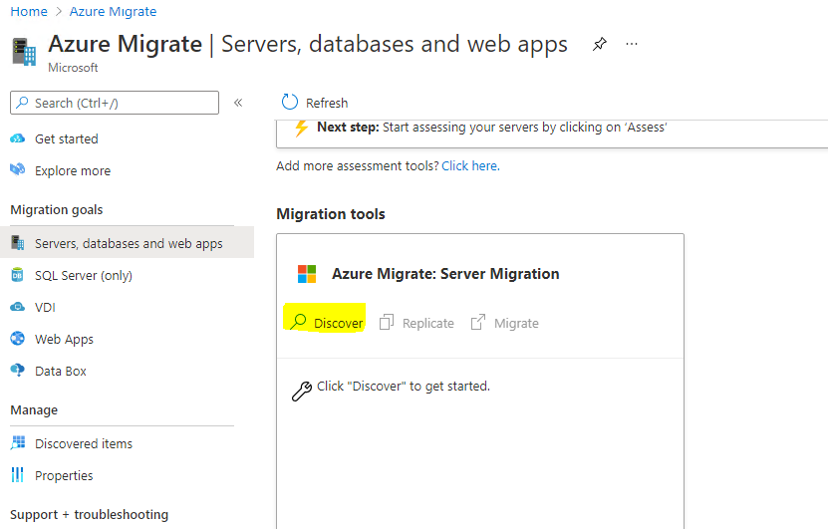

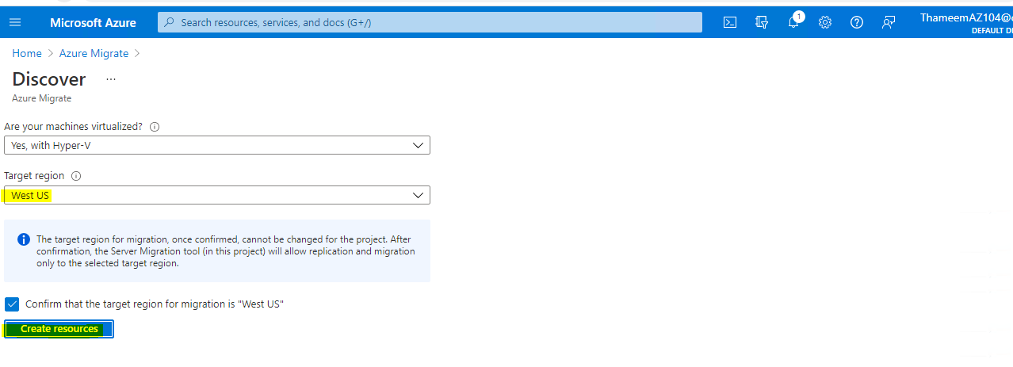

### Task 4: Create a migration assessment

In this task, you will use Azure Migrate to create a migration assessment for the SmartHotel application, using the data gathered during the discovery phase.

1. Continuing from Task 3, select **Assess** under **Azure Migrate: Server Assessment** to start a new migration assessment.

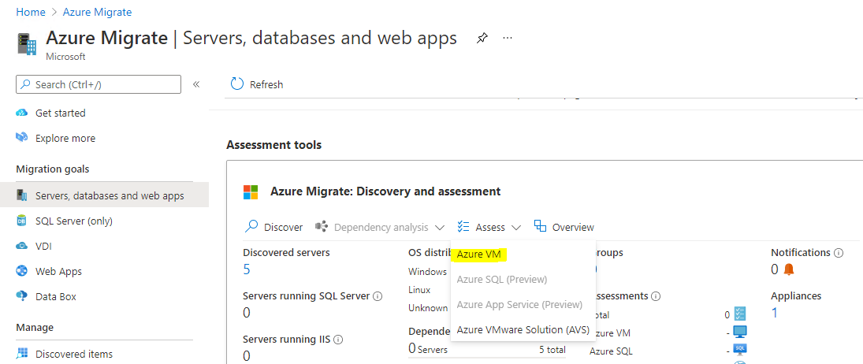

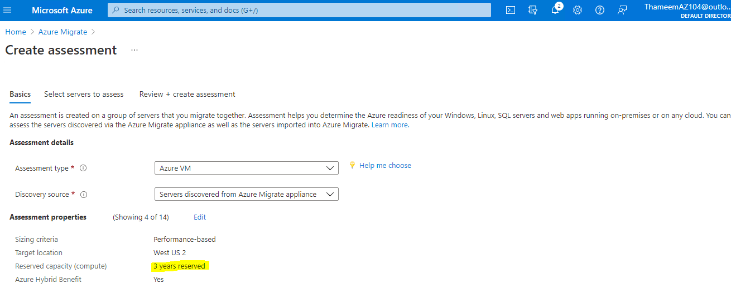

The **Assessment properties** blade allows you to tailor many of the settings used when making a migration assessment report. Take a few moments to explore the wide range of assessment properties. Hover over the information icons to see more details on each setting. Choose any settings you like, then select **Save**. (You have to make a change for the Save button to be enabled; if you don't want to make any changes, just close the blade.)

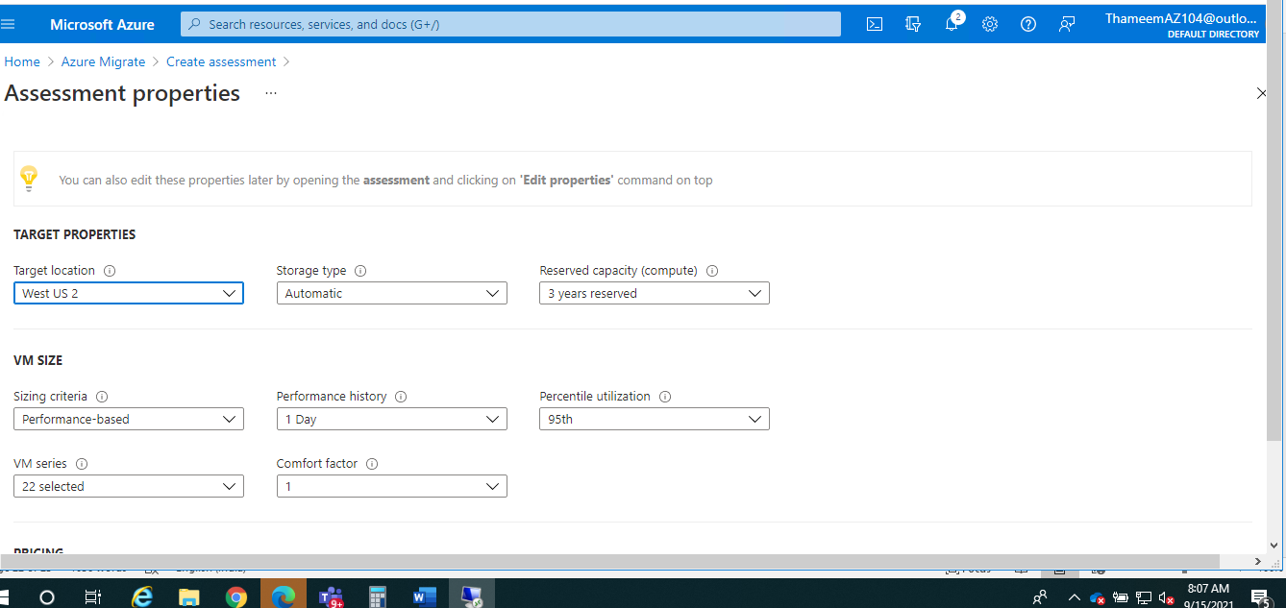

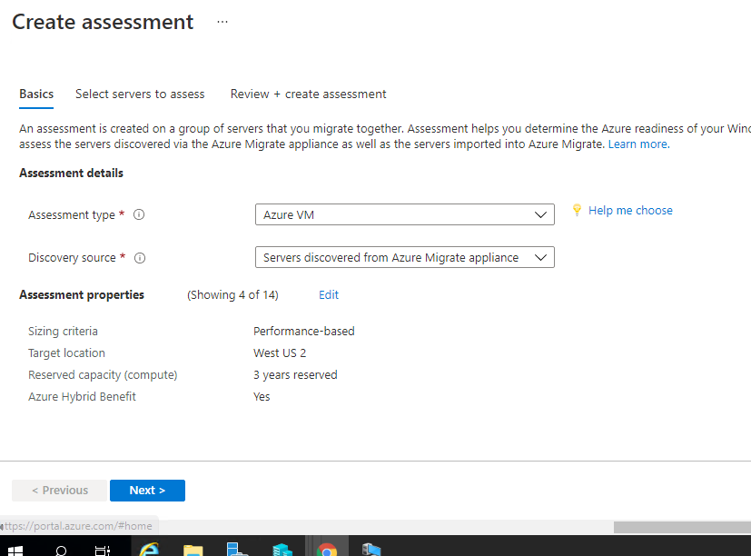

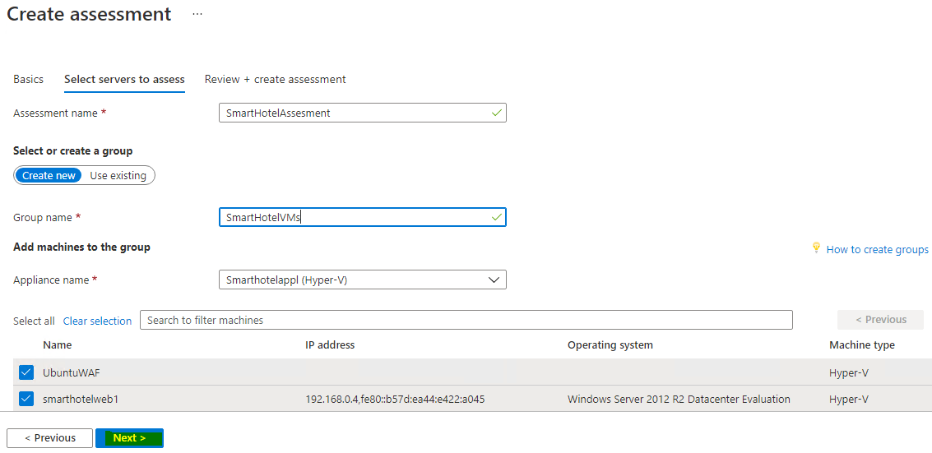

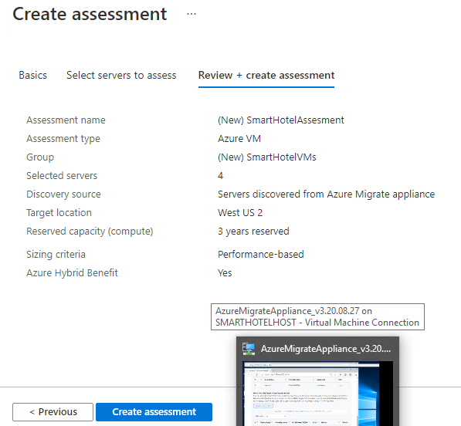

Select **Next**, followed by **Create assessment**. On the **Azure Migrate - Windows, Linux and SQL Server** blade, select **Refresh** periodically until the number of assessments shown is **1**. This may take several minutes.

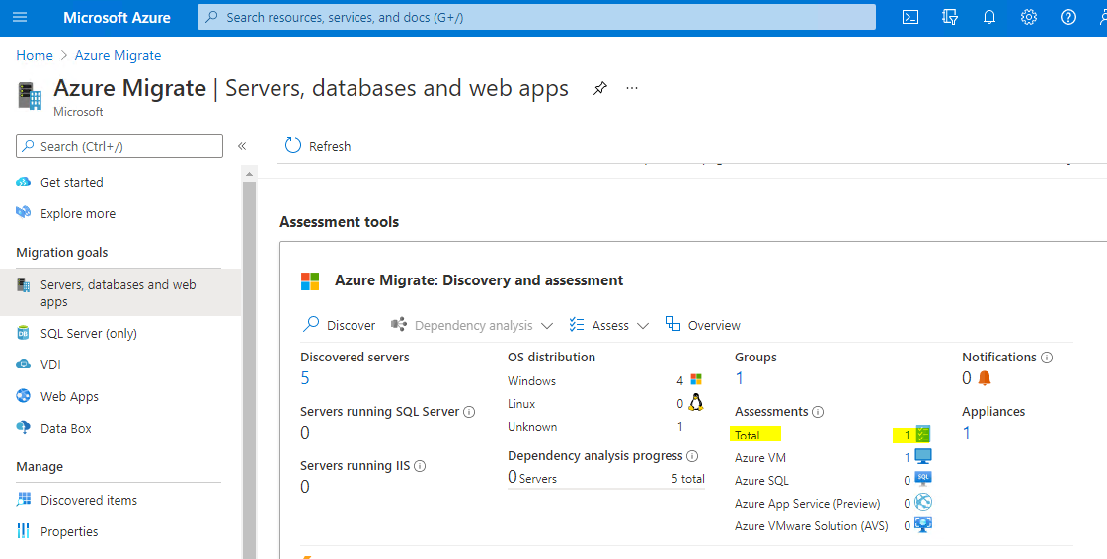

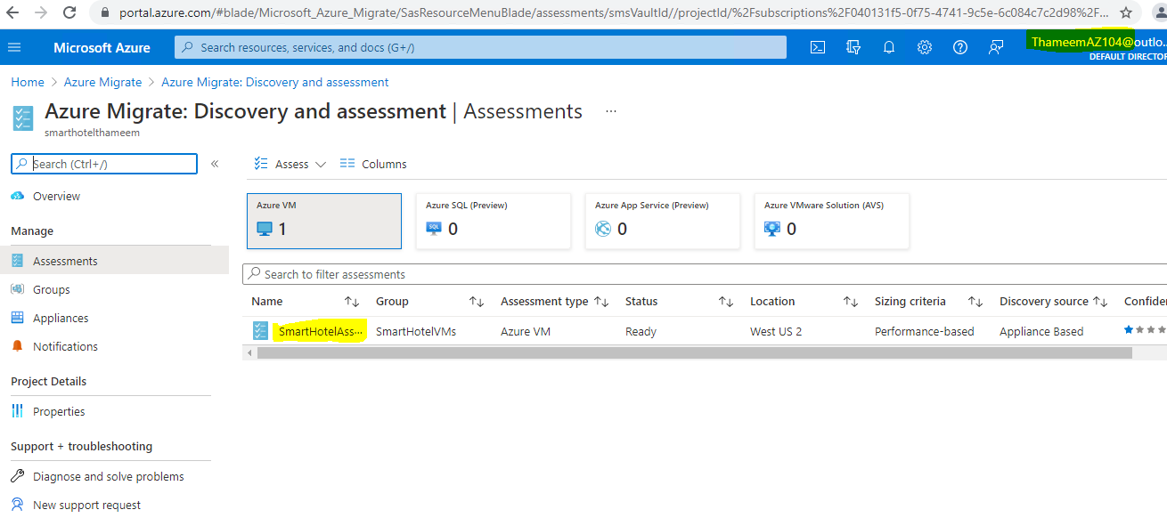

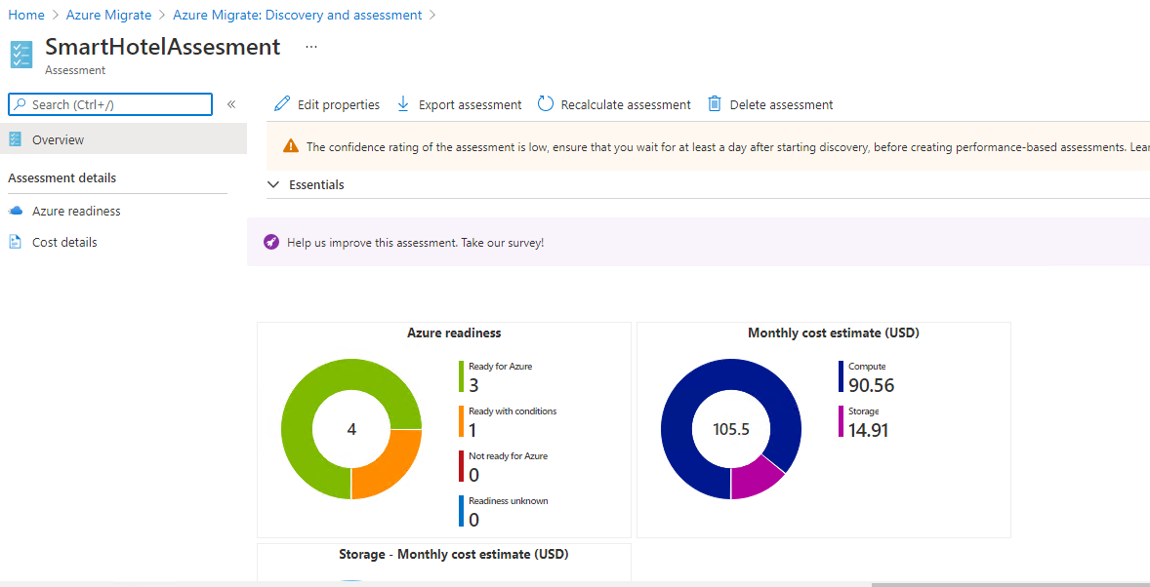

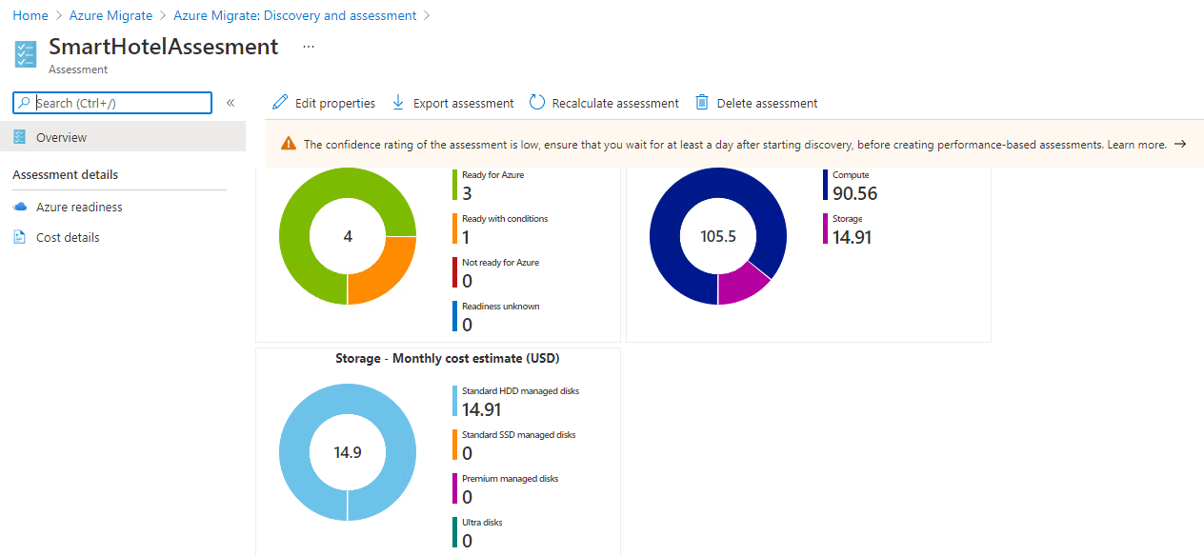

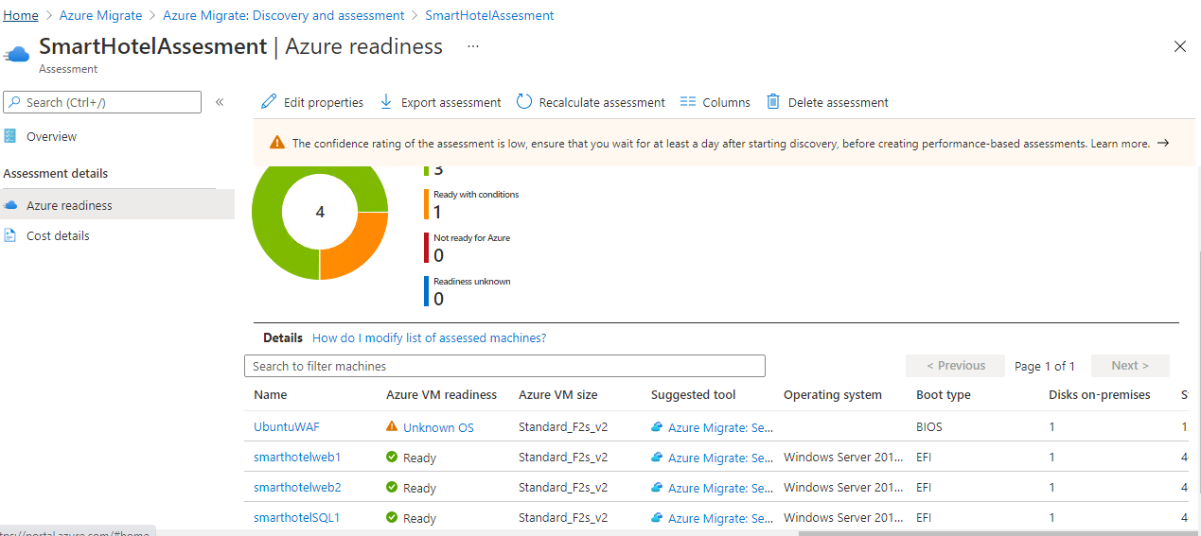

Select **Unknown OS** for **UbuntuWAF**. A new browser tab opens showing Azure Migrate documentation. Note on the page that the issue relates the OS not being specified in the host hypervisor, so you must confirm the OS type and version is supported.

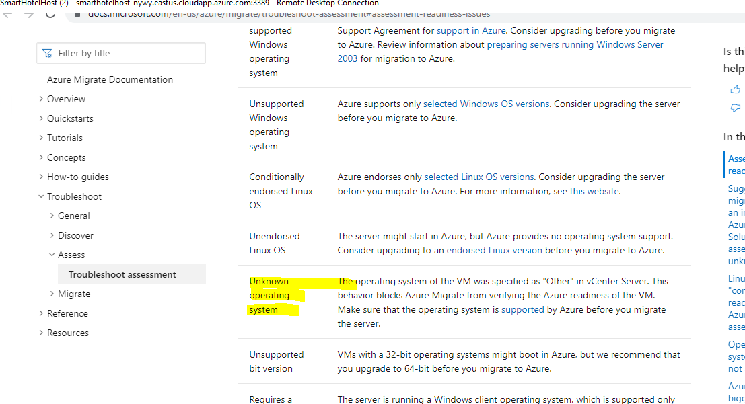

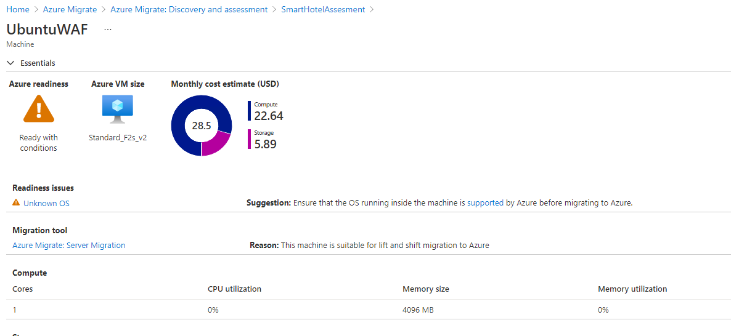

### Task 5: Configure dependency visualization

When migrating a workload to Azure, it is important to understand all workload dependencies. A broken dependency could mean that the application doesn't run properly in Azure, perhaps in hard-to-detect ways. Some dependencies, such as those between application tiers, are obvious. Other dependencies, such as DNS lookups, Kerberos ticket validation or certificate revocation checks, are not.

In this task, you will configure the Azure Migrate dependency visualization feature. This requires you to first create a Log Analytics workspace, and then to deploy agents on the to-be-migrated VMs.

1. Return to the **Azure Migrate** blade in the Azure Portal, and select **Windows, Linux and SQL Server**. Under **Azure Migrate: Discovery and assessment** select **Groups**, then select the **SmartHotel VMs** group to see the group details. Note that each VM has their **Dependencies** status as **Requires agent installation**. Select **Requires agent installation** for the **smarthotelweb1** VM.

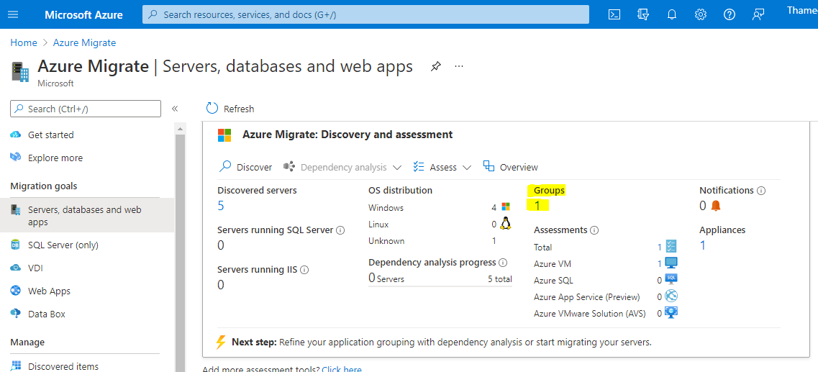

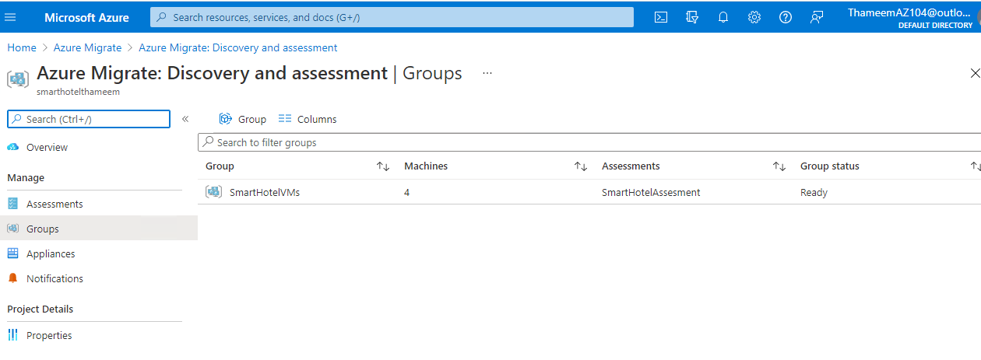

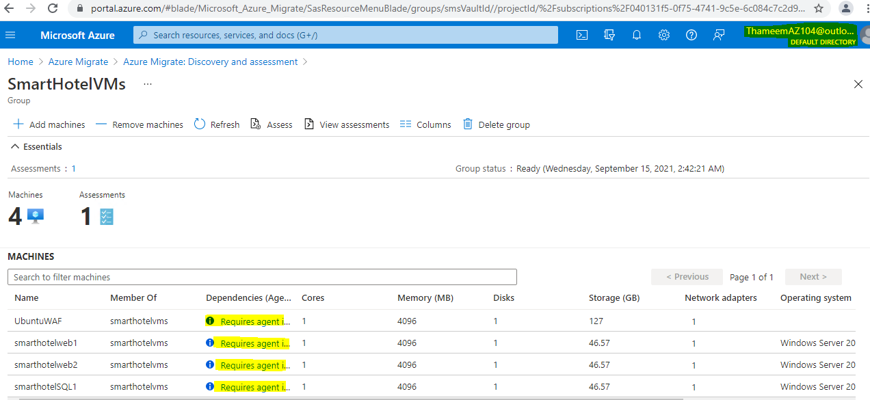

On the **Dependencies** blade, select **Configure OMS workspace**.

Install the configure OMS workspace on the host machine

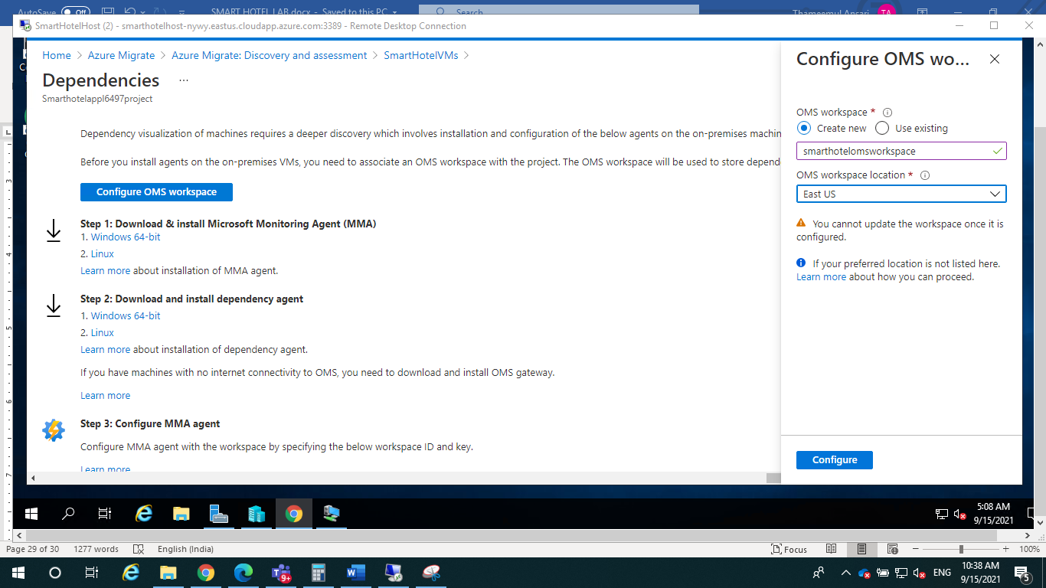

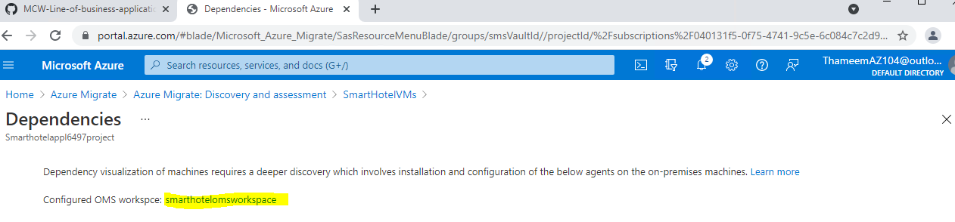

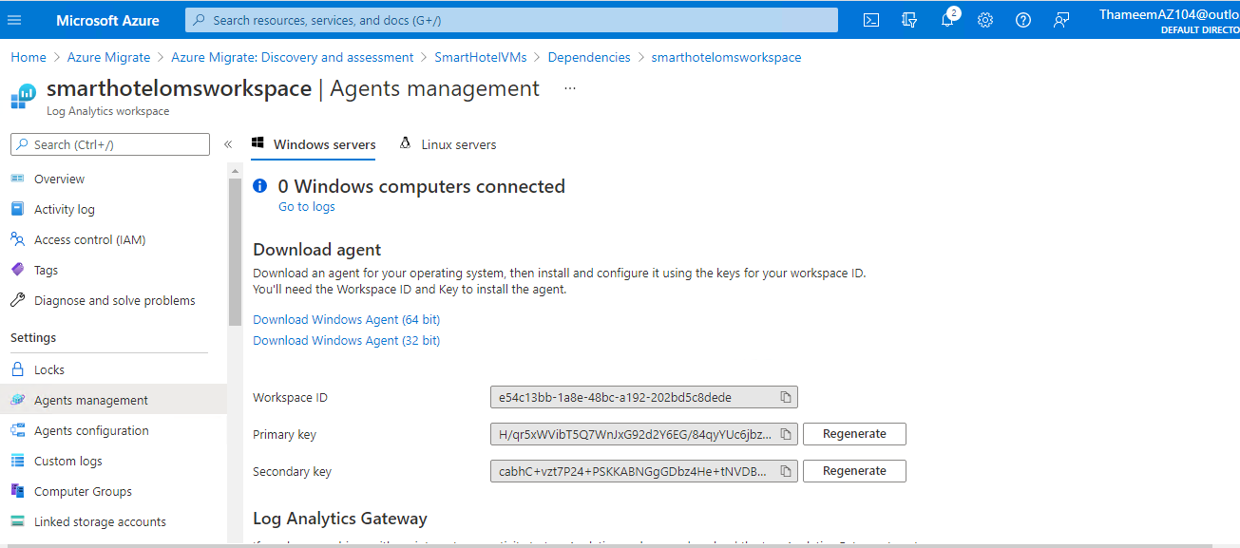

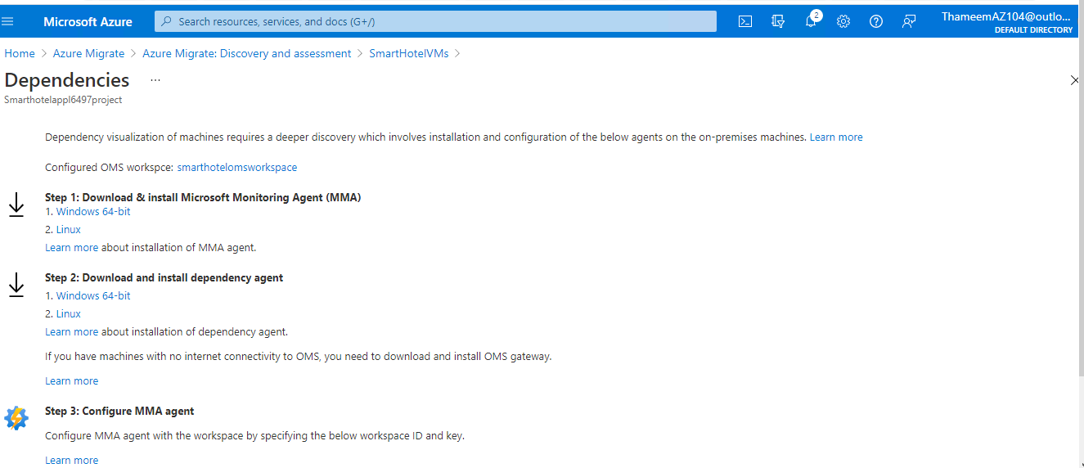

Workspace ID

e54c13bb-1a8e-48bc-a192-202bd5c8dede

Primary key

H/qr5xWVibT5Q7WnJxG92d2Y6EG/84qyYUc6jbztgKXx/i+kl/8eYyB7C6+6srFwC5/HKokDGNq0lzNPlX0PmA==

Secondary key

cabhC+vzt7P24+PSKKABNGgGDbz4He+tNVDBXVhbB7oeOfyoK91z9VMcK4+ZqZ41Eyd65eBHaNvx1xlMj//6NQ==

Return to the Azure Migrate 'Dependencies' blade. Copy each of the 4 agent download URLs and paste them alongside the Workspace ID and key you noted in the previous step.

Return to the RDP session with the **SmartHotelHost**. In **Hyper-V Manager**, select **smarthotelweb1** and select **Connect**.

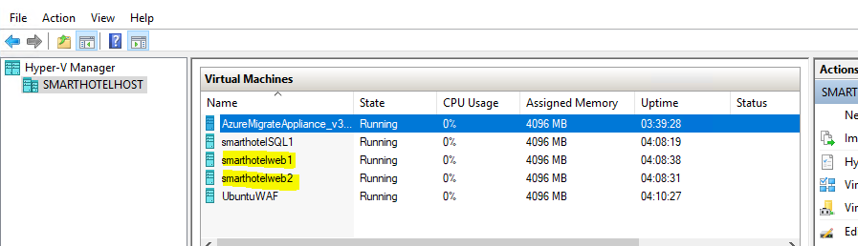

1. Select **Connect** again when prompted and log in to the **Administrator** account using the password **demo!pass123**.
2. Open **Internet Explorer**, and paste the link to the 64-bit Microsoft Monitoring Agent for Windows, which you noted earlier. When prompted, **Run** the installer.

**Note:** You may need to disable **Internet Explorer Enhanced Security Configuration** on **Server Manager** under **Local Server** to complete the download.

[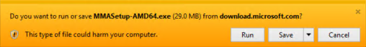](https://github.com/microsoft/MCW-Line-of-business-application-migration/blob/master/Hands-on%20lab/images/Exercise1/mma-win-run.png)

Select through the installation wizard until you get to the **Agent Setup Options** page. From there, select **Connect the agent to Azure Log Analytics (OMS)** and select **Next**. Enter the Workspace ID and Workspace Key that you copied earlier, and select **Azure Commercial** from the Azure Cloud drop-down. Select through the remaining pages and install the agent.

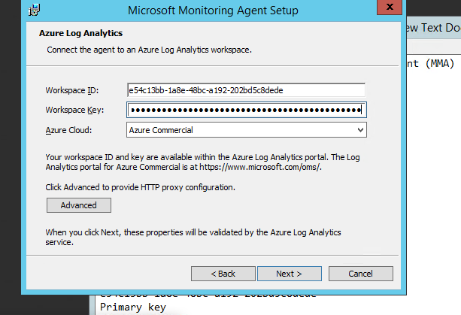

Paste the link to the Dependency Agent Windows installer into the browser address bar. **Run** the installer and select through the install wizard to complete the installation.

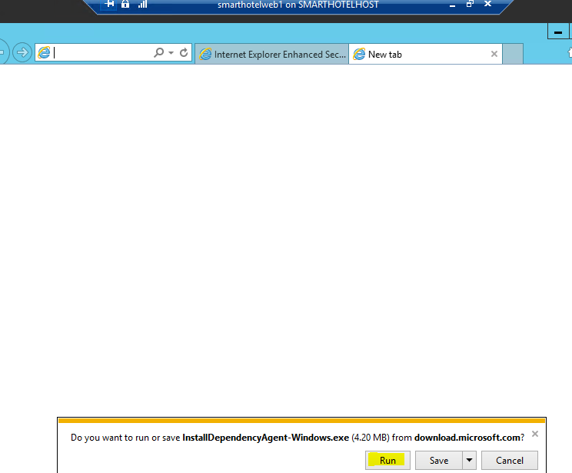

Close the virtual machine connection window for the **smarthotelweb1** VM. Connect to the **smarthotelweb2** VM and repeat the installation process (steps 8-10) for both agents (the administrator password is the same as for smarthotelweb1).

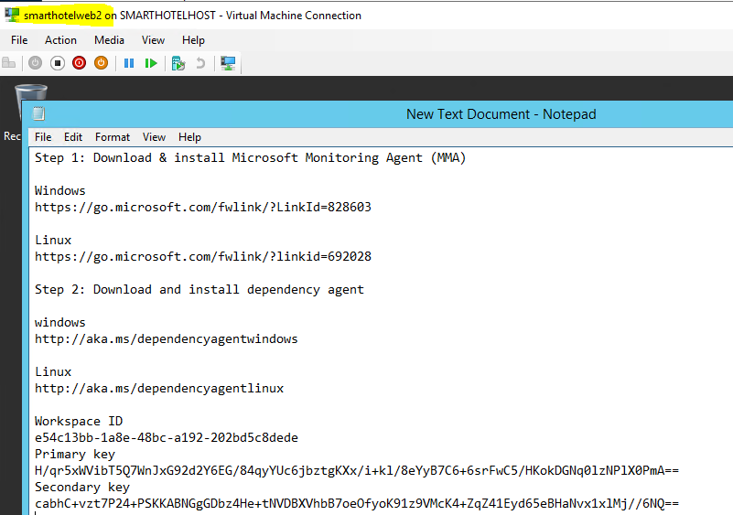

You will now deploy the Linux versions of the Microsoft Monitoring Agent and Dependency Agent on the **UbuntuWAF** VM. To do so, you will first connect to the UbuntuWAF remotely using an SSH session.

1. Return to the RDP session with the **SmartHotelHost** and open a command prompt using the desktop shortcut.
2. **Note**: The SmartHotelHost runs Windows Server 2019 with the Windows Subsystem for Linux enabled. This allows the command prompt to be used as an SSH client. More info of supported Linux on Azure can be found here: [https://Azure.com/Linux](https://azure.com/Linux).
3. Enter the following command to connect to the **UbuntuWAF** VM running in Hyper-V on the SmartHotelHost:

ssh demouser@192.168.0.8

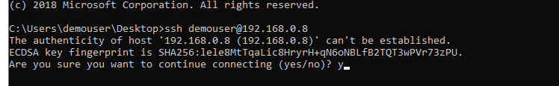

1. Enter 'yes' when prompted whether to connect. Use the password **demo!pass123**.

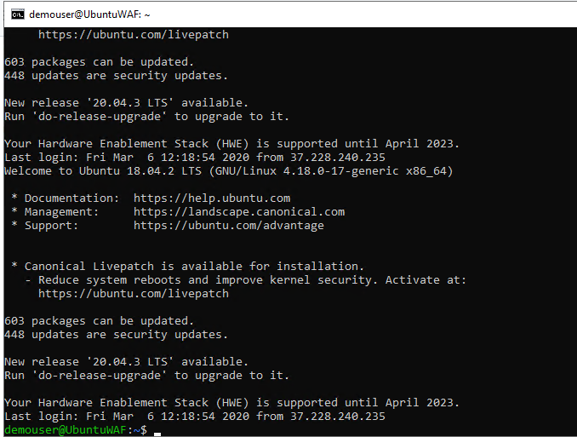

1. Enter the following command, substituting <Workspace ID> and <Workspace Key> with the values copied previously. Answer when prompted to restart services during package upgrades without asking.

wget https://raw.githubusercontent.com/Microsoft/OMS-Agent-for-Linux/master/installer/scripts/onboard_agent.sh && sh onboard_agent.sh -w e54c13bb-1a8e-48bc-a192-202bd5c8dede -s H/qr5xWVibT5Q7WnJxG92d2Y6EG/84qyYUc6jbztgKXx/i+kl/8eYyB7C6+6srFwC5/HKokDGNq0lzNPlX0PmA==

press yes

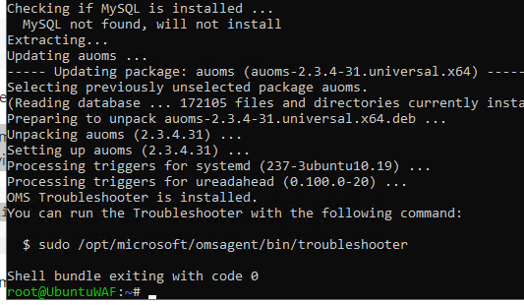

Workspace ID

e54c13bb-1a8e-48bc-a192-202bd5c8dede

Primary key

H/qr5xWVibT5Q7WnJxG92d2Y6EG/84qyYUc6jbztgKXx/i+kl/8eYyB7C6+6srFwC5/HKokDGNq0lzNPlX0PmA==

1. Enter the following command, substituting <Workspace ID> with the value copied earlier:

/opt/microsoft/omsagent/bin/service_control restart e54c13bb-1a8e-48bc-a192-202bd5c8dede



1. Enter the following command. This downloads a script that will install the Dependency Agent.

wget --content-disposition https://aka.ms/dependencyagentlinux -O InstallDependencyAgent-Linux64.bin

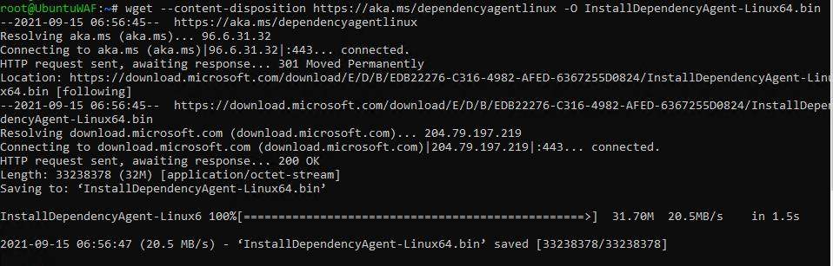

1. Install the dependency agent by running the script download in the previous step.

sh InstallDependencyAgent-Linux64.bin -s

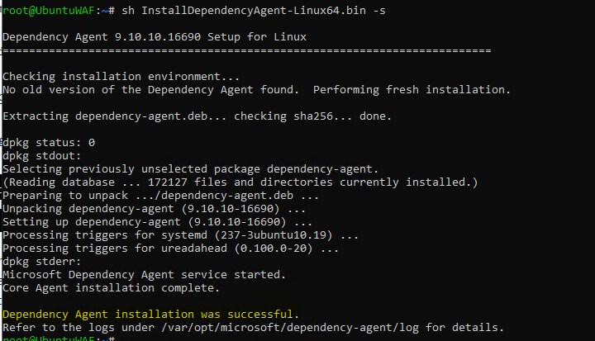

The agent installation is now complete. Next, you need to generate some traffic on the SmartHotel application so the dependency visualization has some data to work with. Browse to the public IP address of the SmartHotelHost, and spend a few minutes refreshing the page and checking guests in and out

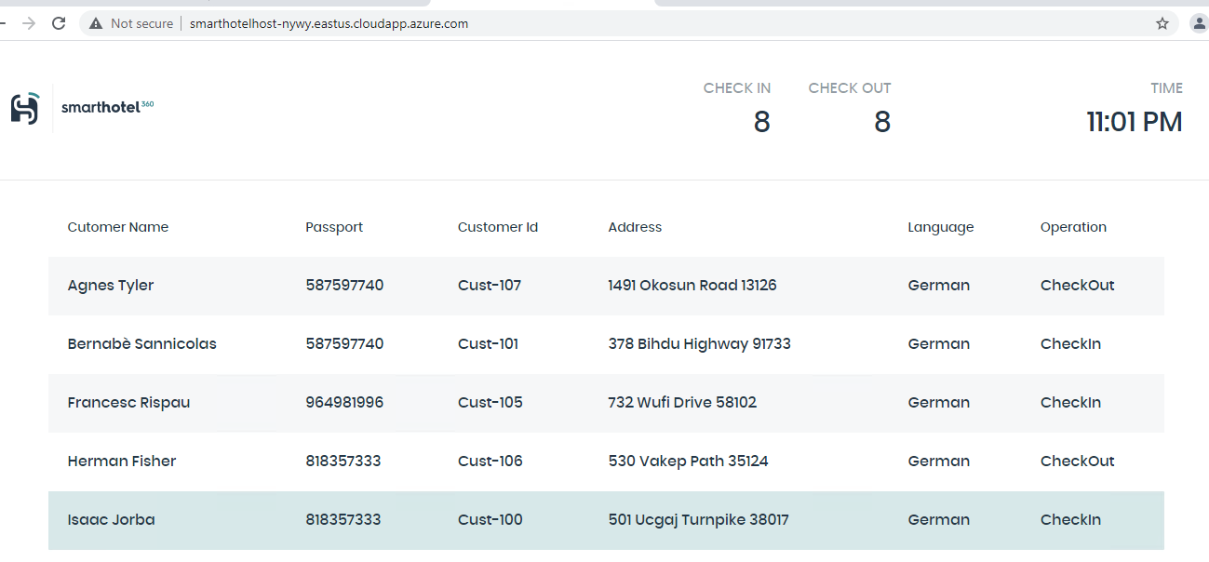

## Application Migration

## Exercise 2: Migrate the Application Database

### Task 1: Register the Microsoft.DataMigration resource provider

Prior to using the Azure Database Migration Service, the resource provider **Microsoft.DataMigration** must be registered in the target subscription.

Open the Azure Cloud Shell by navigating to [https://shell.azure.com](https://shell.azure.com/). Log in using your Azure subscription credentials if prompted to do so, select a **PowerShell** session, and accept any prompts.

Run the following command to register the **Microsoft.DataMigration** resource provider:

Register-AzResourceProvider -ProviderNamespace Microsoft.DataMigration

**Note**: It may take several minutes for the resource provider to register. You can proceed to the next task without waiting for the registration to complete. You will not use the resource provider until task 3.

You can check the status by running:

Get-AzResourceProvider -ProviderNamespace Microsoft.DataMigration | Select-Object ProviderNamespace, RegistrationState, ResourceTypes

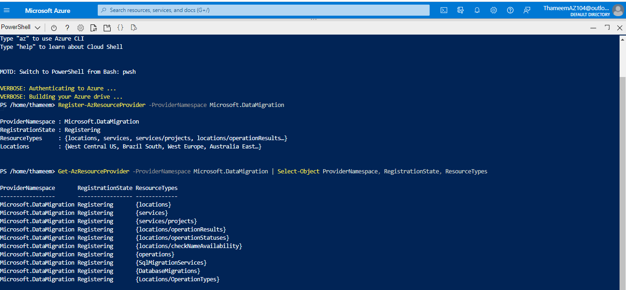

### Task 2: Create an Azure SQL Database

In this task you will create a new Azure SQL database to migrate the on-premises database to.

1. Open the Azure portal at [https://portal.azure.com](https://portal.azure.com/) and log in using your subscription credentials if it's not still up.
2. Expand the portal's left navigation by selecting **Show portal menu** in the top left then select **+ Create a resource**, then select **Databases**, then select **SQL Database**.

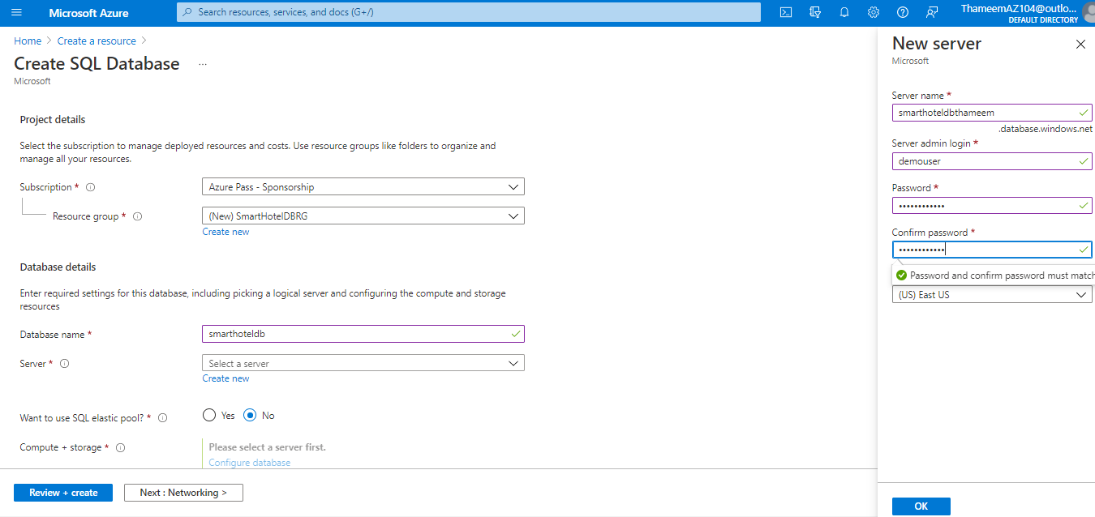

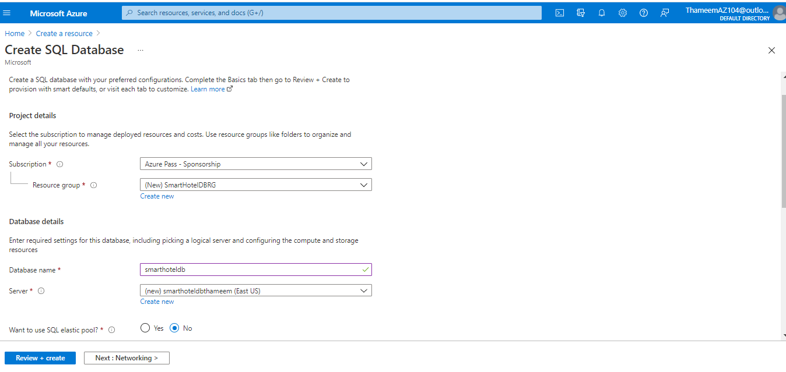

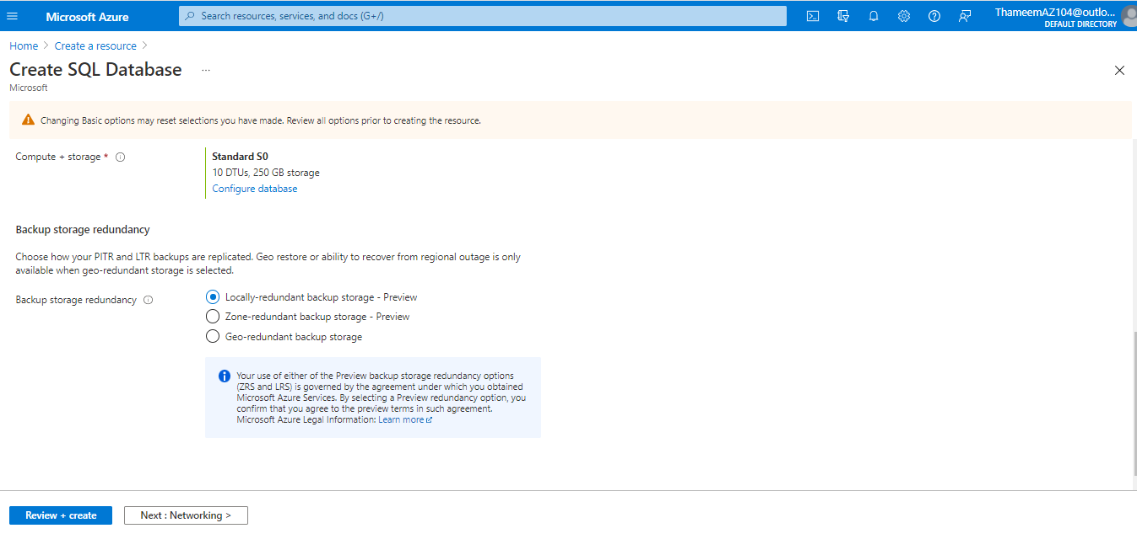

### Task 3: Create the Database Migration Service

In this task you will create an Azure Database Migration Service resource. This resource is managed by the Microsoft.DataMigration resource provider which you registered in task 1.

Return to the cloud shell browser tab you used in task 1 to register the Microsoft.DataMigration resource provider. Check that the registration has been completed by running the following command before proceeding further.

Get-AzResourceProvider -ProviderNamespace Microsoft.DataMigration | Select-Object ProviderNamespace, RegistrationState, ResourceTypes

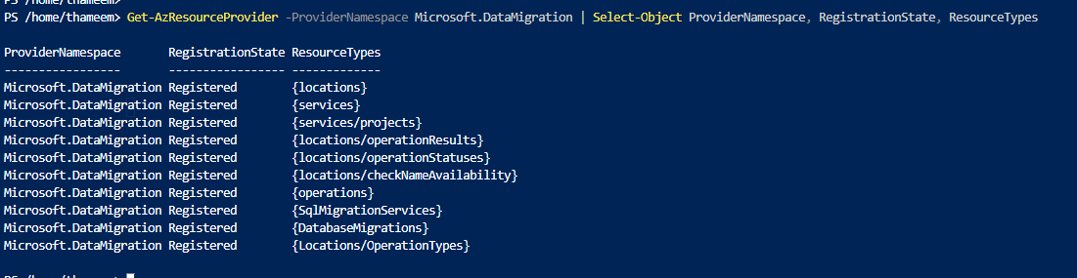

1. In the Azure portal, expand the portal's left navigation and select **+ Create a resource**, search for **migration**, and then select **Azure Database Migration Service** from the drop-down list.
2. On the **Azure Database Migration Service** blade, select **Create**.

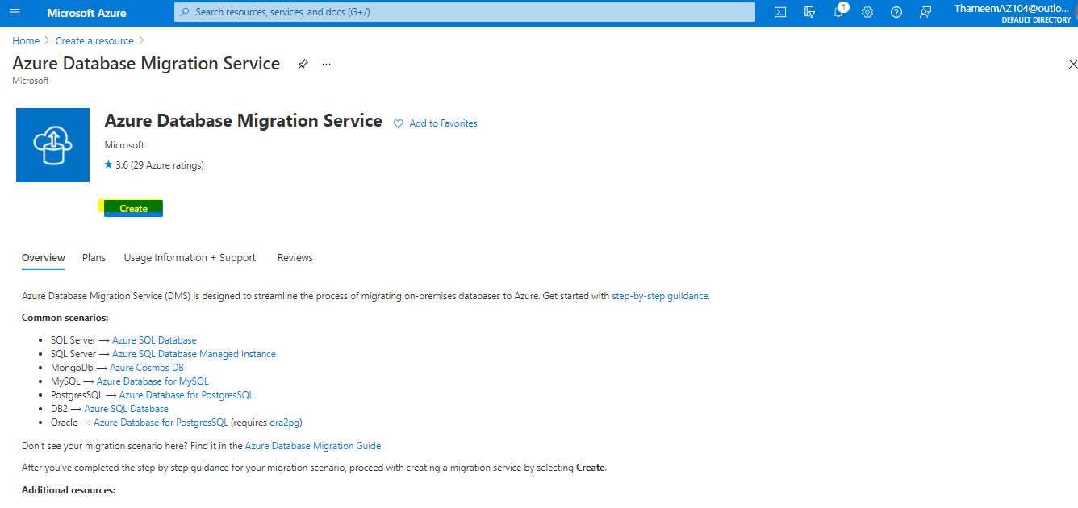

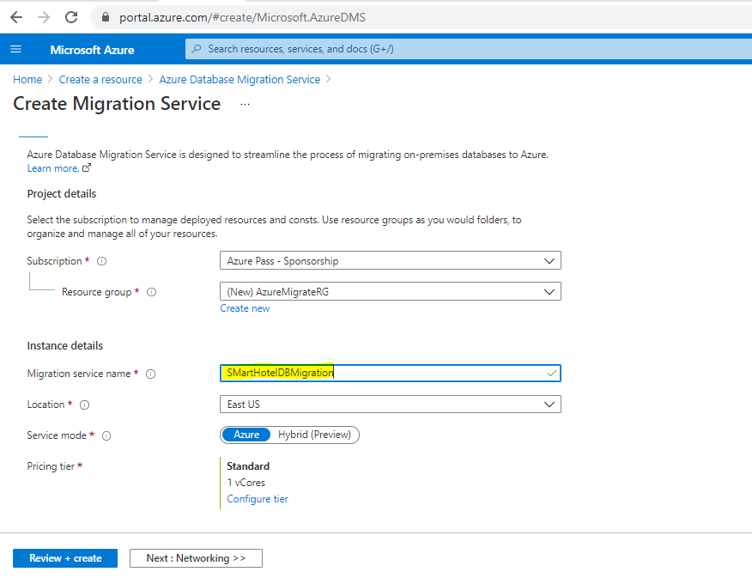

Select **Next: Networking** to move to the **Networking** tab, and select the **DMSvnet/DMS** virtual network and subnet in the **SmartHotelHostRG** resource group.

1. Select **Review + create**, followed by **Create**.

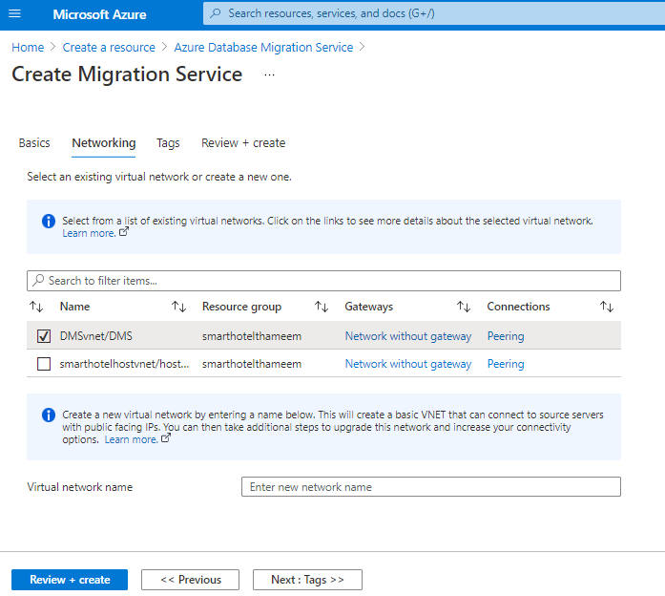

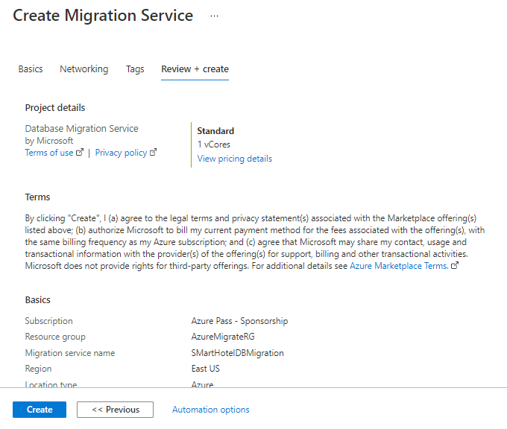

### Task 4: Assess the on-premises database using Data Migration Assistant

In this task you will install and use Microsoft Data Migration Assistant (DMA) to assess the on-premises database. DMA is integrated with Azure Migrate providing a single hub for assessment and migration tools.

1. Return to the **Azure Migrate** blade in the Azure portal. Select the **Overview** panel, then select **Assess and migrate databases**.

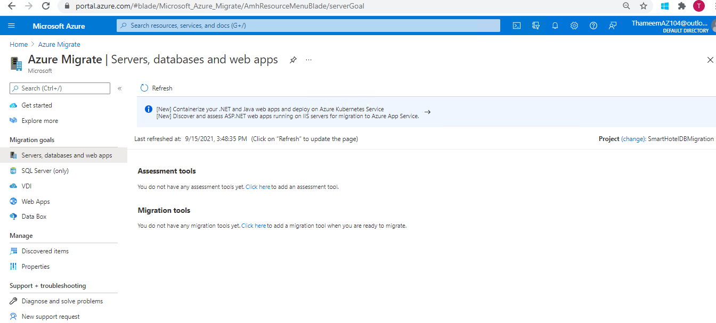

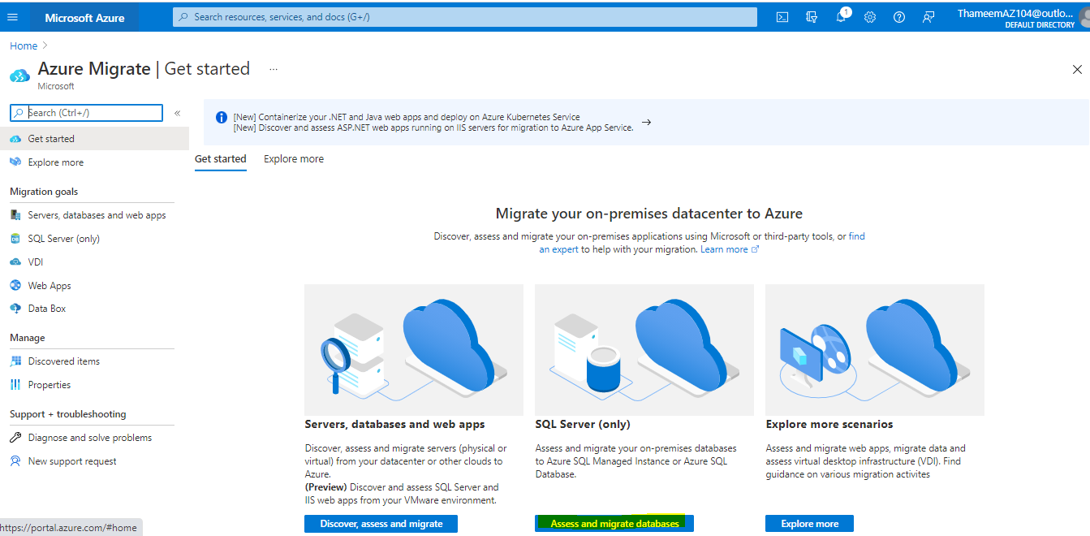

Under **Assessment tools**, select the link to add a tool, then select **Azure Migrate: Database Assessment**, then select **Next**.

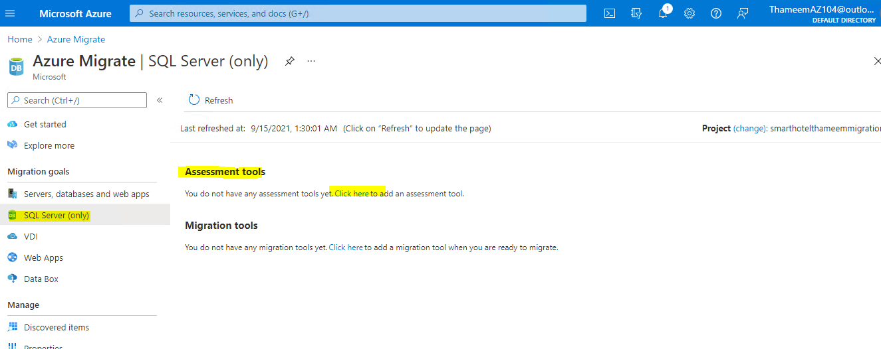

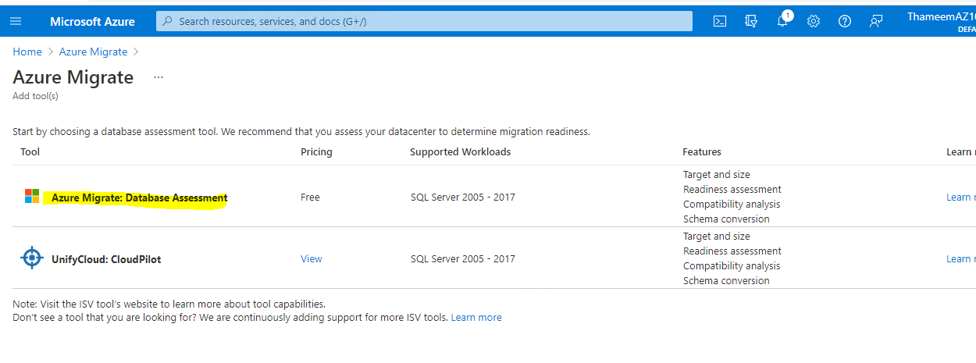

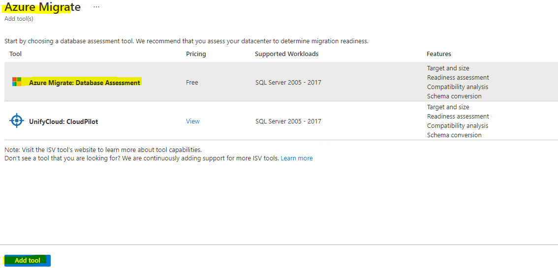

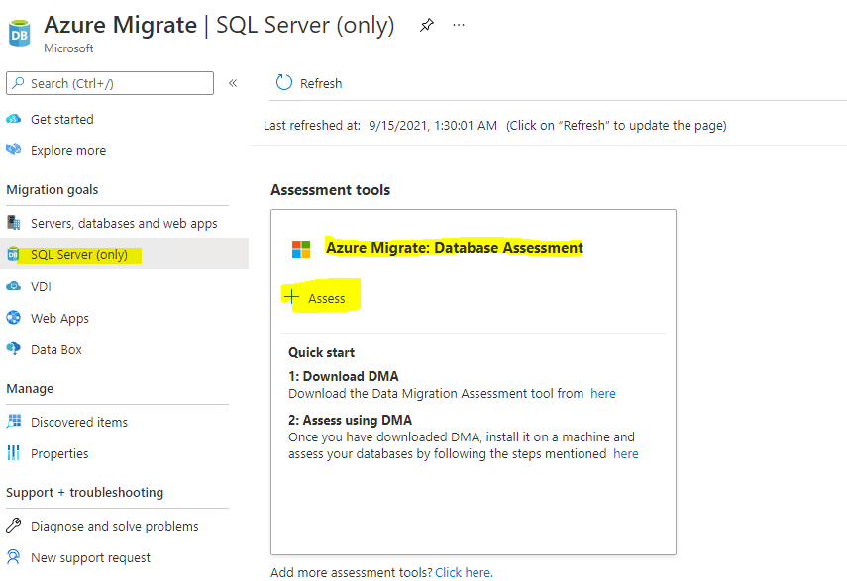

Install **Data Migration Assessment on SmartHotelHost** VM.

Before installing DMA install .Net Framework 4.8

## Assess databases

**To assess your on-premises databases, you need to download the Data Migration Assistant tool (DMA). Follow the steps below to download and install DMA. Once installed, DMA will assess your on-premises databases and upload results to a project.**

**1: Download DMA**

Download DMA and get the Azure target, size and comprehensive assessment report migrating to Azure Databases.

**2: Create an Assessment project**

Create an assessment project in DMA by providing the source server type, intended Azure target type to get the feature parity and database compatibility assessments.

**3: In DMA login to a project and sync assessment summary**

In DMA, login to the Azure, select the project and upload the summary results of the assessments.

Install .net framework 4.8

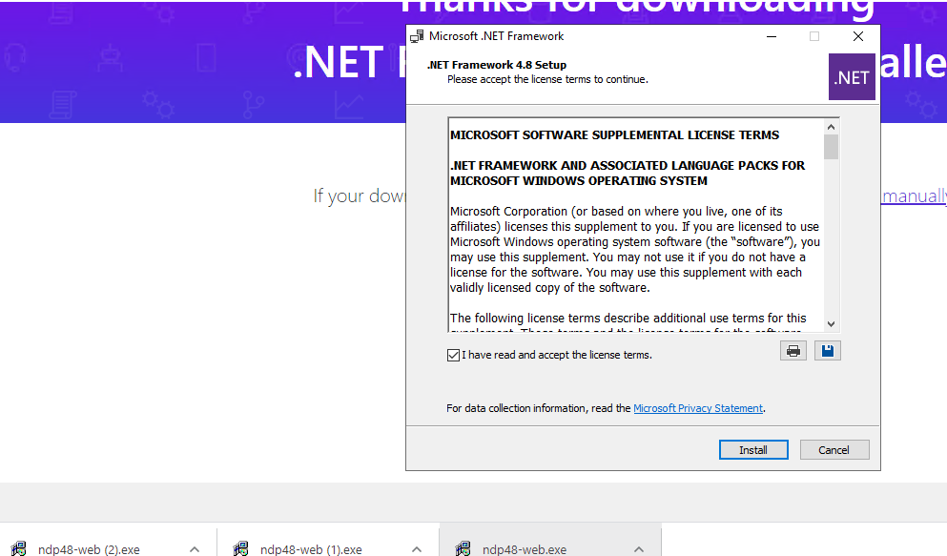

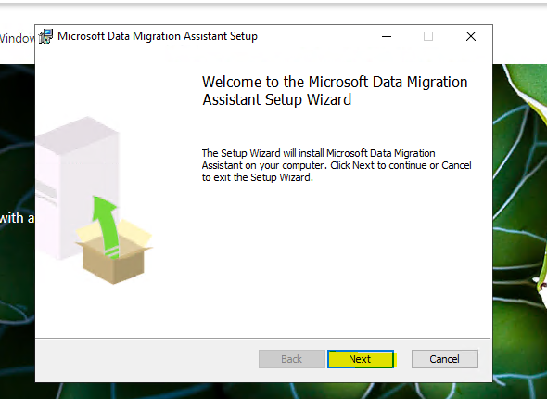 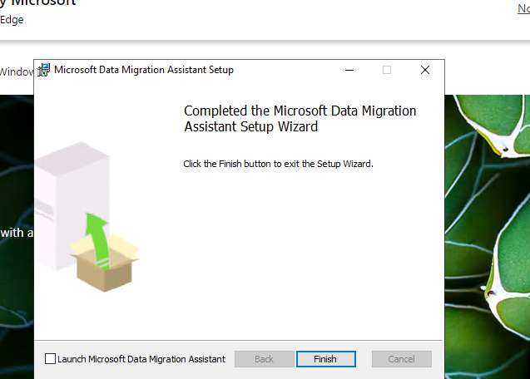

From within **SmartHotelHost**, open **Windows Explorer** and navigate to the **C:\Program Files\Microsoft Data Migration Assistant** folder. Open the **Dma.exe.config** file using Notepad. Search for **AzureMigrate** and remove the **<!--** and **-->** around the line setting the **EnableAssessmentUploadToAzureMigrate** key. **Save** the file and close Notepad when done.

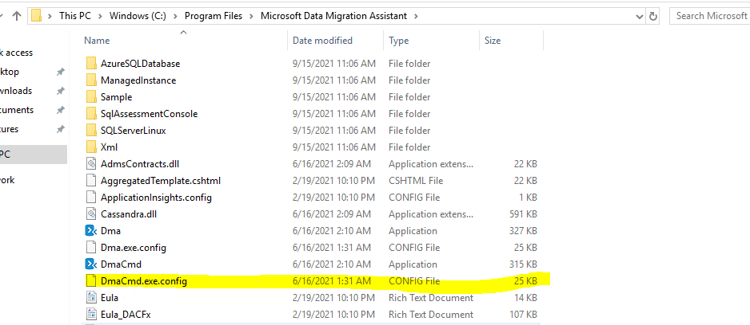

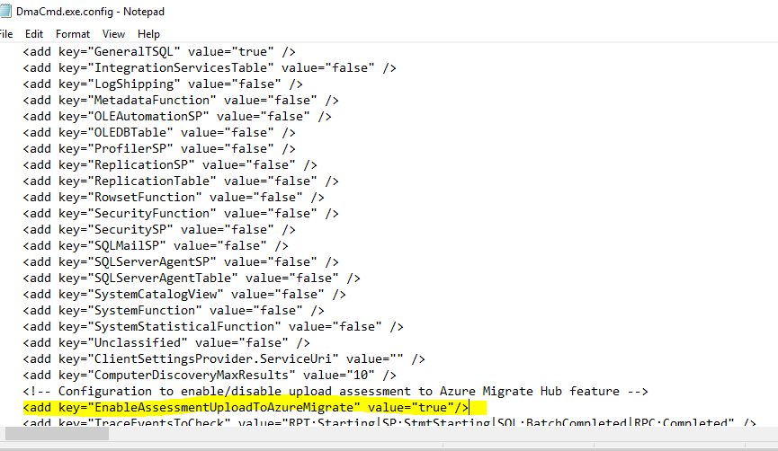

1. From within **SmartHotelHost** launch **Microsoft Data Migration Assistant** using the desktop icon.
2. In the Data Migration Assistant, select the **+ New** icon. Fill in the project details as follows:
   * Project type: **Assessment**
   * Project name: **SmartHotelAssessment**
   * Assessment type: **Database Engine**
   * Source server type: **SQL Server**
   * Target server type: **Azure SQL Database**
3. Select **Create** to create the project.

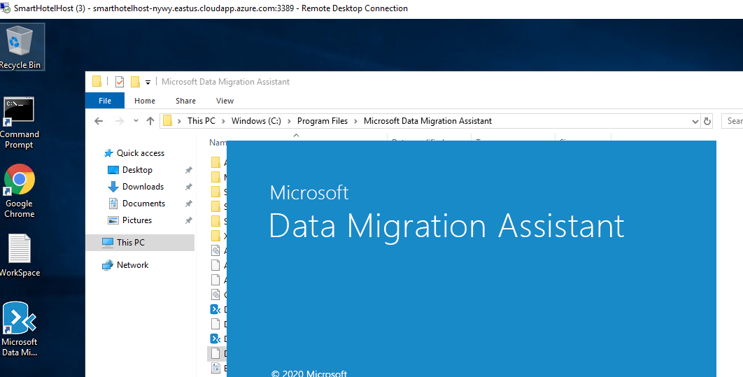

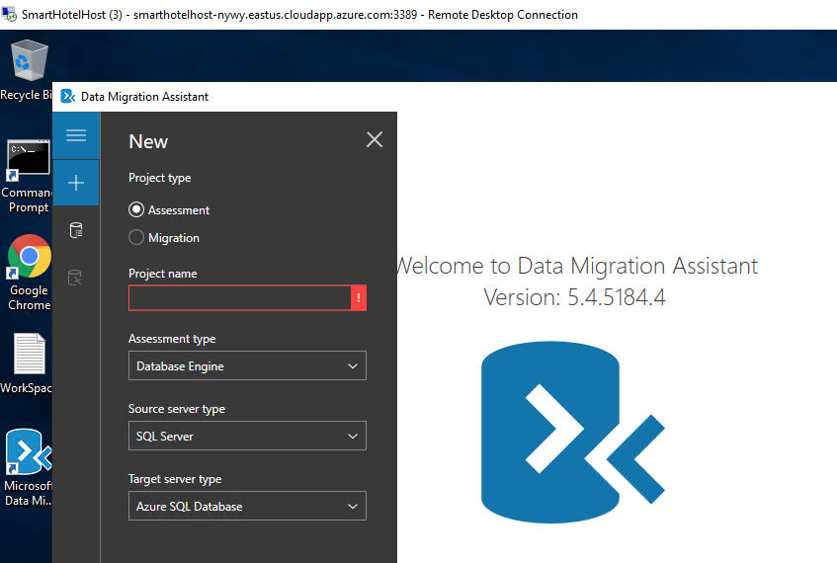

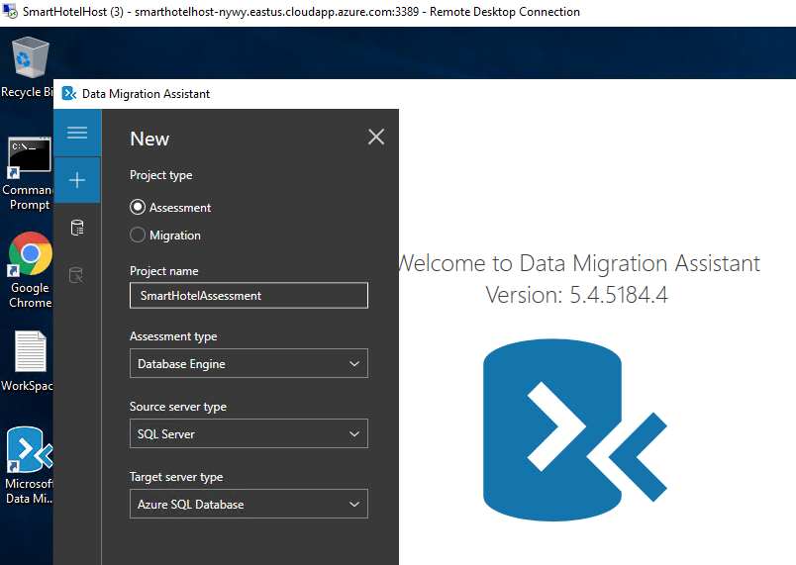

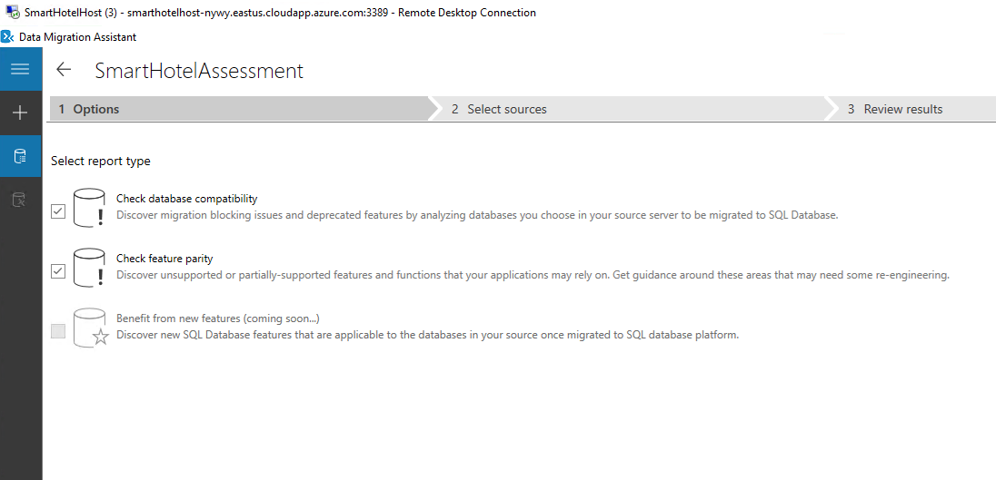

1. On the **Options** tab select **Next**.
2. On the **Select sources** page, in the **Connect to a server** dialog box, provide the connection details to the SQL Server, and then select **Connect**.
   * Server name: **192.168.0.6**
   * Authentication type: **SQL Server Authentication**
   * Username: **sa**
   * Password: **demo!pass123**
   * Encrypt connection: **Checked**
   * Trust server certificate: **Checked**

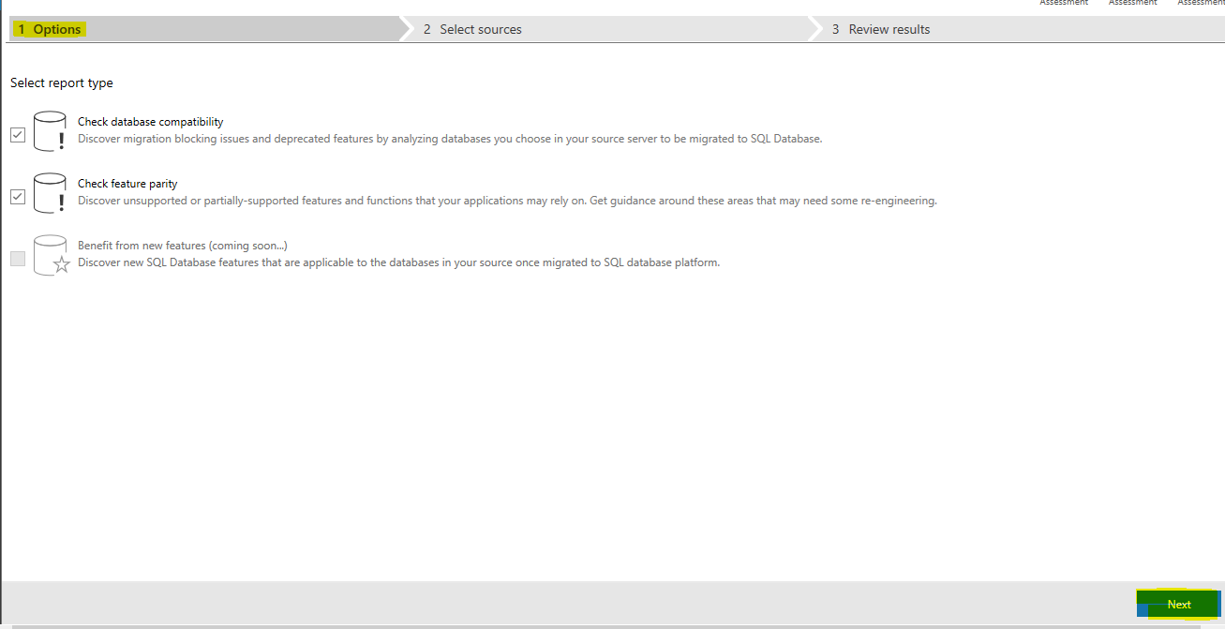

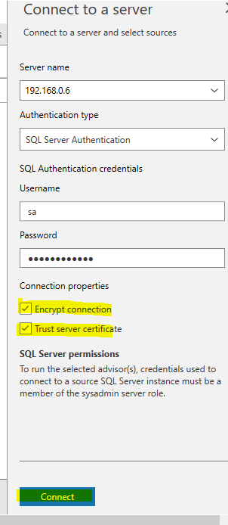

In the **Add sources** dialog box, select **SmartHotel.Registration**, then select **Add**.

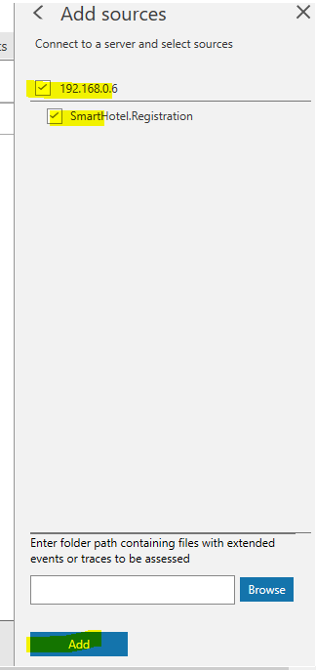

Select **Start Assessment** to start the assessment.

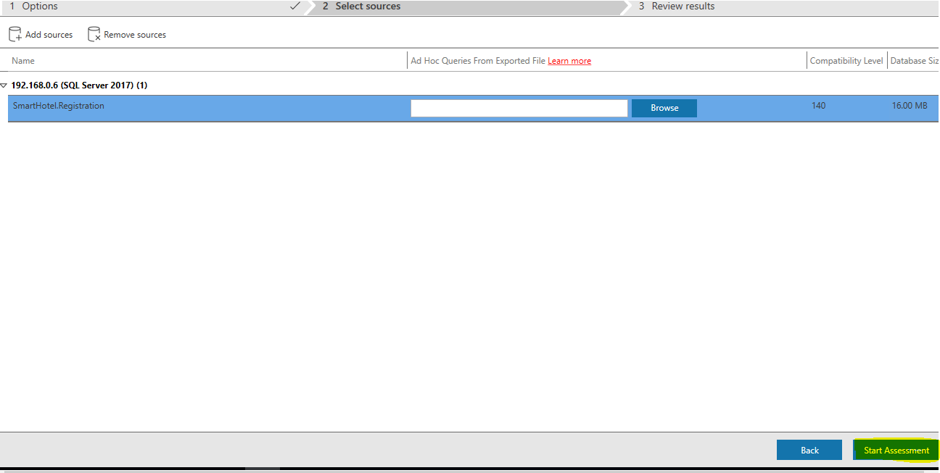

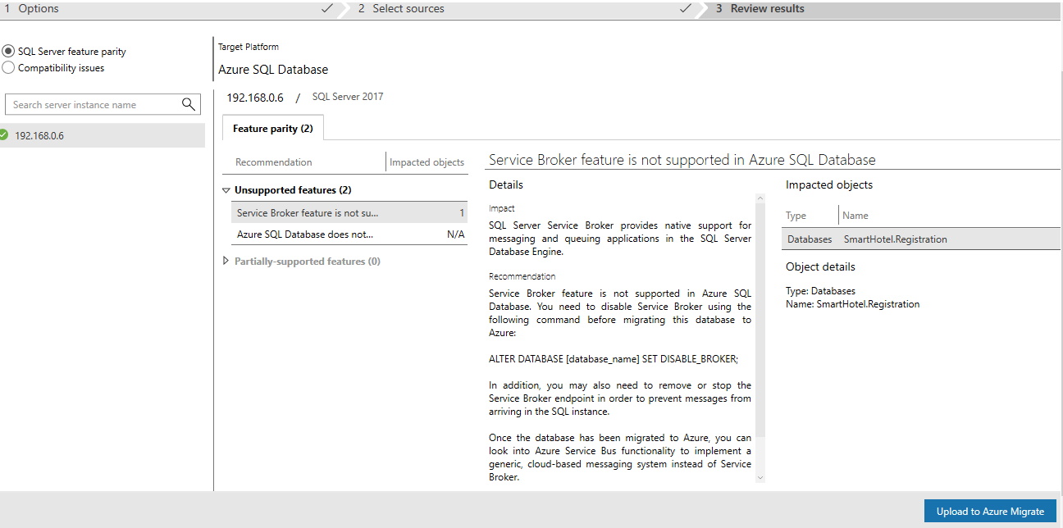

1. **Wait** for the assessment to complete, and review the results. The results should show two unsupported features, **Service Broker feature is not supported in Azure SQL Database** and **Azure SQL Database does not support EKM and Azure Key Vault integration**. For this migration, you can ignore these issues.

**Note**: For Azure SQL Database, the assessments identify feature parity issues and migration blocking issues.

* + The SQL Server feature parity category provides a comprehensive set of recommendations, alternative approaches available in Azure, and mitigating steps to help you plan the effort into your migration projects.
  + The Compatibility issues category identifies partially supported or unsupported features that reflect compatibility issues that might block migrating on-premises SQL Server database(s) to Azure SQL Database. Recommendations are also provided to help you address those issues.

1. Select **Upload to Azure Migrate** to upload the database assessment to your Azure Migrate project (this button may take a few seconds to become enabled).

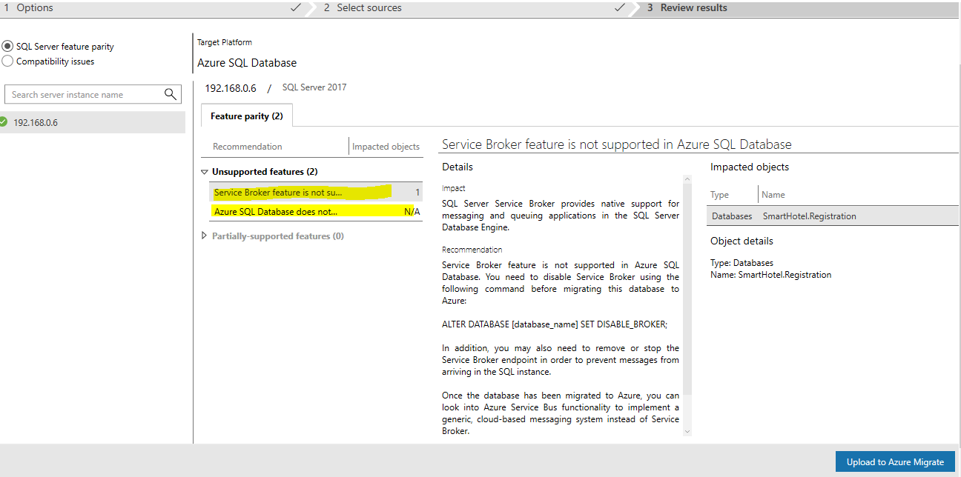

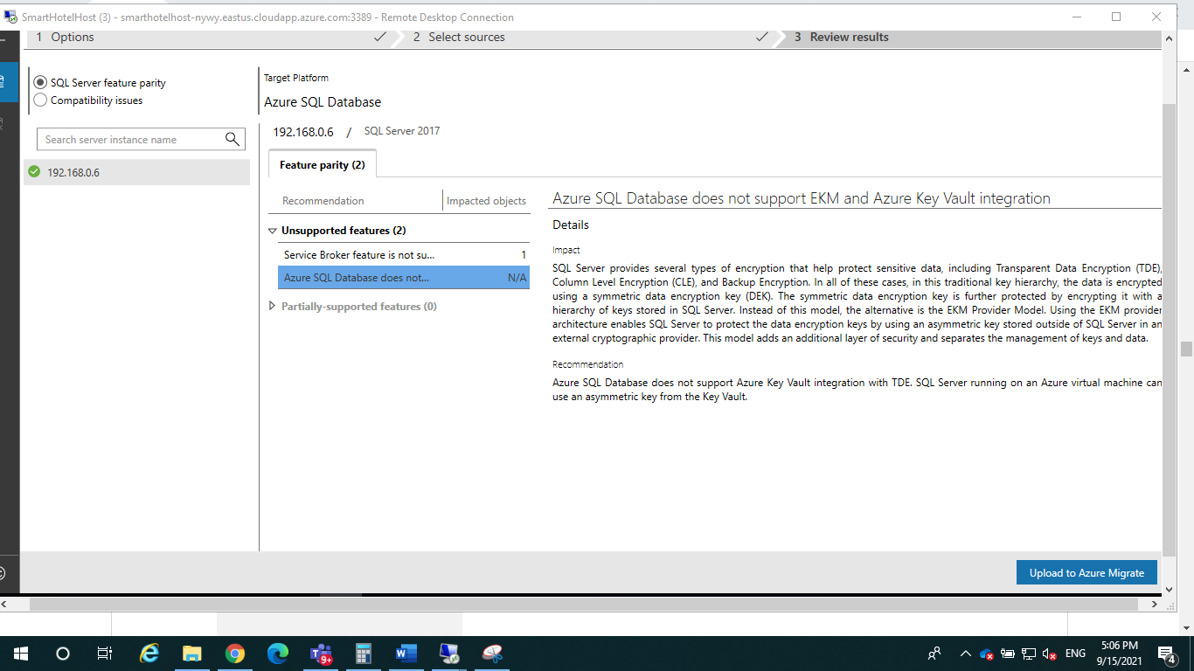

Select **Azure** from the dropdown on the right then select **Connect**. Enter your subscription credentials when prompted. Select your **Subscription** and **Azure Migrate Project** using the dropdowns, then select **Upload**. Once the upload is complete, select **OK** to dismiss the notification.

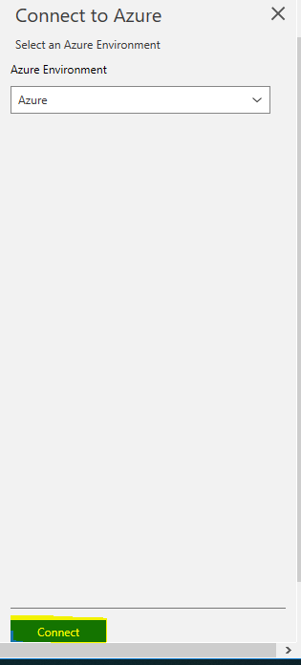

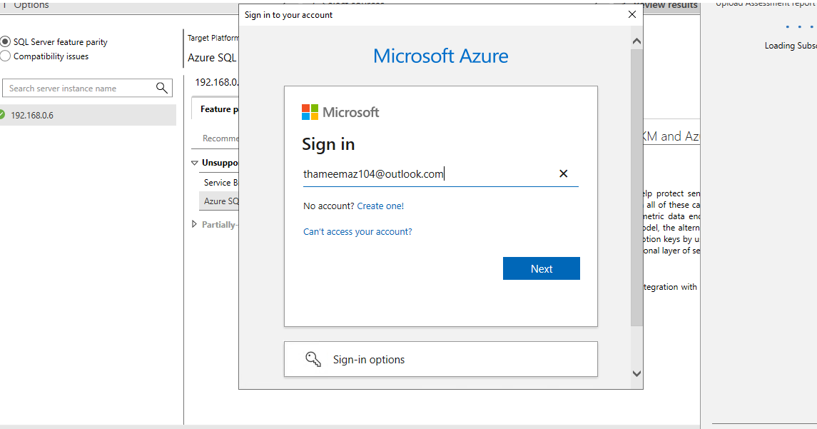

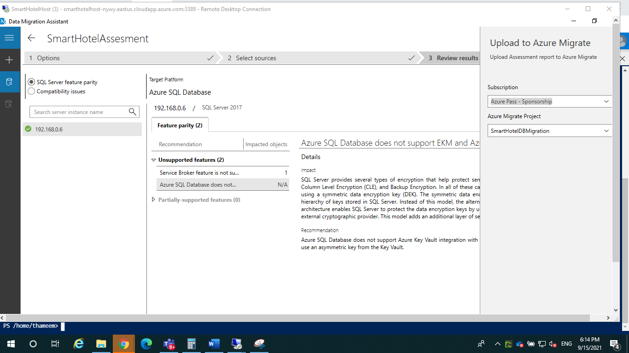

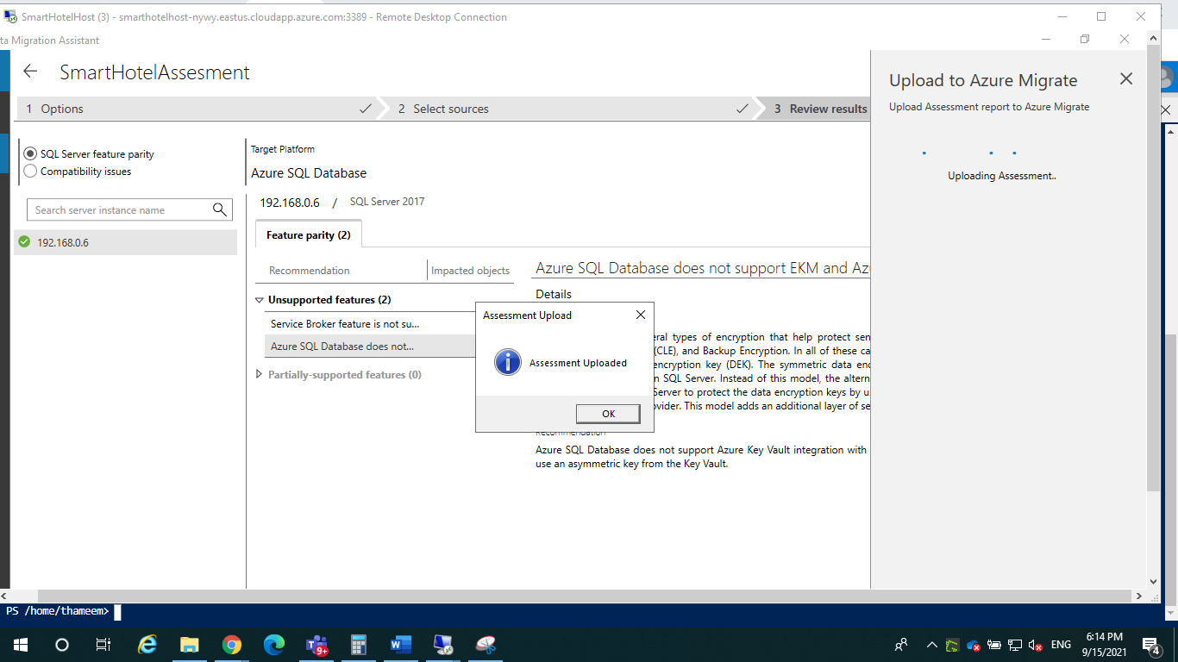

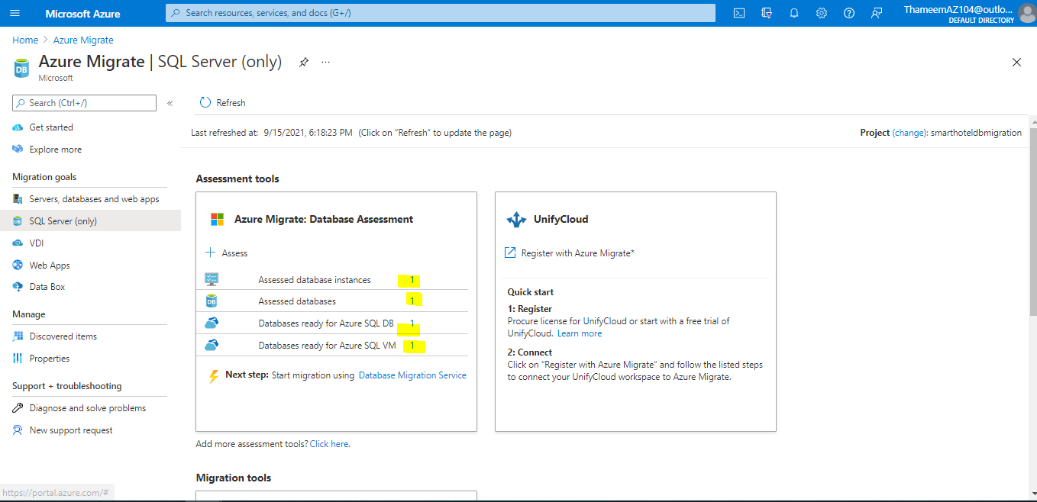

### Task 5: Create a DMS migration project

In this task you will create a Migration Project within the Azure Database Migration Service (DMS). This project contains the connection details for both the source and target databases. In order to connect to the target database, you will also create a private endpoint allowing connectivity from the subnet used by the DMS.

In subsequent tasks, you will use this project to migrate both the database schema and the data itself from the on-premises SQL Server database to the Azure SQL Database.

We'll start by creating the private endpoint that allows the DMS to access the database server.

1. In the Azure portal, navigate to the **SmartHotelHostDBRG** resource group, and then to the database server.
2. Select **Private endpoint connections** under **Security**, then **+ Private endpoint**.
3. On the **Basics** tab that appears, enter the following configuration then select **Next: Resource**.
   * Resource group: **SmartHotelDBRG**
   * Name: **SmartHotel-DB-for-DMS**
   * Region: **Select the same location as the DMSvnet (Should be the region closest to you)**.

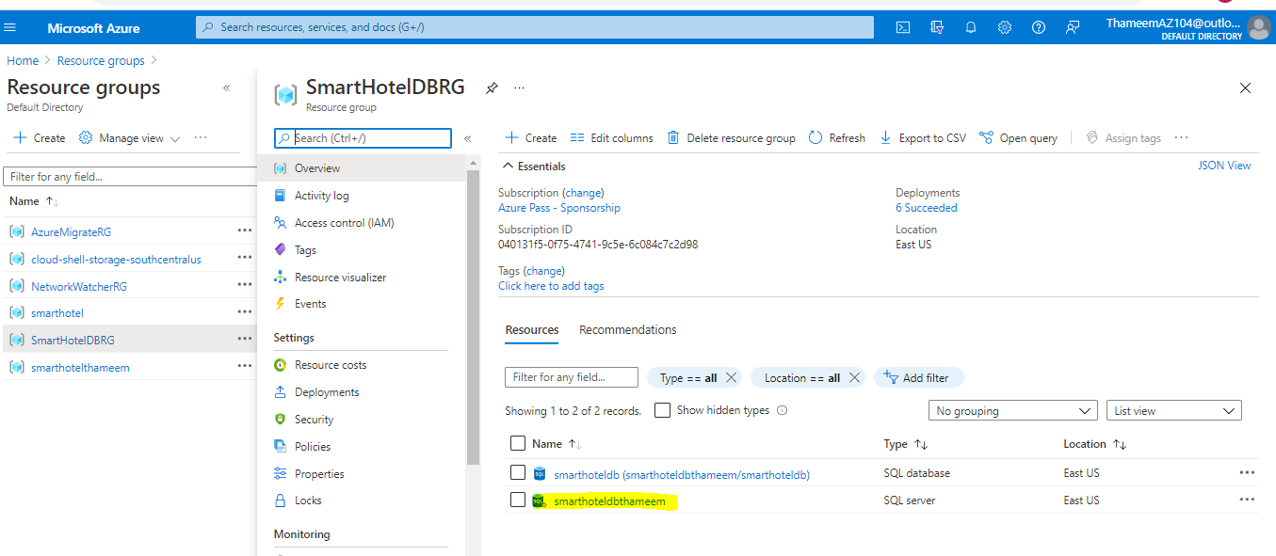

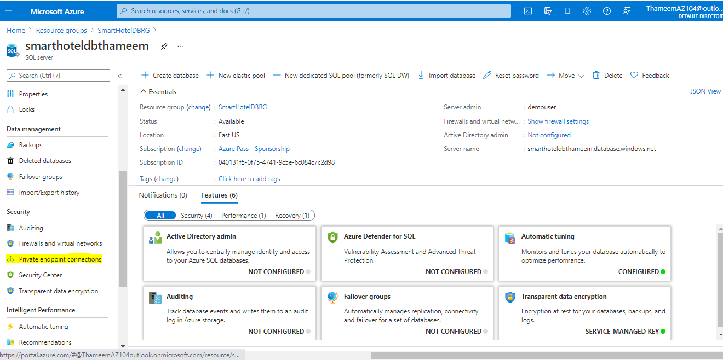

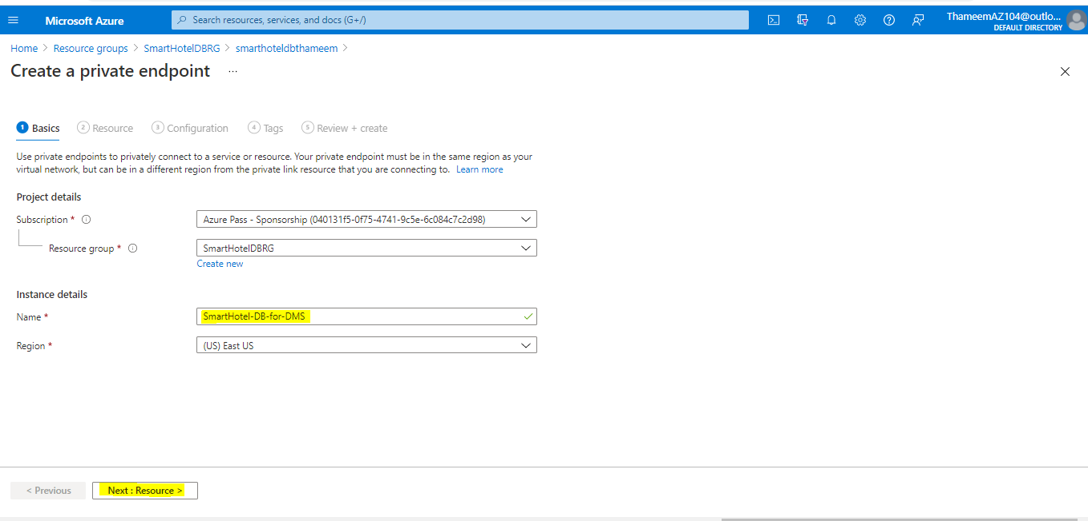

On the **Resource** tab, entering the following configuration then select **Next: Configuration**.

* Connection method: **Connect to an Azure resource in my directory**.
* Subscription: **Select your subscription**.
* Resource type: **Microsoft.Sql/servers**
* Resource: **Your SQL database server name**.
* Target sub-resource: **sqlServer**

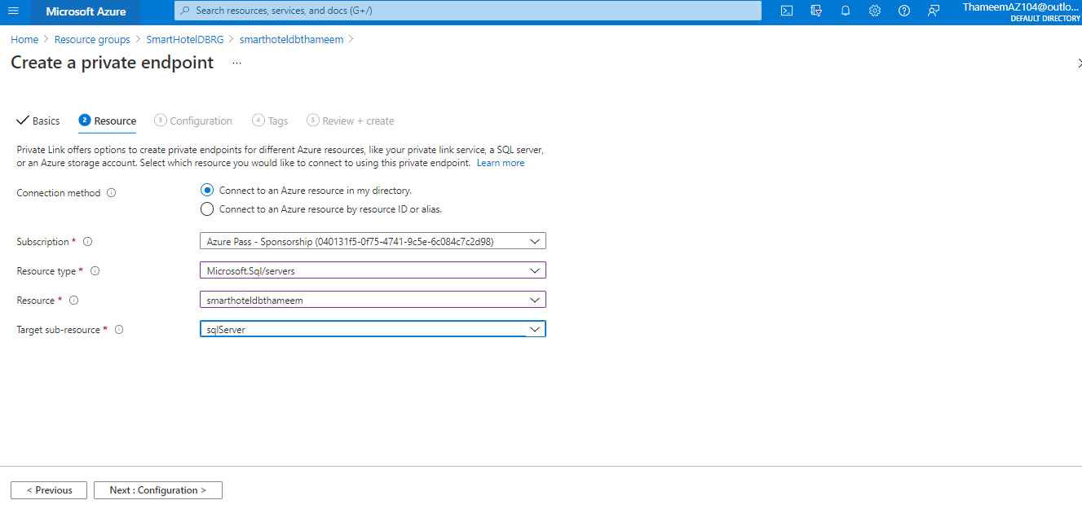

On the **Configuration** tab enter the following configuration then select **Review + create**, then **Create**.

* Virtual network: **DMSvnet**
* Subnet: **DMS (10.1.0.0/24)**
* Integrate with private DNS zone: **Yes**
* Private DNS zones: (default) **privatelink.database.windows.net**

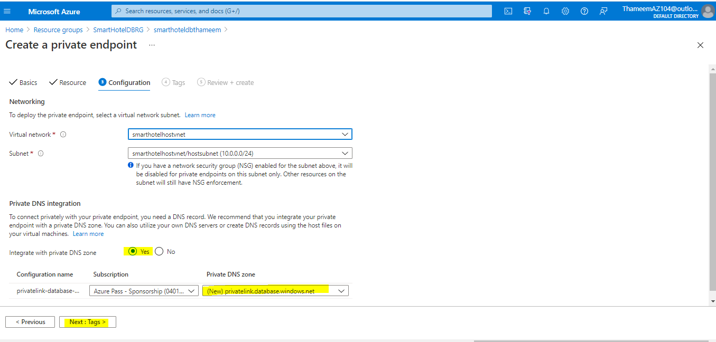

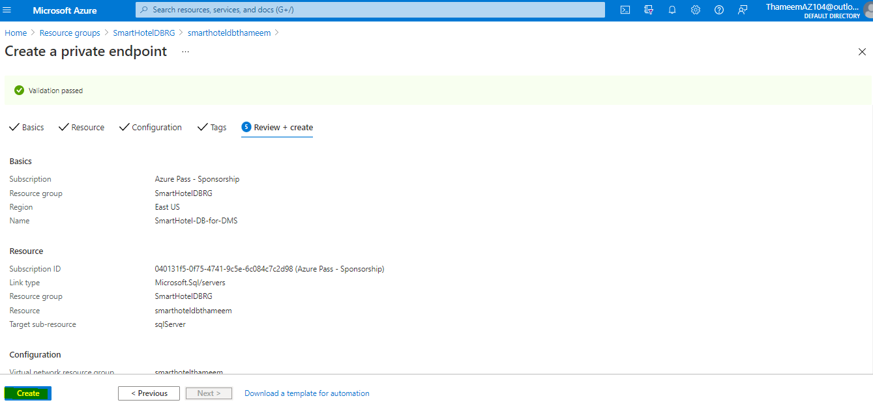

**Wait** for the deployment to complete. Open the Private Endpoint blade, and note that the FQDN for the endpoint is listed as **<your database>.database.windows.net**, with an internal IP address **10.1.0.5**.

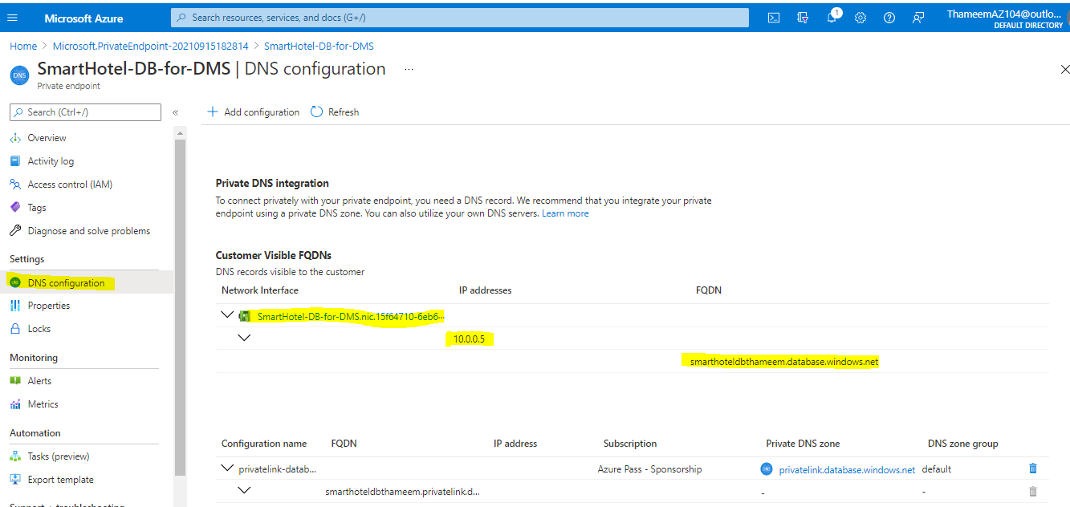

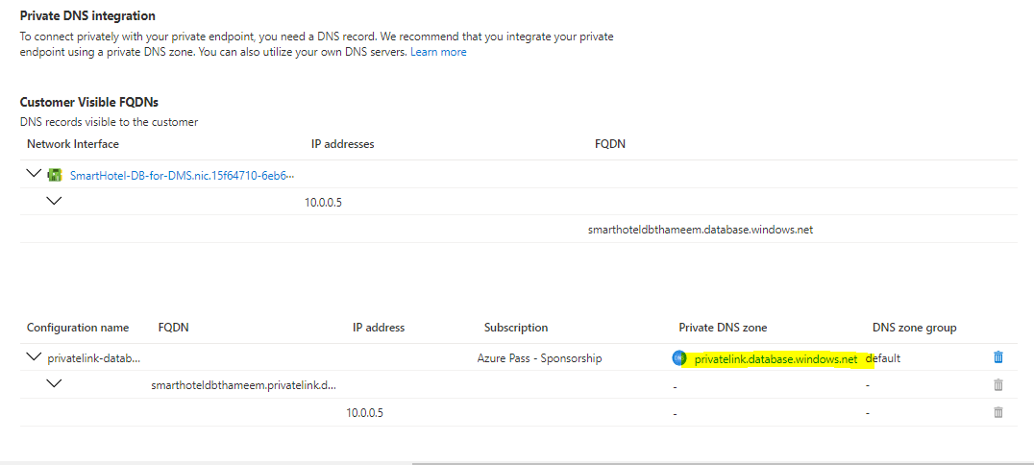

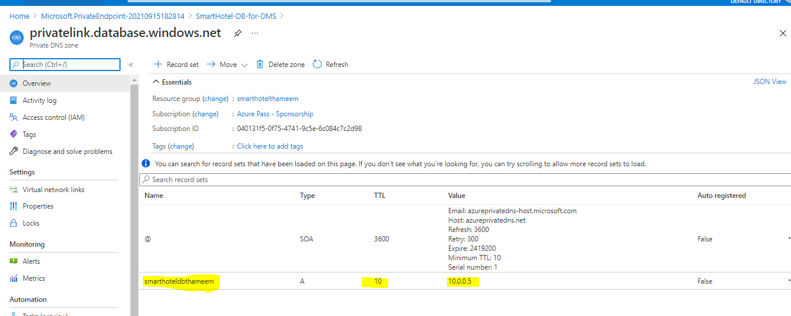

Return to the Database server blade. Under **Security**, select **Firewalls and virtual networks**. Set 'Deny public network access' to **Yes**, then **Save** your changes.

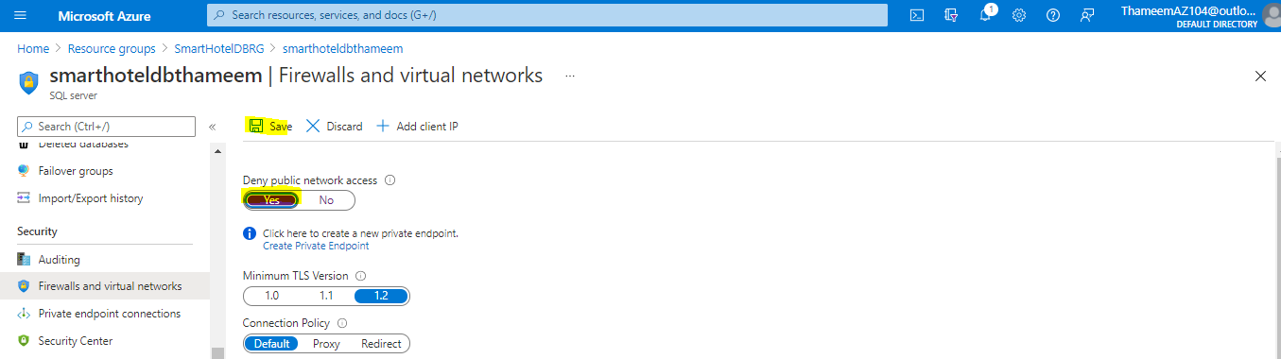

Check that the Database Migration Service resource you created in task 3 has completed provisioning. You can check the deployment status from the **Deployments** pane in the **AzureMigrateRG** resource group blade.

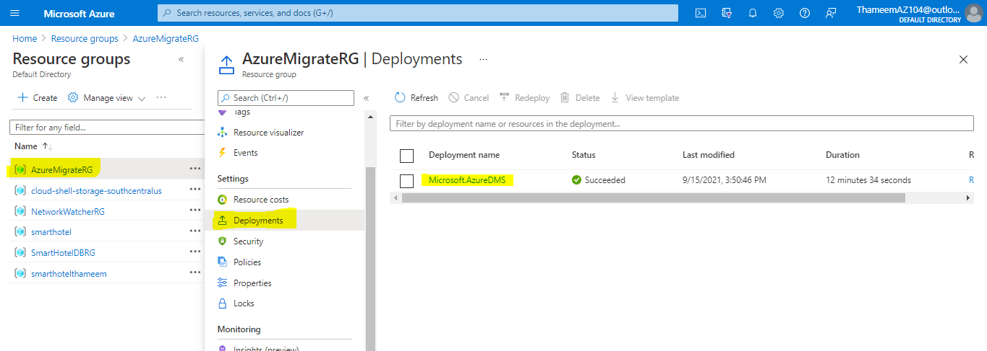

Navigate to the Database Migration Service resource blade in the **AzureMigrateRG** resource group and select **+ New Migration Project**.

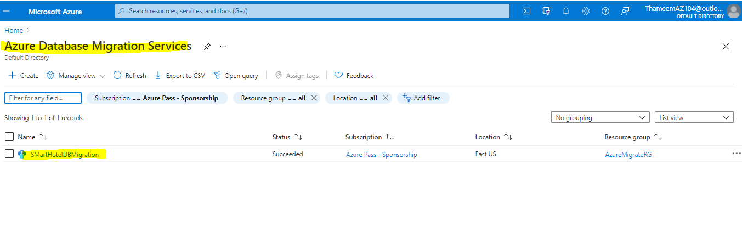

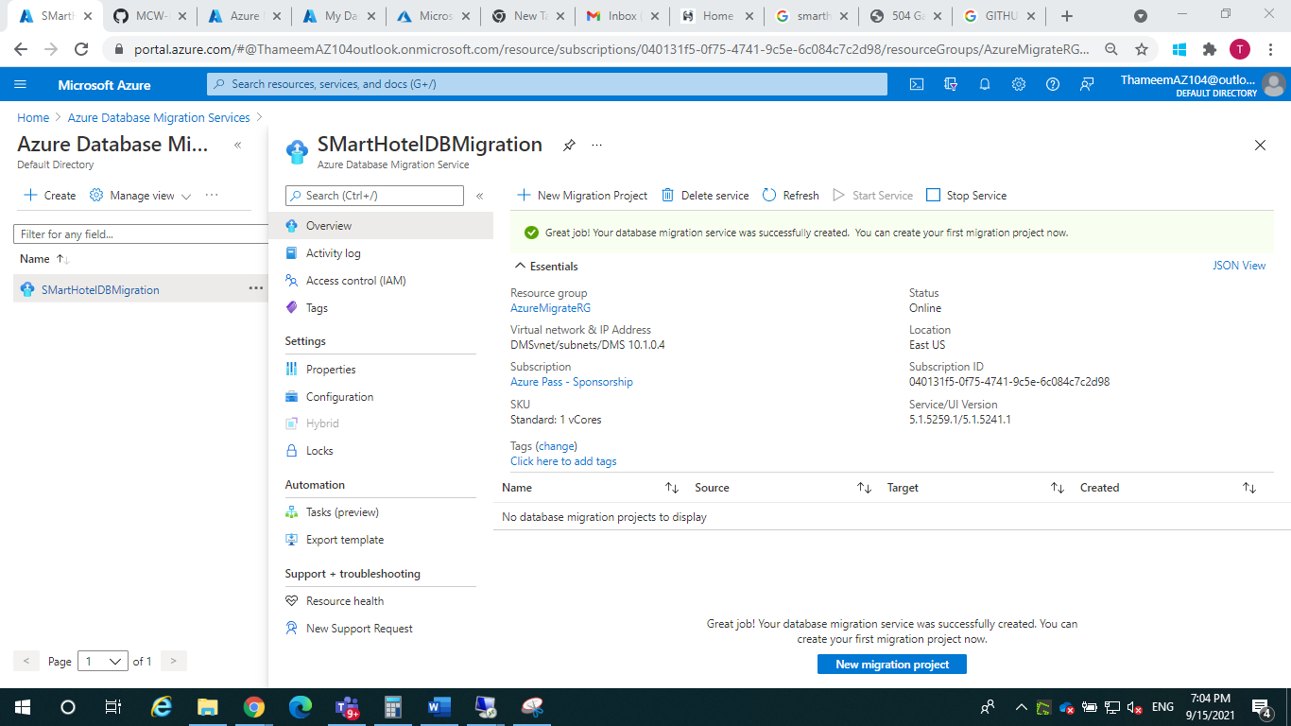

the **New migration project** blade, enter **DBMigrate** as the project name. Leave the source server type as **SQL Server** and target server type as **Azure SQL Database**. Select **Choose type of activity** and select **Create project only**. Select **Save** then select **Create**

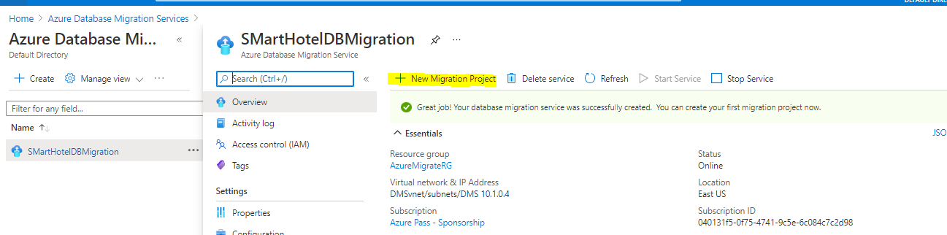

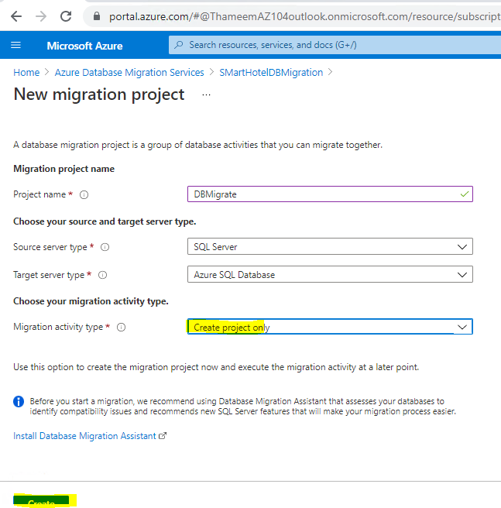

The Migration Wizard opens, showing the **Select source** step. Complete the settings as follows, then select **Next: Select databases**.

* Source SQL Server instance name: **10.0.0.4**
* Authentication type: **SQL Authentication**
* User Name: **sa**
* Password: **demo!pass123**
* Encryption connection: **Checked**
* Trust server certificate: **Checked**

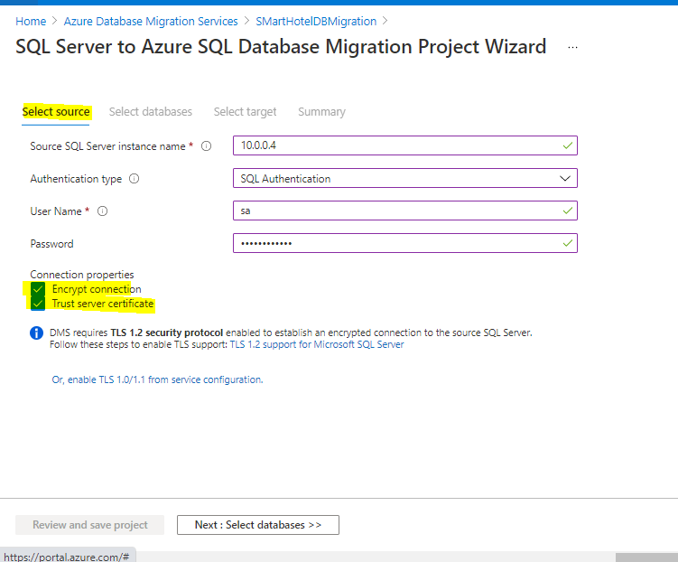

In the **Select databases** step, the **Smarthotel.Registration** database should already be selected. Select **Next: Select target**.

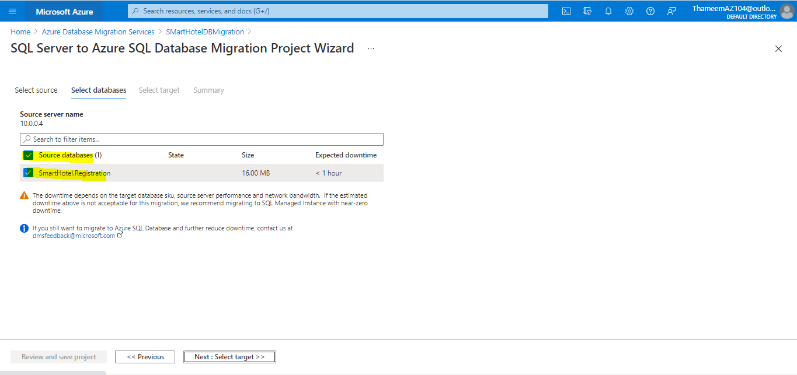

Complete the **Select target** step as follows, then select **Next: Summary**:

* Target server name: **Value from your database, {something}.database.windows.net**.
* Authentication type: **SQL Authentication**
* User Name: **demouser**
* Password: **demo!pass123**
* Encrypt connection: **Checked**

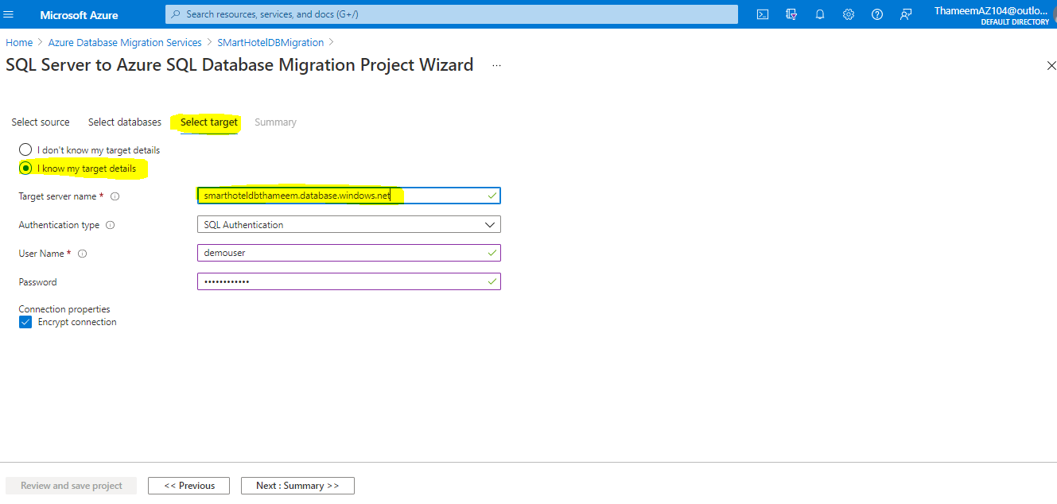

DB Name

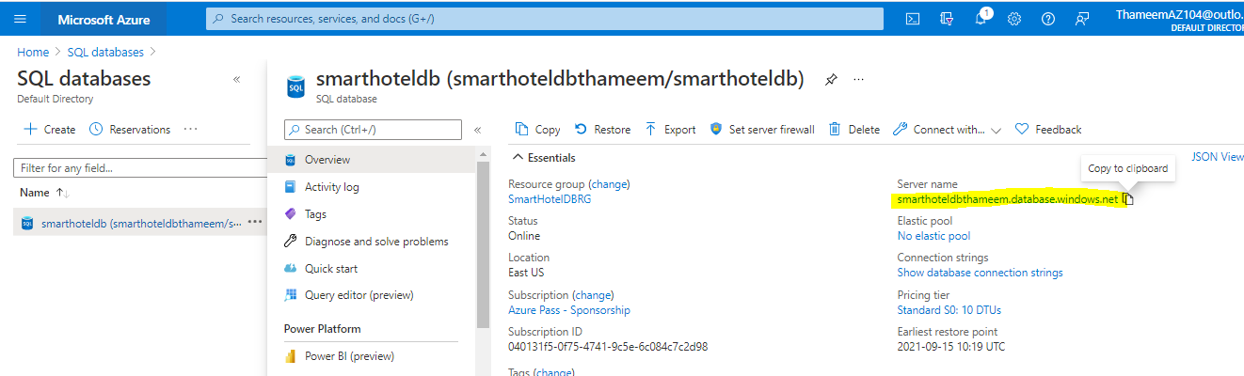

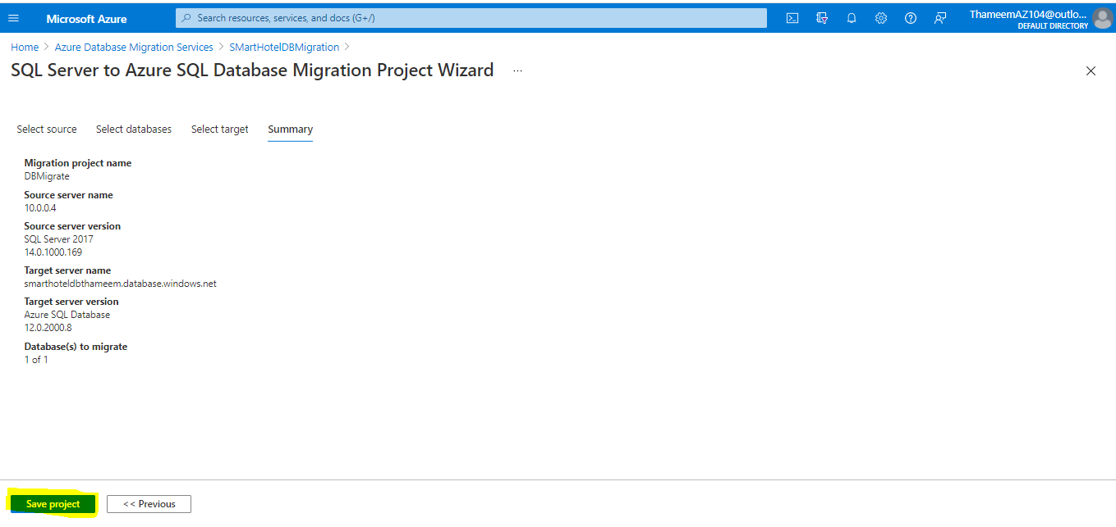

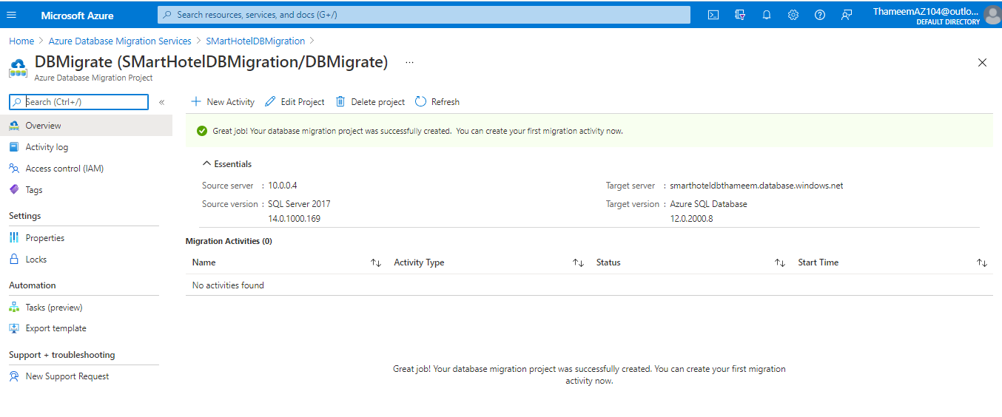

### Task 6: Migrate the database schema

In this task you will use the Azure Database Migration Service to migrate the database schema to Azure SQL Database. This step is a prerequisite to migrating the data itself.

The schema migration will be carried out using a schema migration activity within the migration project created in task 5.

1. Following task 5, the Azure portal should show a blade for the DBMigrate DMS project. Select **+ New Activity** and select **Schema only migration** from the drop-down.

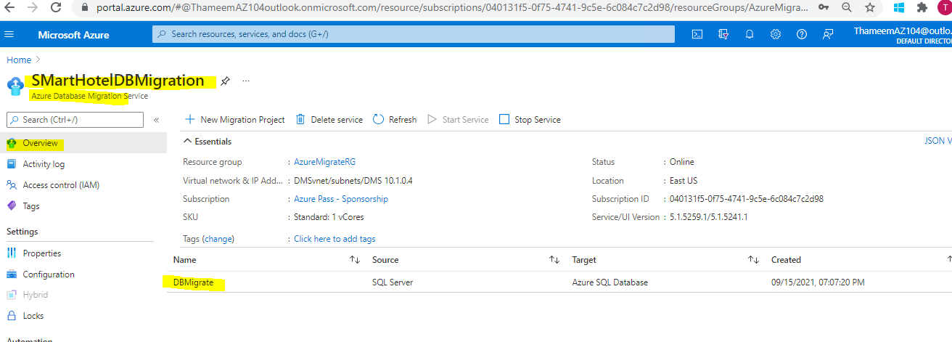

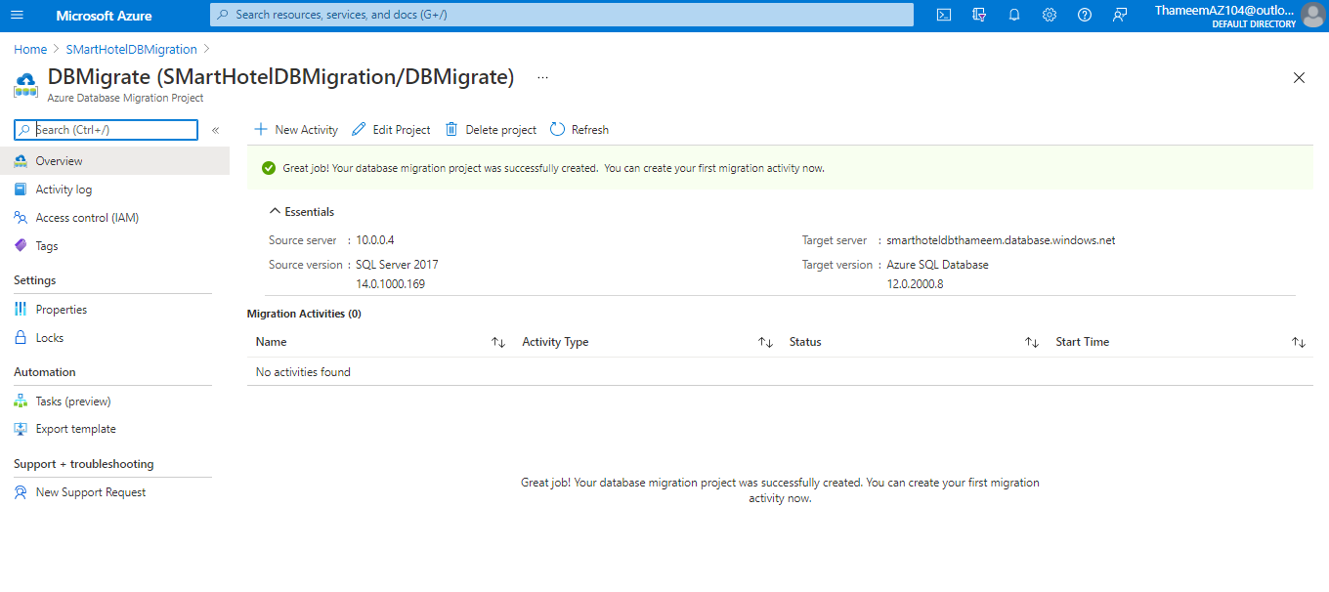

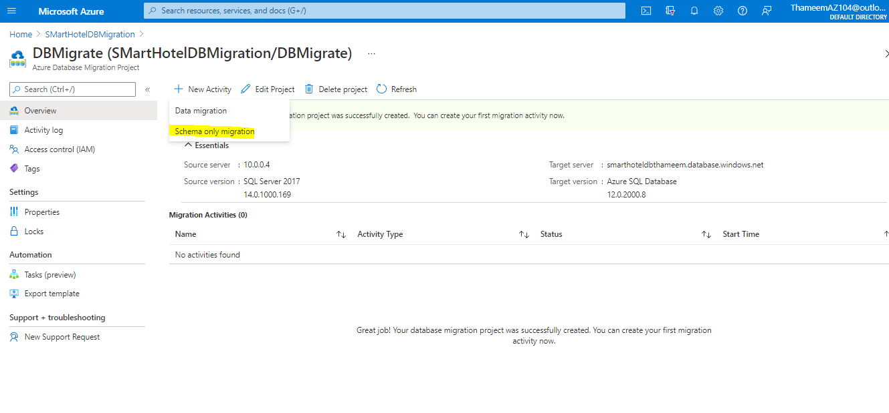

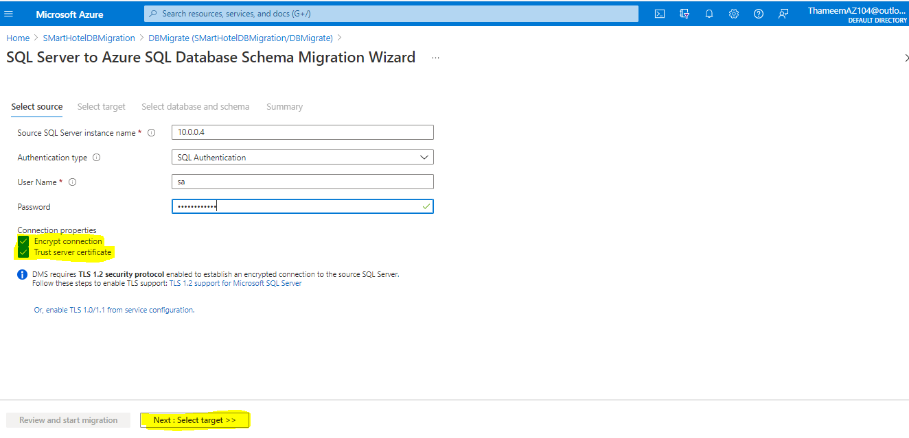

At the **Select target** step, enter the password **demo!pass123** and select **Next: Select database and schema**.

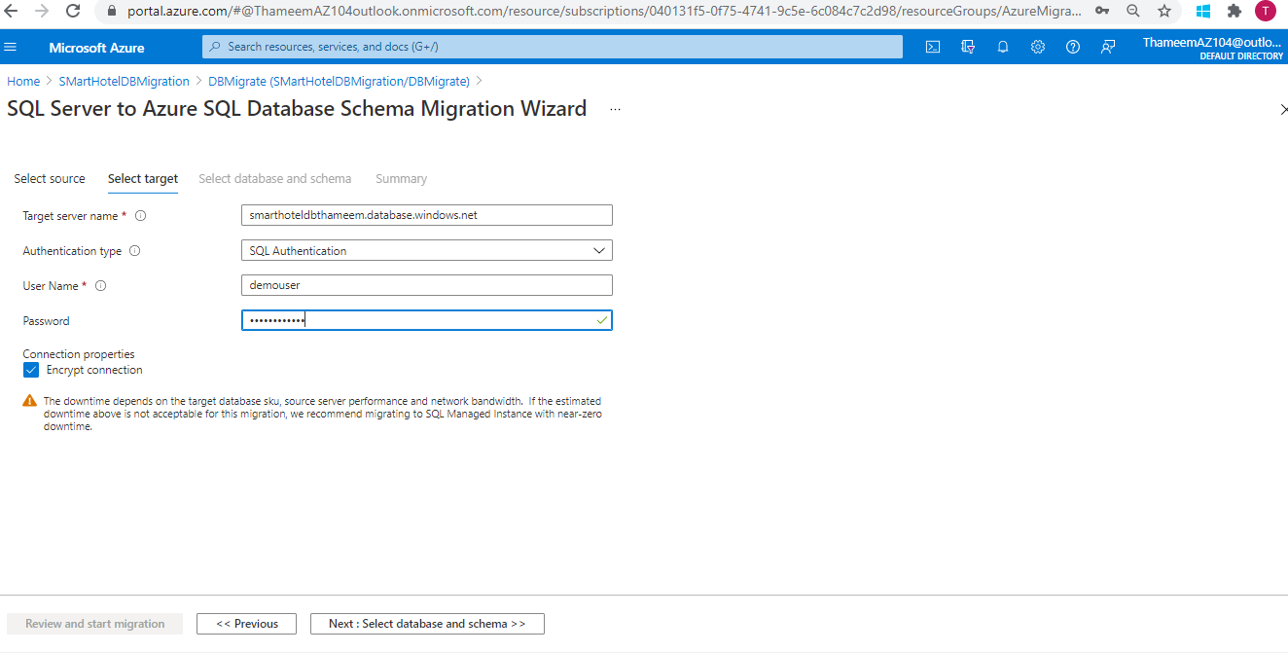

At the **Select database and schema** step, check that the **SmartHotel.Registration** database is selected. Under **Target Database** select **smarthoteldb** and under **Schema Source** select **Generate from source**. Select **Next: Summary**.

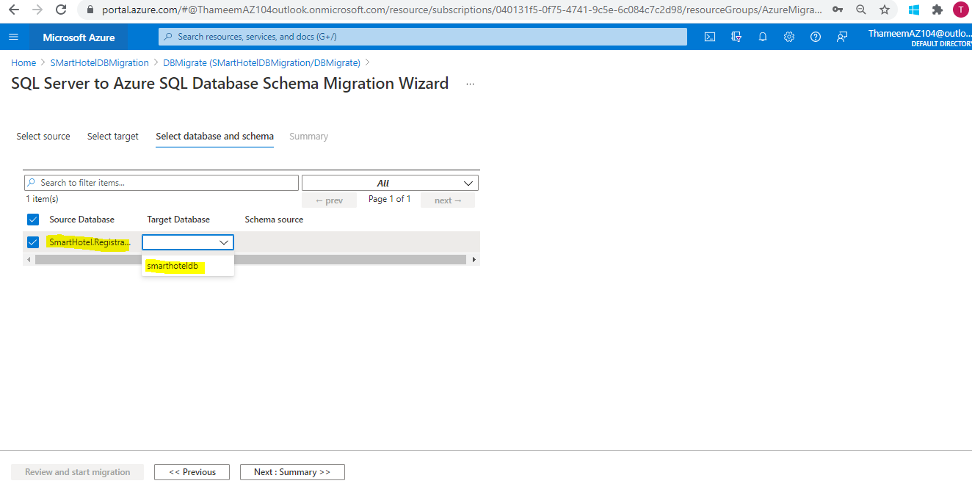

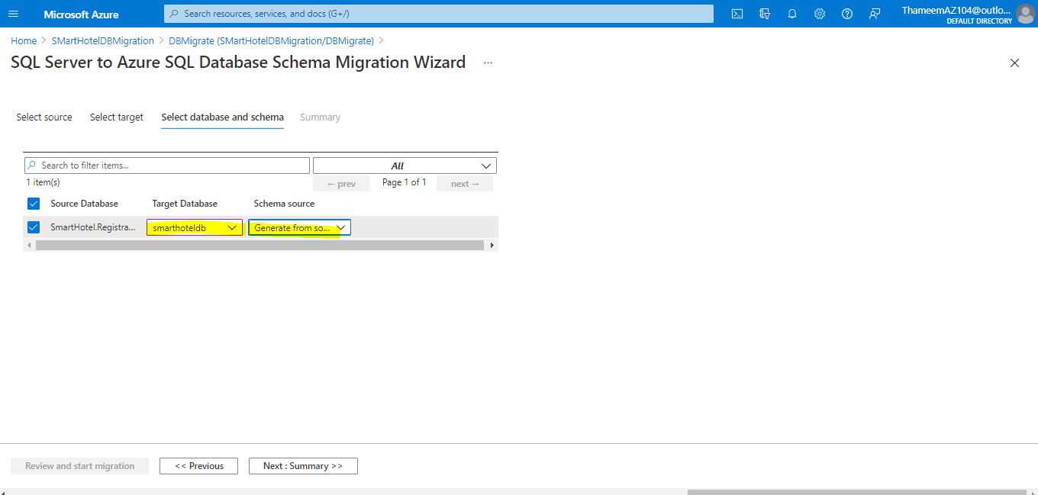

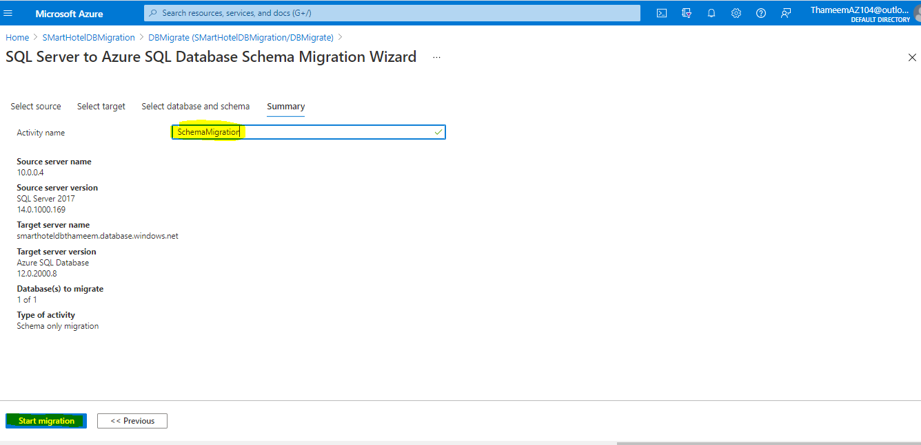

The schema migration will begin. Select the **Refresh** button and watch the migration progress, until it shows as **Completed**.

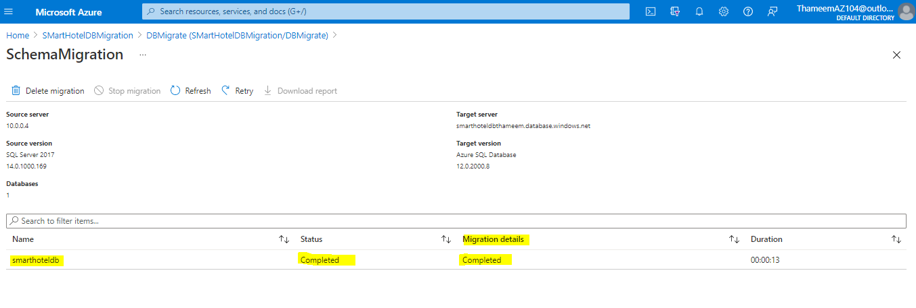

### Task 7: Migrate the on-premises data

In this task you will use the Azure Database Migration Service to migrate the database data to Azure SQL Database.

The schema migration will be carried out using an offline data migration activity within the migration project created in task 5.

1. Return to the Azure portal blade for your **DBMigrate** migration project in DMS. Select **+ New Activity** and select **Offline data migration** from the drop-down.

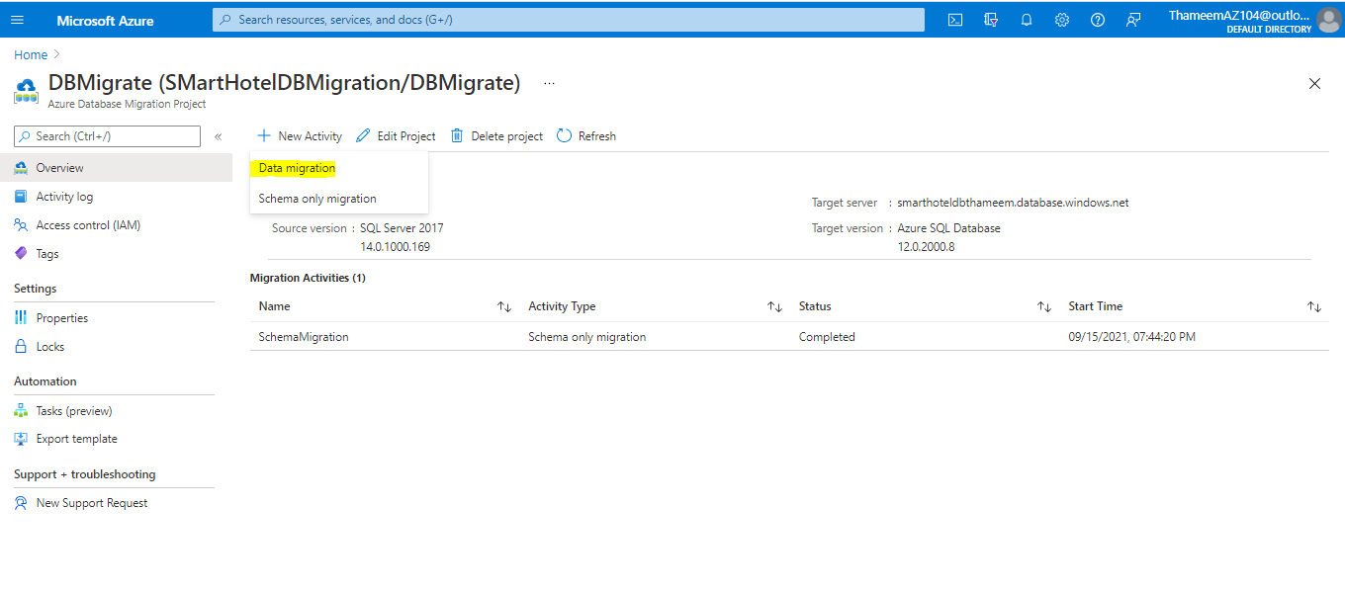

The Migration Wizard is shown. Most settings are already populated from the existing migration project. At the **Select source** step, re-enter the source database password **demo!pass123**, then select **Next: Select target**.

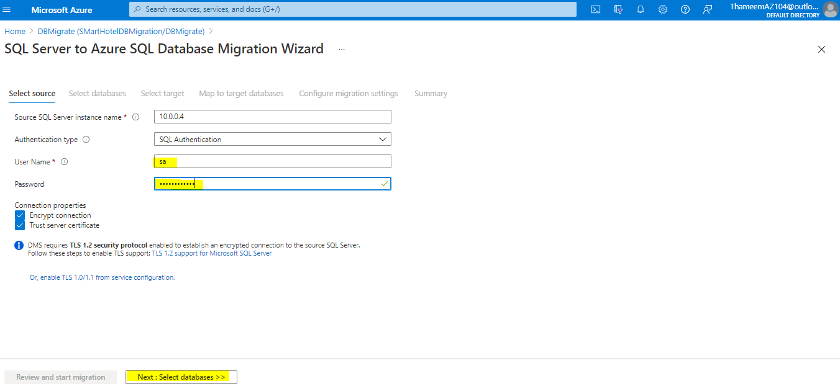

At the **Select target** step, enter the password **demo!pass123** and select **Next: Map to target databases**.

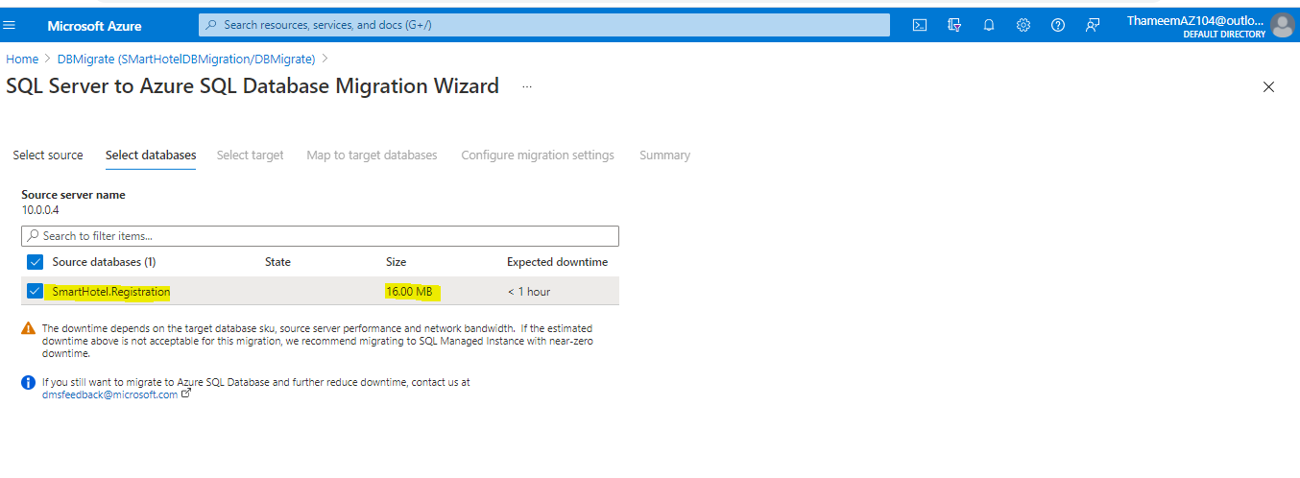

At the **Select target** step, enter the password **demo!pass123** and select **Next: Map to target databases**.

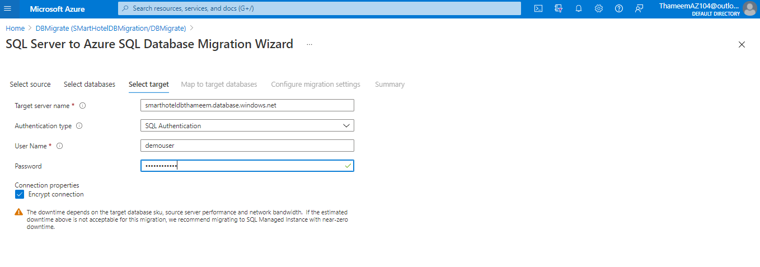

At the **Map to target databases** step, check the **SmartHotel.Registration** database. Under **Target Database** select **smarthoteldb**. Select **Next: Configure migration settings**.

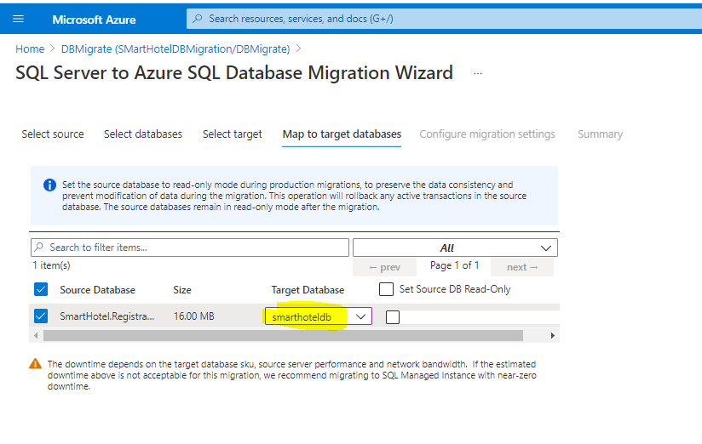

The **Configure migration settings** step allows you to specify which tables should have their data migrated. Select the **Bookings** table (Make sure the **MigrationHistory** table is not checked) and select **Next: Summary**

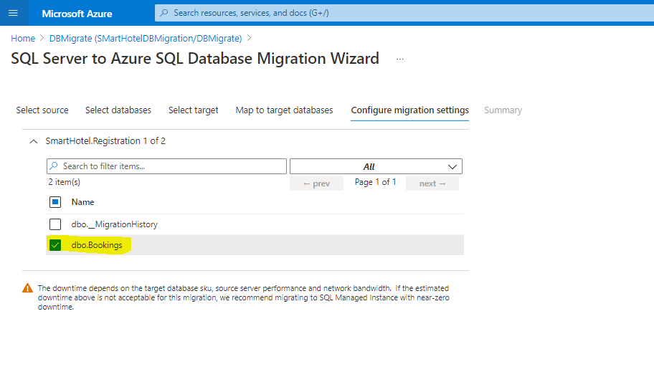

At the **Migration summary** step, enter **DataMigration** as the **Activity name**. Select **Start migration**.

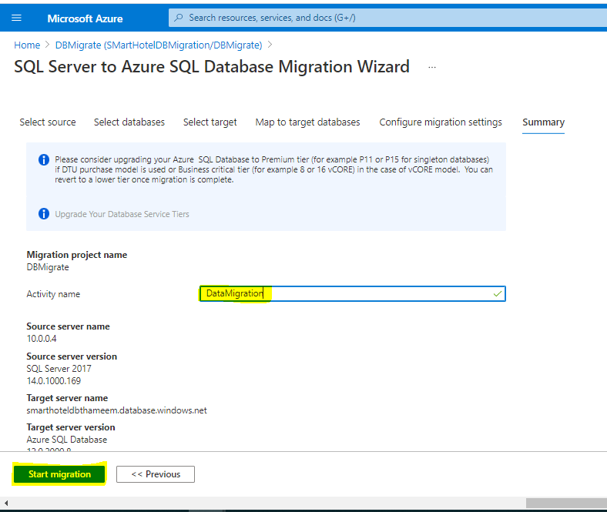

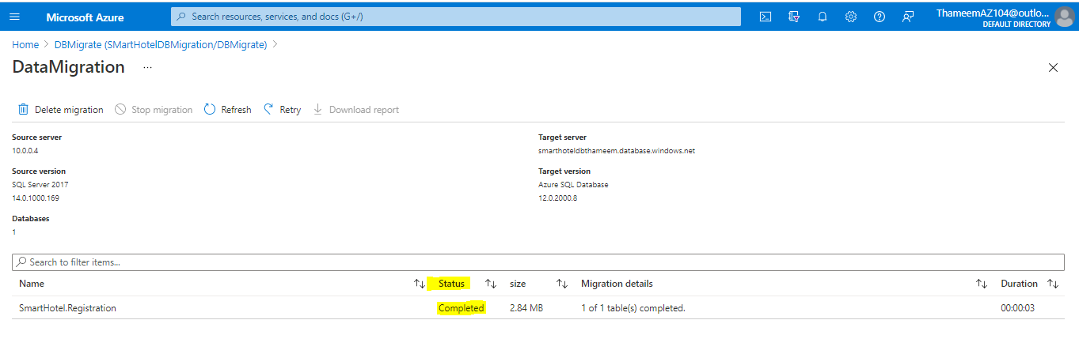

As a final step, we will remove the private endpoint that allows the DMS service access to the database, since this access is no longer required.

1. In the Azure portal, navigate to the **SmartHotelHostDBRG** resource group, and then to the database server. Under **Security**, select **Private endpoint connections**.
2. Select the **SmartHotel-DB-for-DMS** endpoint added earlier, and select **Remove**, followed by **Yes**.

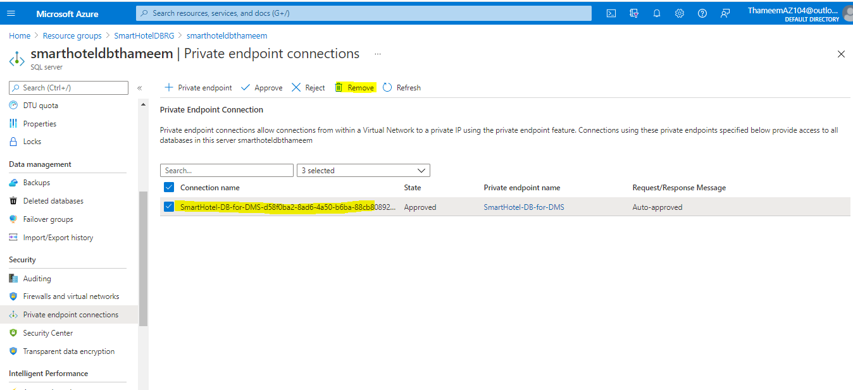

## **Exercise 3: Migrate the application and web tiers using Azure Migrate: Server Migration**

### Task 1: Create a Storage Account

In this task you will create a new Azure Storage Account that will be used by Azure Migrate: Server Migration for storage of your virtual machine data during migration

In the Azure portal's left navigation, select **+ Create a resource**, then search for and select **Storage account**, followed by **Create**.

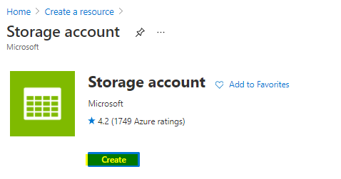

In the **Create storage account** blade, on the **Basics** tab, use the following values:

* Subscription: **Select your Azure subscription**.
* Resource group: **AzureMigrateRG**
* Storage account name: **migrationstorage[unique number]**
* Location: **IMPORTANT: Select the same location as your Azure SQL Database** (can be found in the Azure portal).
* Account kind: **Storage (general purpose v1)** (do not use a v2 account).
* Replication: **Locally-redundant storage (LRS)**

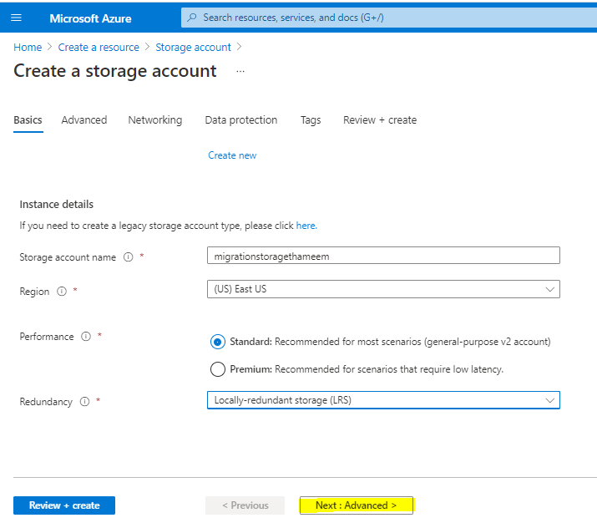

Review and Create Storage

### Task 2: Create a Virtual Network

In this task you will create a new virtual network that will be used by your migrated virtual machines when they are migrated to Azure. (Azure Migrate will only create the VMs, their network interfaces, and their disks; all other resources must be staged in advance.)

1. In the Azure portal's left navigation, select **+ Create a resource**, then select **Networking**, followed by **Virtual network**.

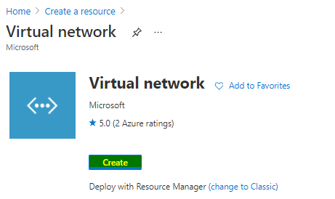

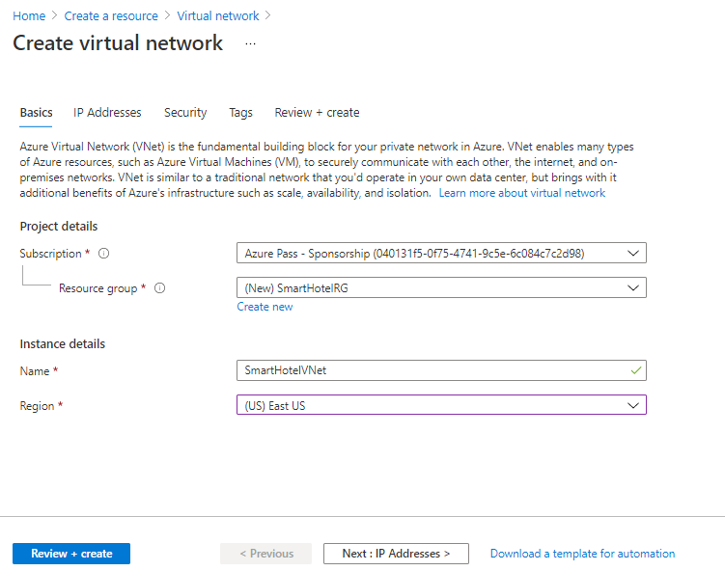

Select **Next: IP Addresses >**, and enter the following configuration. Then select **Review + create**, then **Create**.

* IPv4 address space: **192.168.0.0/24**
* First subnet: Select **Add subnet** and enter the following then select **Add**
  + Subnet name: **SmartHotel**
  + Address range: **192.168.0.0/25**
* Second subnet: Select **Add subnet** and enter the following then select **Add**.
  + Subnet name: **SmartHotelDB**
  + Address range: **192.168.0.128/25**

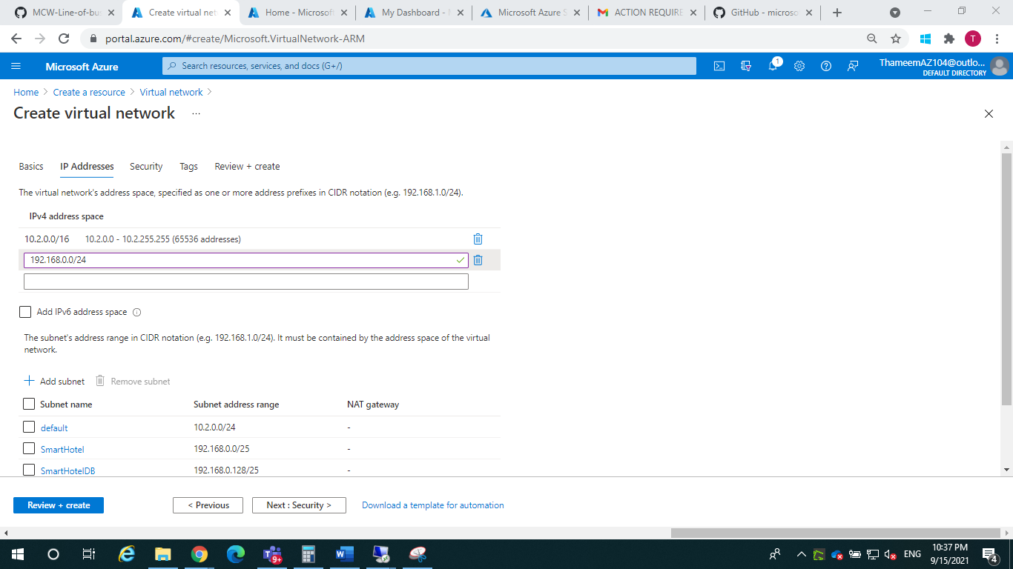

1. Navigate to the **SmartHotelHostDBRG** resource group, and then to the database server. Under **Security**, select **Private endpoint connections**, then select **+ Private endpoint**.
2. On the **Basics** tab, enter the following configuration then select **Next: Resource**:
   * Resource group: **SmartHotelDBRG**
   * Name: **SmartHotel-DB-Endpoint**
   * Region: **Select the same location as the SmartHotelVNet**.

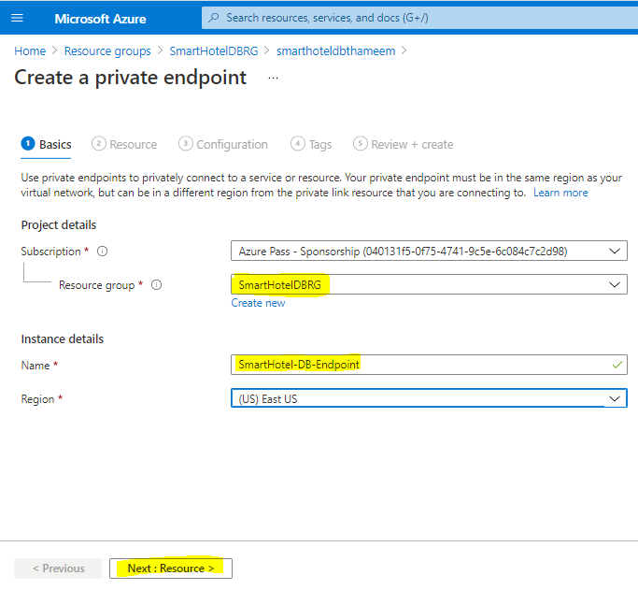

On the **Resource** tab, enter the following configuration then select **Next: Configuration**:

* Connection method: **Connect to an Azure resource in my directory**.
* Subscription: **Select your subscription**.
* Resource type: **Microsoft.Sql/servers**
* Resource: **Your SQL database server**.
* Target sub-resource: **sqlServer**

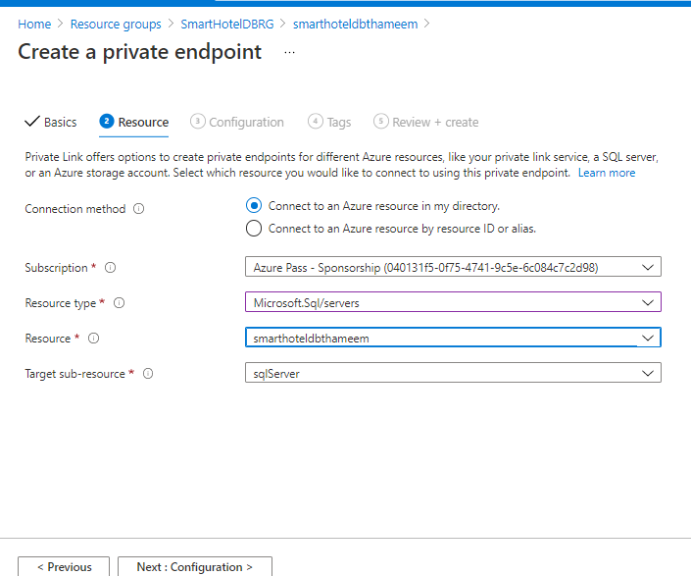

On the **Configuration** tab, enter the following configuration then select **Review + Create** then **Create**:

* Virtual network: **SmartHotelVNet**
* Subnet: **SmartHotelDB (192.168.0.128/25)**
* Integrate with private DNS zone: **Yes**
* Private DNS zone: (default) **privatelink.database.windows.net**

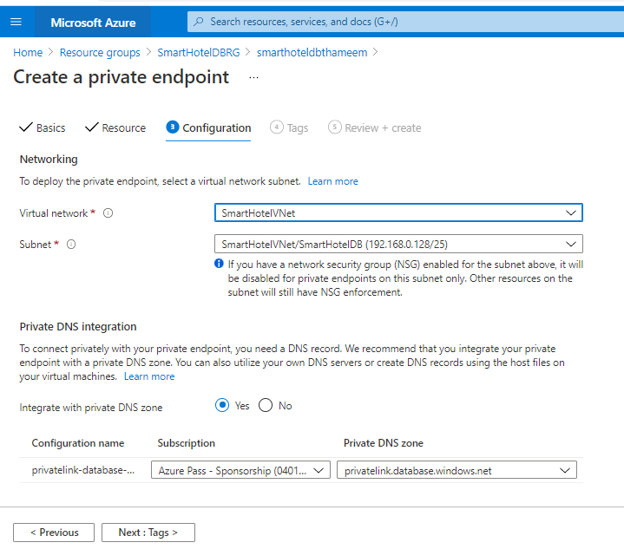

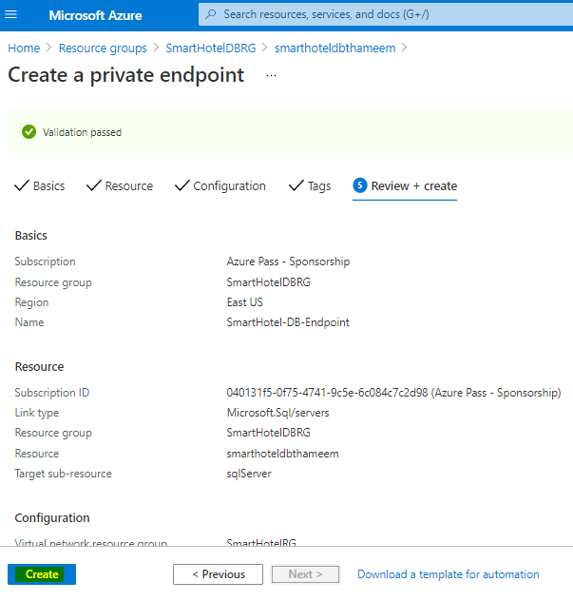

**Wait** for the deployment to complete. Open the Private Endpoint blade, and note that the FQDN for the endpoint is listed as **<your database>.database.windows.net**, with an internal IP address **192.168.0.132**.

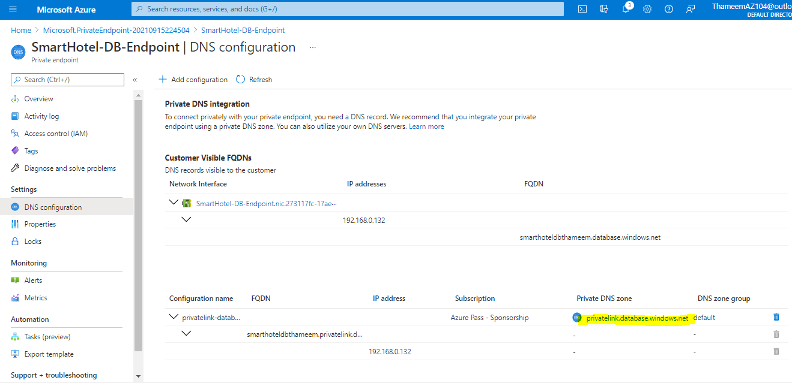

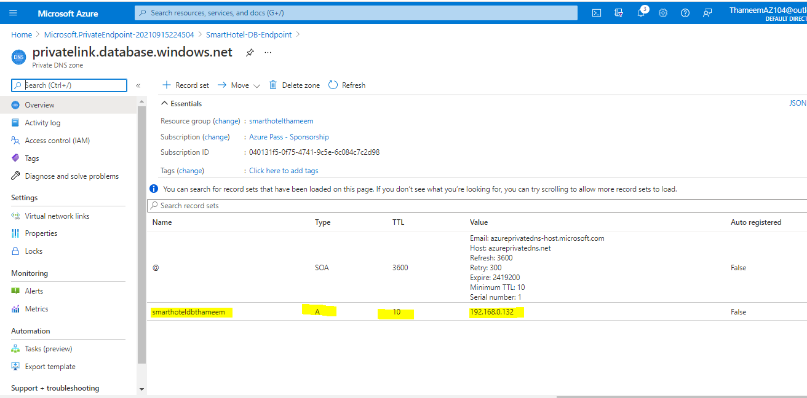

### Task 3: Register the Hyper-V Host with Azure Migrate: Server Migration

In this task, you will register your Hyper-V host with the Azure Migrate: Server Migration service. This service uses Azure Site Recovery as the underlying migration engine. As part of the registration process, you will deploy the Azure Site Recovery Provider on your Hyper-V host.

1. Return to the **Azure Migrate** blade in the Azure Portal, and select **Servers** under **Migration goals** on the left. Under **Migration Tools**, select **Discover**.

**Note:** You may need to add the migration tool yourself by following the link below the **Migration Tools** section, selecting **Azure Migrate: Server Migration**, then selecting **Add tool(s)**.

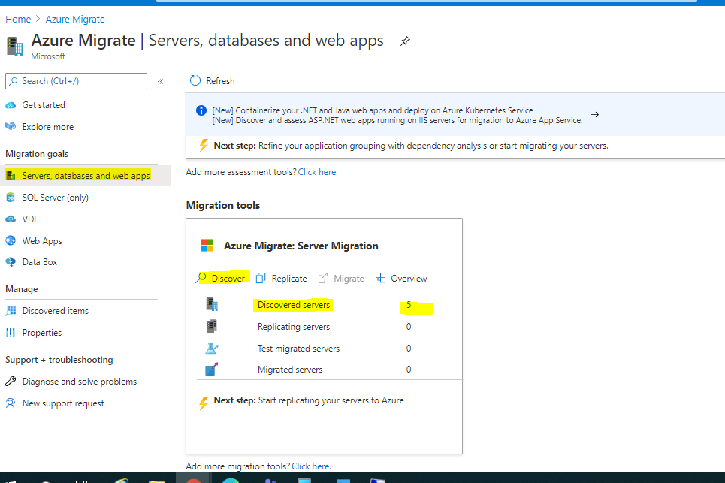

In the **Discover machines** panel, under **Are your machines virtualized**, select **Yes, with Hyper-V**. Under **Target region** enter **the same region as used for your Azure SQL Database** which can be found in the Azure portal and check the confirmation checkbox. Select **Create resources** to begin the deployment of the Azure Site Recovery resource used by Azure Migrate: Server Migration for Hyper-V migrations.

Copy the **Download** link for the Hyper-V replication provider software installer to your clipboard.

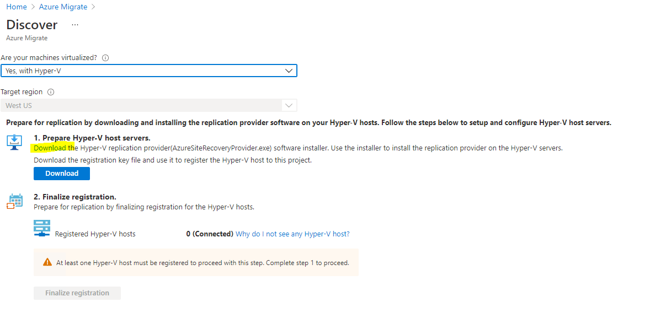

Inside smart hotel server doenload

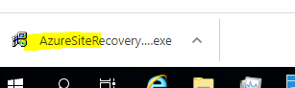

Return to the **Discover machines** page in your browser (outside the SmartHotelHost remote desktop session). Select the blue **Download** button and download the registration key file.

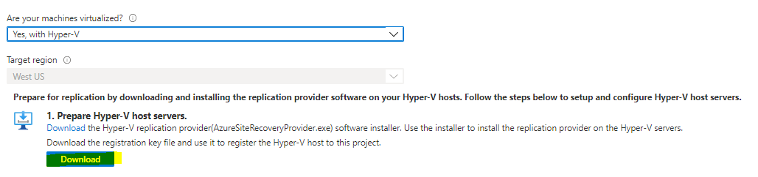

1. Open the file location in Windows Explorer, and copy the file to your clipboard. Return to the **SmartHotelHost** remote desktop session and paste the file to the desktop.
2. Still within the **SmartHotelHost** remote desktop session, open the **AzureSiteRecoveryProvider.exe** installer you downloaded a moment ago. On the **Microsoft Update** tab, select **Off** and select **Next**. Accept the default installation location and select **Install**.

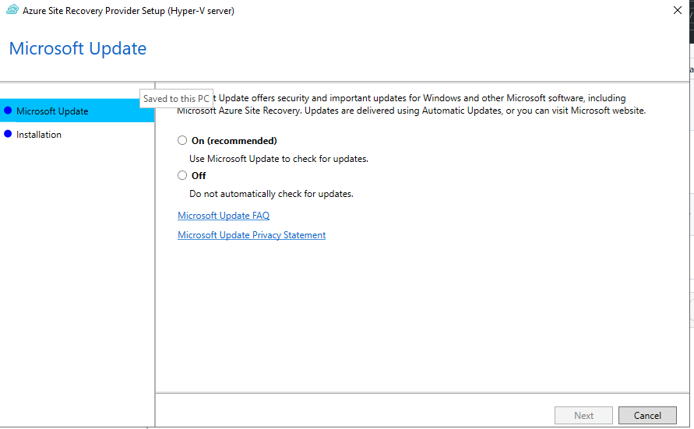

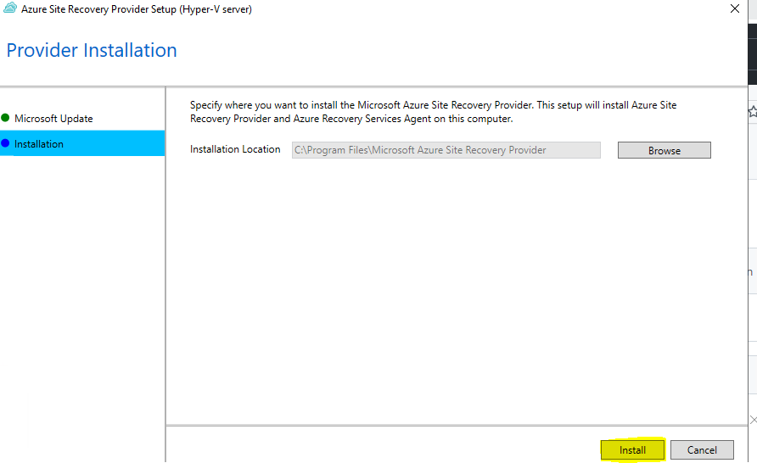

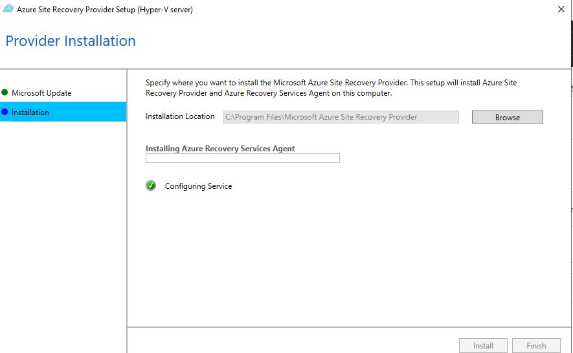

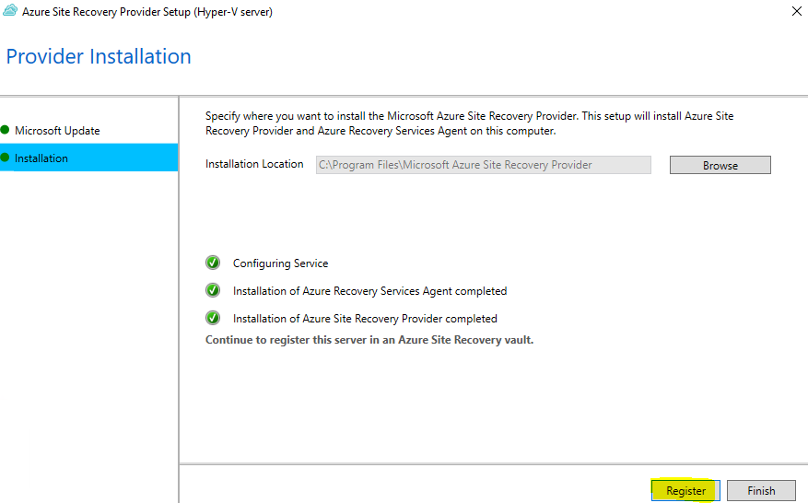

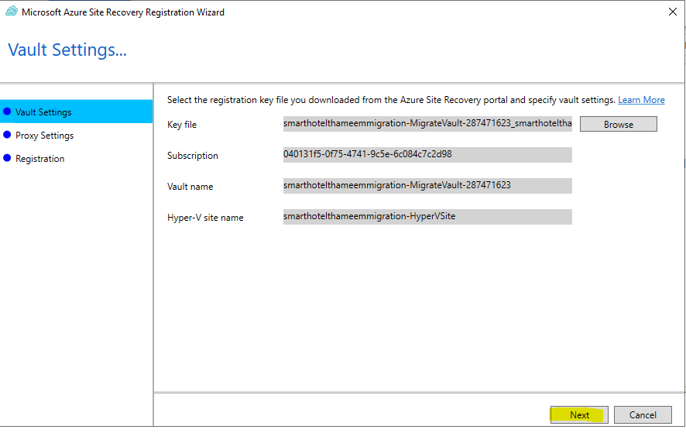

1. Select **Connect directly to Azure Site Recovery without a proxy server** and select **Next**. The registration of the Hyper-V host with Azure Site Recovery will begin.
2. Wait for registration to complete (this may take several minutes). Then select **Finish**.

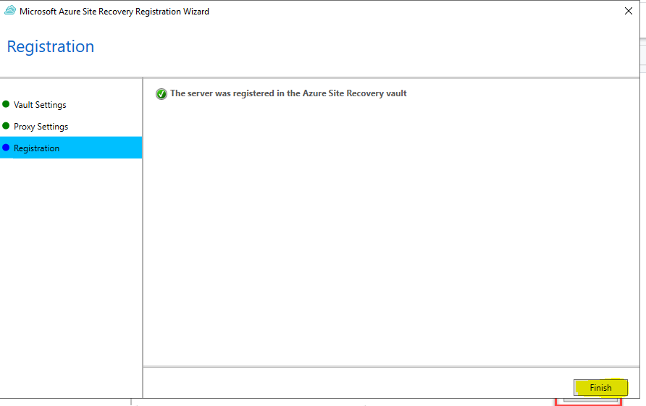

1. Minimize the SmartHotelHost remote desktop session and return to the Azure Migrate browser window. **Refresh** your browser, then re-open the **Discover machines** panel by selecting **Discover** under **Azure Migrate: Server Migration** and selecting **Yes, with Hyper-V** for **Are your machines virtualized?**.
2. Select **Finalize registration**, which should now be enabled.

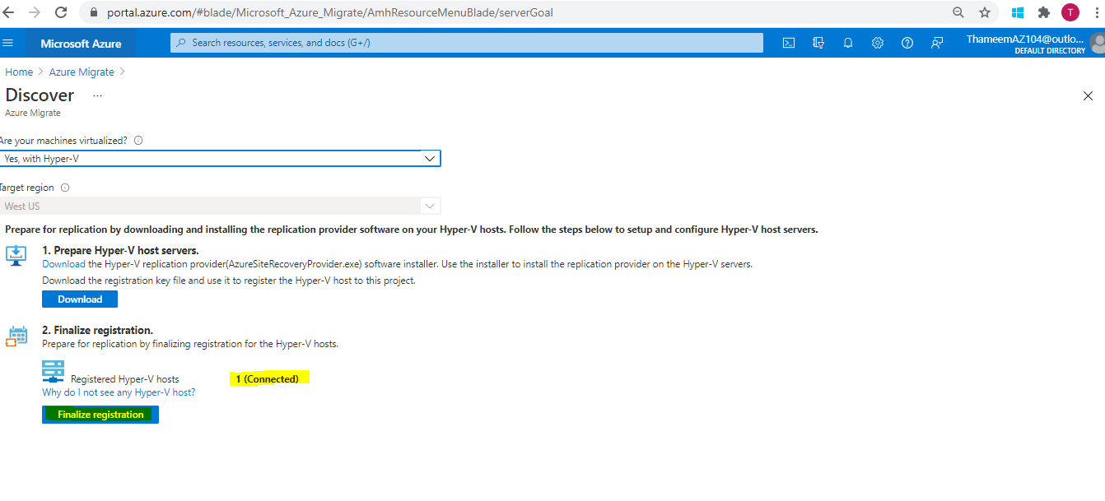

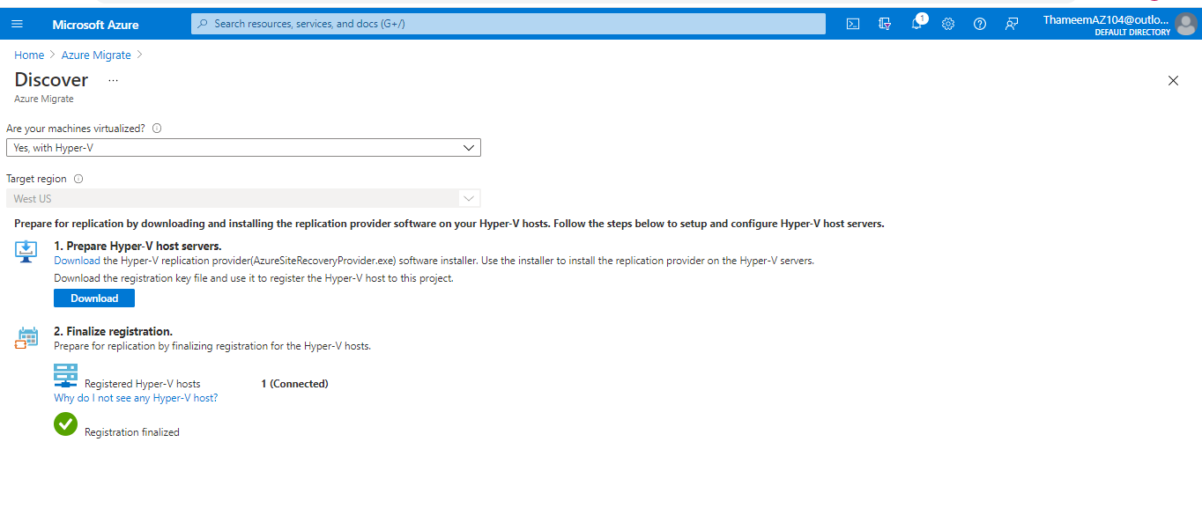

The **Azure Migrate: Server Migration** panel should now show 5 discovered servers.

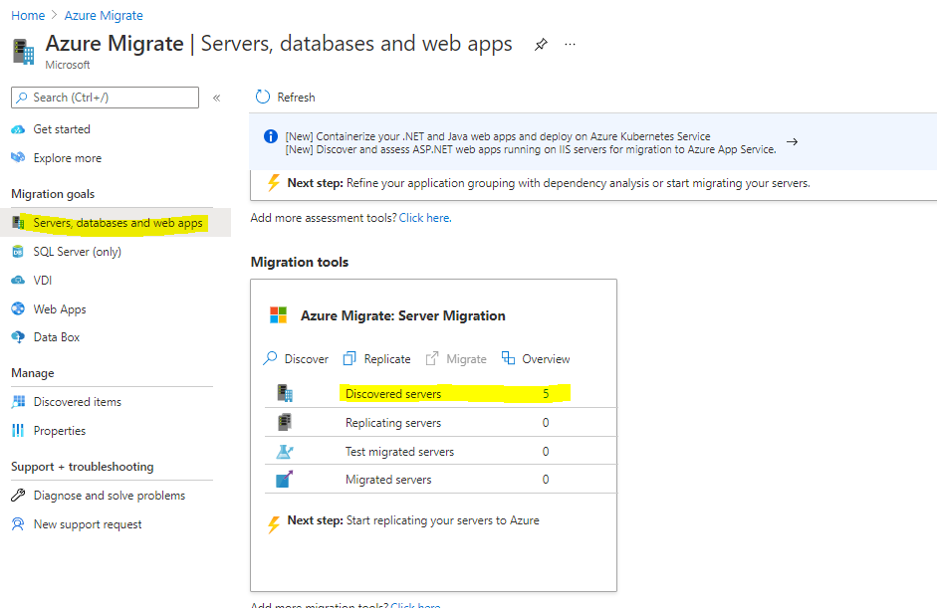

### Task 4: Enable Replication from Hyper-V to Azure Migrate

In this task, you will configure and enable the replication of your on-premises virtual machines from Hyper-V to the Azure Migrate Server Migration service.

1. Under **Azure Migrate: Server Migration**, select **Replicate**. This opens the **Replicate** wizard.

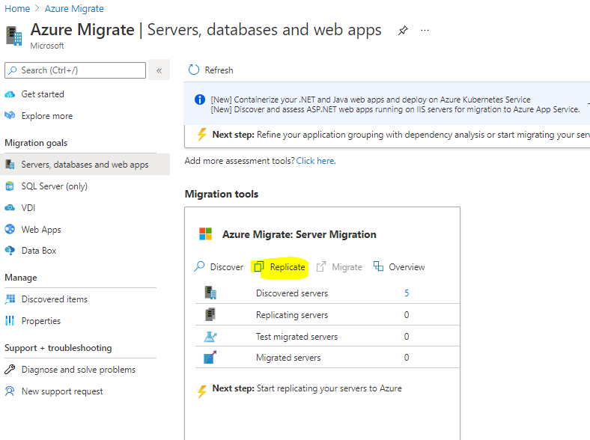

 the **Source settings** tab, under **Are your machines virtualized?**, select **Yes, with Hyper-V** from the drop-down. Then select **Next**.

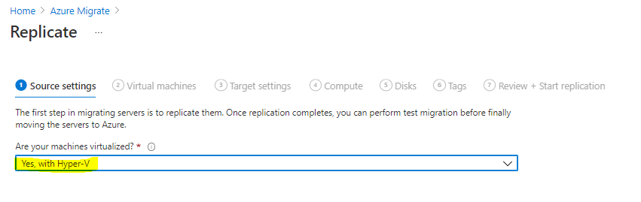

In the **Virtual machines** tab, under **Import migration settings from an assessment**, select **Yes, apply migration settings from an Azure Migrate assessment**. Select the **SmartHotel VMs** VM group and the **SmartHotelAssessment** migration assessment.

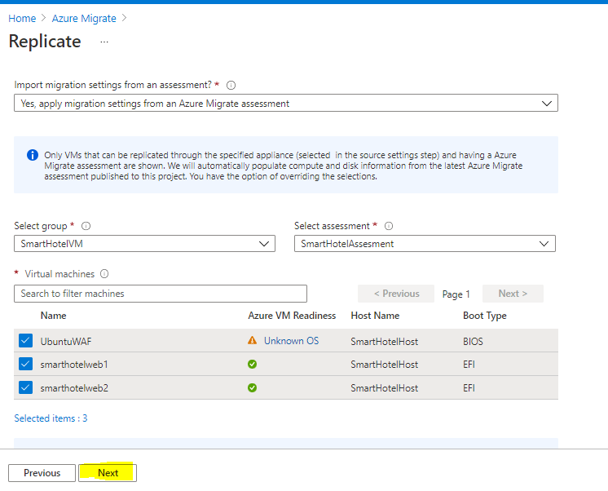

In the **Target settings** tab, select your subscription and the existing **SmartHotelRG** resource group. Under **Replication storage account** select the **migrationstorage...** storage account and under **Virtual Network** select **SmartHotelVNet**. Under **Subnet** select **SmartHotel**. Select **Next**.

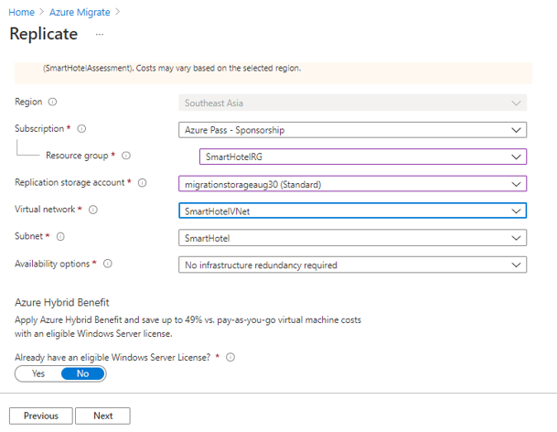

In the **Compute** tab, select the **Standard_F2s_v2** VM size for each virtual machine. Select the **Windows** operating system for the **smarthotelweb** virtual machines and the **Linux** operating system for the **UbuntuWAF** virtual machine. Select **Next**.

**Note**: If you are using an Azure Pass subscription, your subscription may not have a quota allocated for FSv2 virtual machines. In this case, use **DS2_v2 or D2s_v3** virtual machines instead.

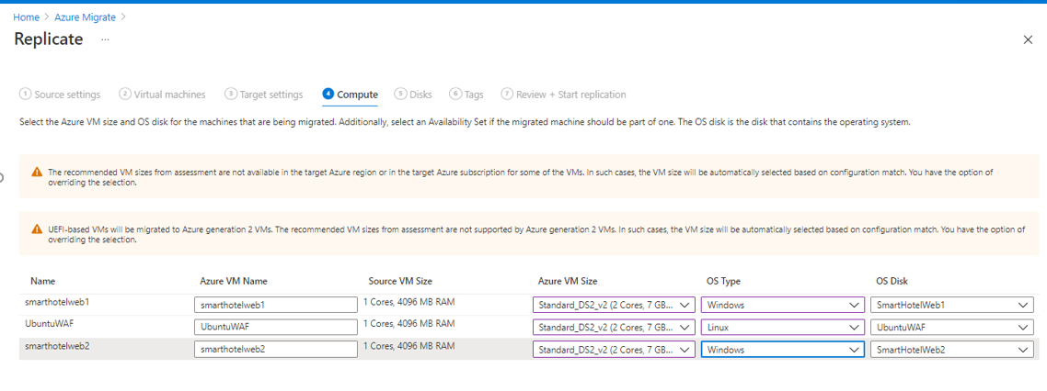

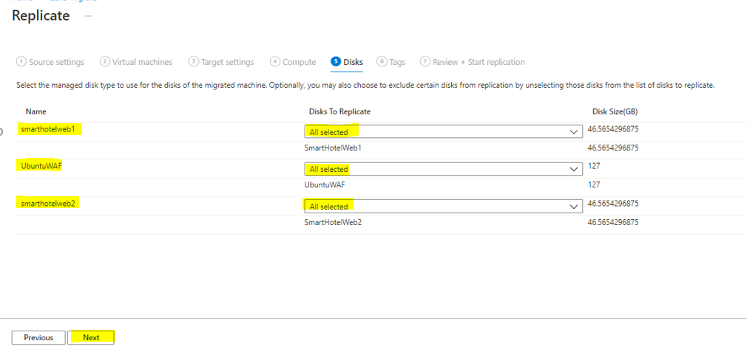

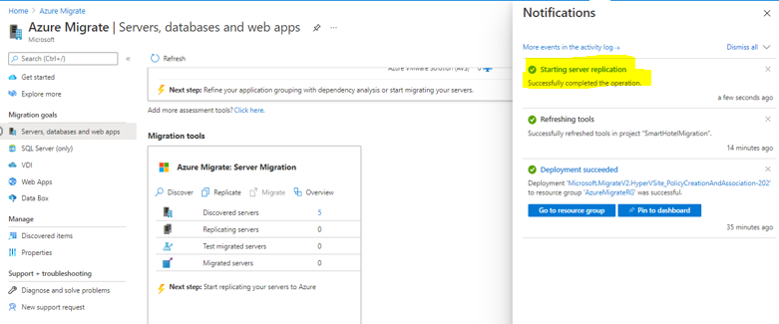

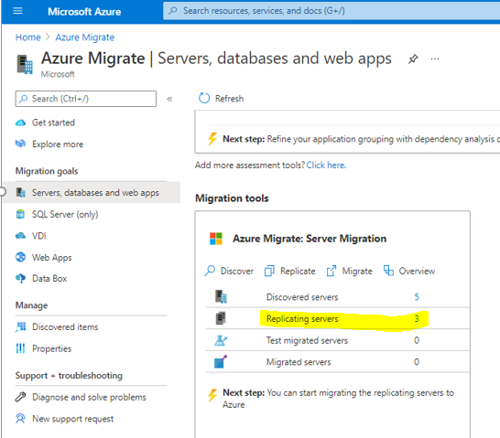

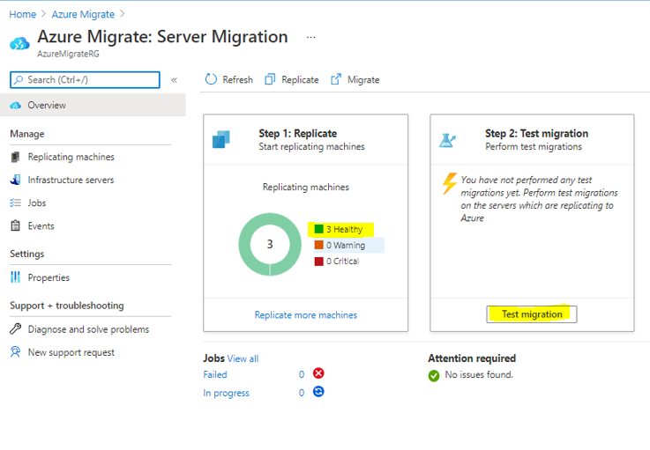

Select **Replicating Machines** under **Manage** on the left. Select **Refresh** occasionally and wait until all three machines have a **Protected** status, which shows the initial replication is complete. This will take several minutes.

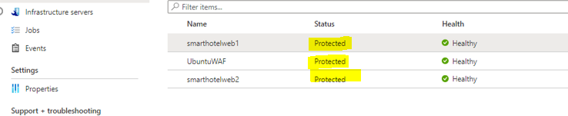

### Task 5: Configure static internal IP addresses for each VM

In this task you will modify the settings for each replicated VM to use a static private IP address that matches the on-premises IP addresses for that machine.

Still using the **Azure Migrate: Server Migration - Replicating machines** blade, select the **smarthotelweb1** virtual machine. This opens a detailed migration and replication blade for this machine. Take a moment to study this information.

Select **Compute and Network** under **General** on the left, then select **Edit**.

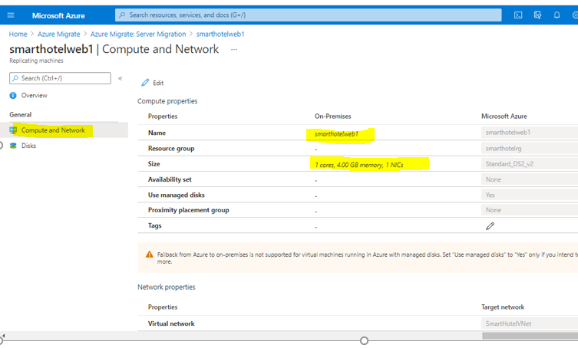

Confirm that the VM is configured to use the **F2s_v2** VM size (or **DS2_v2 or D2s_v3** if using an Azure Pass subscription) and that **Use managed disks** is set to **Yes**.

Under **Network Interfaces**, select **InternalNATSwitch** to open the network interface settings.

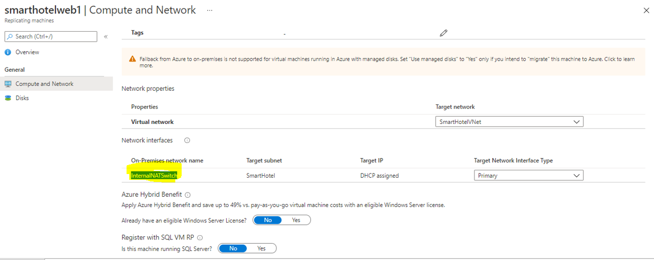

Change the **Private IP address** to **192.168.0.4**

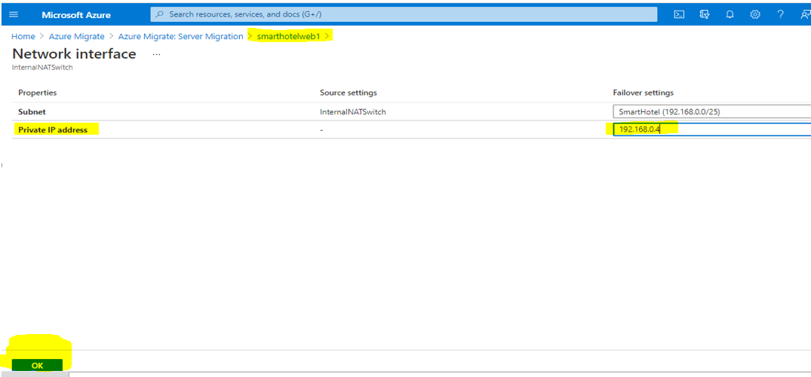

Select **OK** to close the network interface settings blade, then **Save** the **smarthotelweb1** settings.

Repeat these steps to configure the private IP address for the other VMs.

* + For **smarthotelweb2** use private IP address **192.168.0.5**
  + For **UbuntuWAF** use private IP address **192.168.0.8**

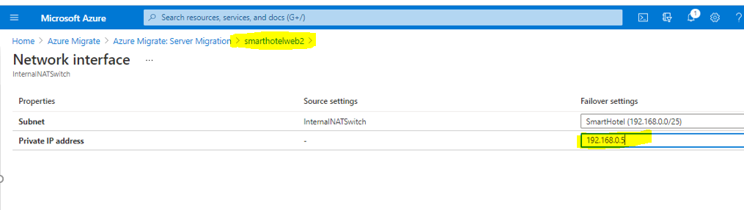

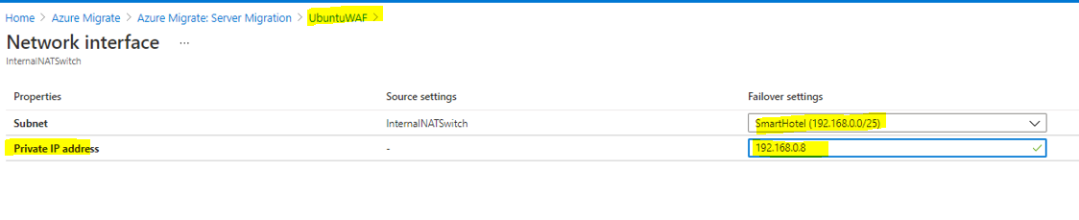

### Task 6: Server migration

In this task you will perform a migration of the UbuntuWAF, smarthotelweb1, and smarthotelweb2 machines to Azure.

**Note**: In a real-world scenario, you would perform a test migration before the final migration. To save time, you will skip the test migration in this lab. The test migration process is very similar to the final migration.

Return to the **Azure Migrate: Server Migration** overview blade. Under **Step 3: Migrate**, select **Migrate**.

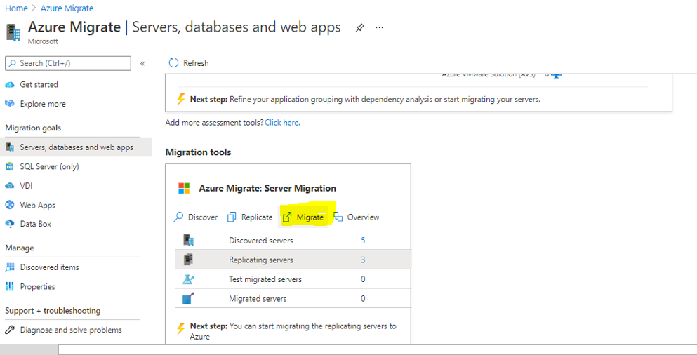

On the **Migrate** blade, select the 3 virtual machines then select **Migrate** to start the migration process.

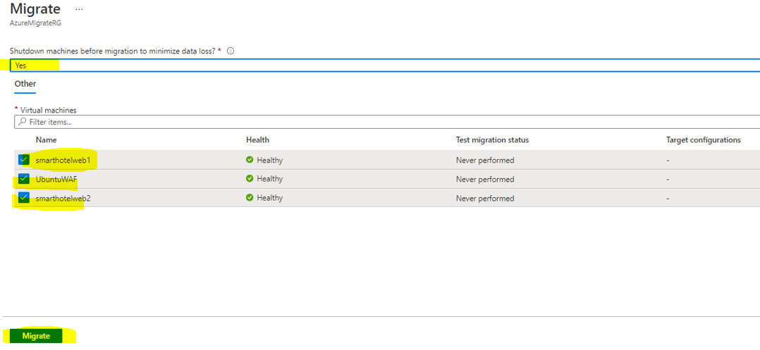

The migration process will start.

To monitor progress, select **Jobs** under **Manage** on the left and review the status of the three **Planned failover** jobs.

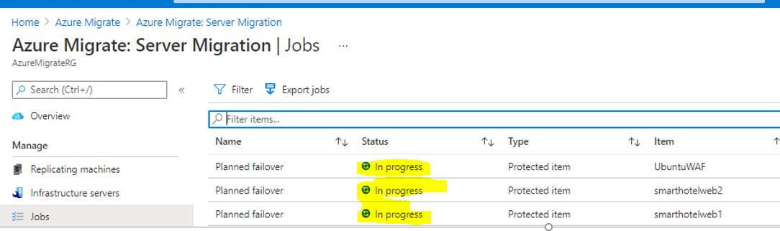

**Wait** until all three **planned failover** jobs show a **Status** of **Successful**. You should not need to refresh your browser. This could take up to 15 minutes.

### Task 7: Enable Azure Bastion

We will need to access our newly-migrated virtual machines to make some configuration changes. However, the machines do not currently have public IP addresses. Rather than add public IP addresses, we will access them using Azure Bastion.

Azure Bastion requires a dedicated subnet within the same virtual network as the virtual machines. Unfortunately, our SmartHotelVNet does not have any free network space available. To address this, we will first extend the network space.

Navigate to the **SmartHotelVNet** virtual network, then select **Address space** under **Settings** on the left. Add the address space **10.10.0.0/24**, and **Save**.

Select **Subnets** under **Settings** on the left, and add a new subnet named **AzureBastionSubnet**, with address space **10.10.0.0/27**.

Select **+ Create a resource** in the portal's left navigation, then search for and select **Bastion**, then select **Create**.

Fill in the **Create a Bastion** blade as follows:

* + Subscription: **Your subscription**
  + Resource group: (Create new) **BastionRG**
  + Name: **SmartHotelBastion**
  + Region: **Same as SmartHotelVNet**
  + Virtual Network: **SmartHotelVNet**
  + Subnet: **AzureBastionSubnet**
  + Public IP address: (Create new) **Bastion-IP**

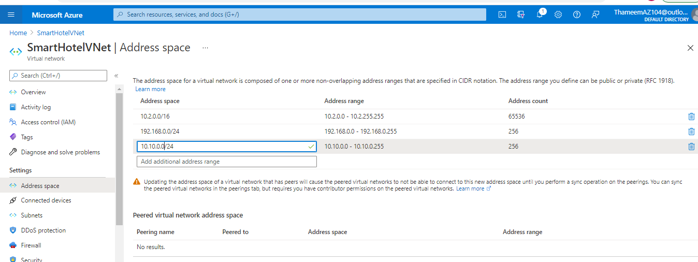

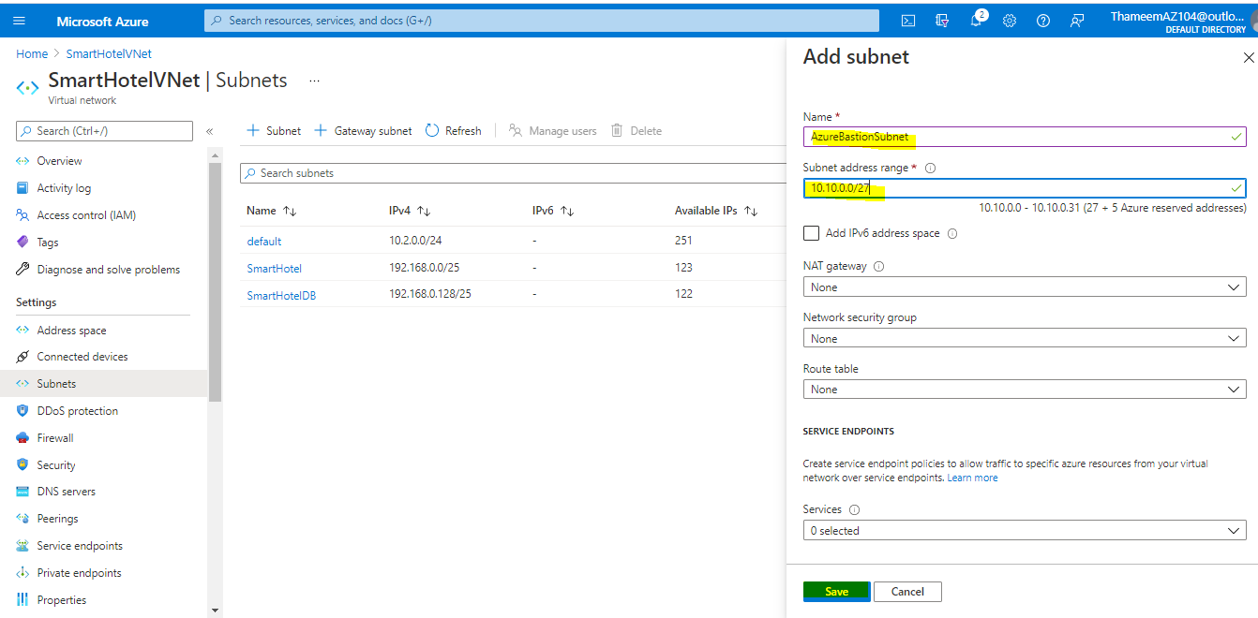

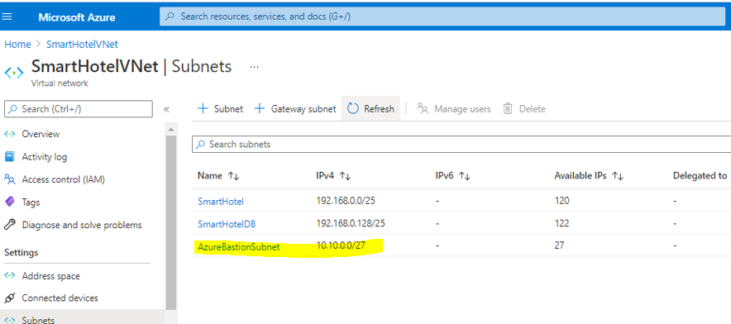

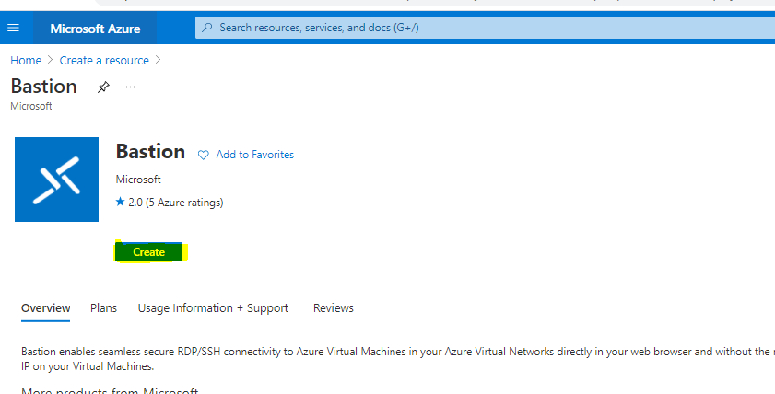

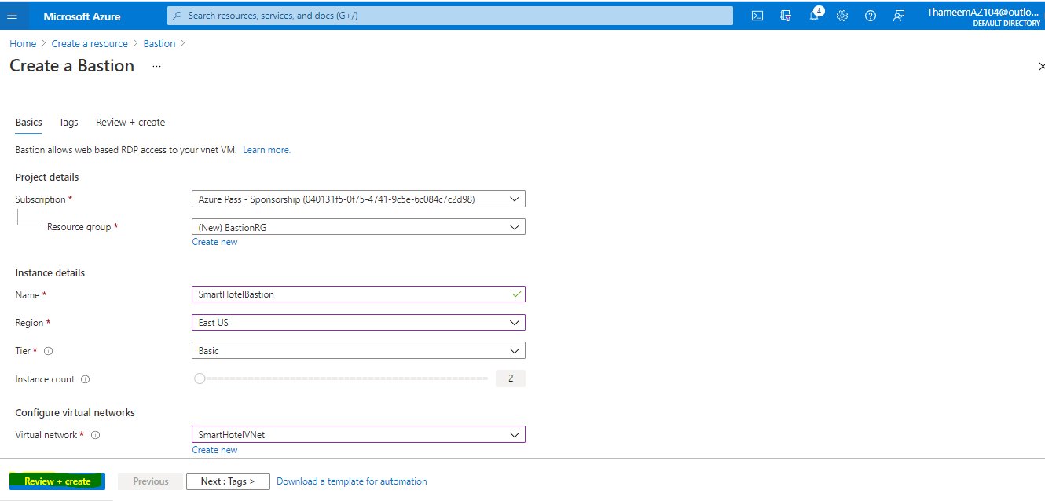

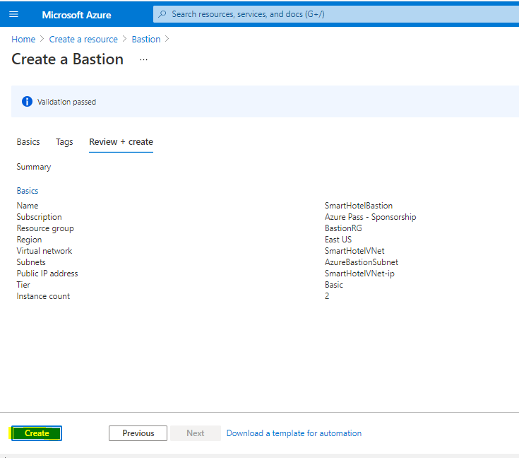

### Task 8: Configure the database connection

The application tier machine **smarthotelweb2** is configured to connect to the application database running on the **smarthotelsql** machine.

On the migrated VM **smarthotelweb2**, this configuration needs to be updated to use the Azure SQL Database instead.

**Note**: You do not need to update any configuration files on **smarthotelweb1** or the **UbuntuWAF** VMs, since the migration has preserved the private IP addresses of all virtual machines they connect with.

1. Navigate to the **smarthotelweb2** VM overview blade, and select **Connect**. Select **Bastion** and connect to the machine with the username **Administrator** and the password **demo!pass123**. When prompted, **Allow** clipboard access.

**Note:** You may have to wait a few minutes and refresh to have the option to enter the credentials.

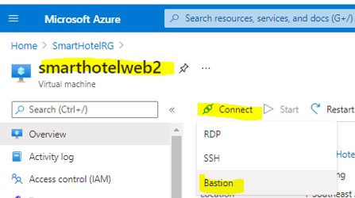

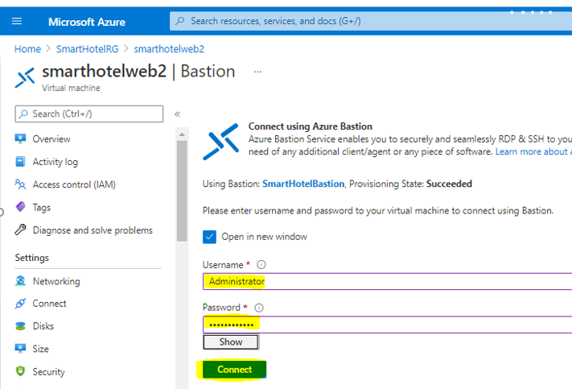

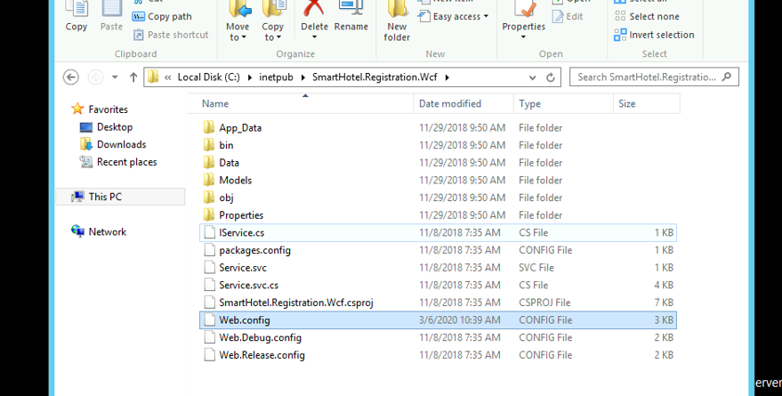

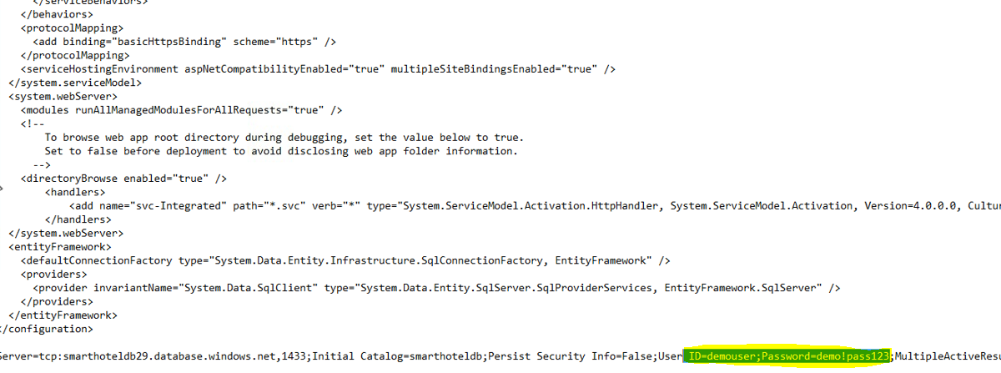

### Task 9: Configure the public IP address and test the SmartHotel application

In this task, you will associate a public IP address with the UbuntuWAF VM. This will allow you to verify that the SmartHotel application is running successfully in Azure.

Navigate to the **UbuntuWAF** VM blade, select **Networking** under **Settings** on the left, then select the network interface (in bold text).

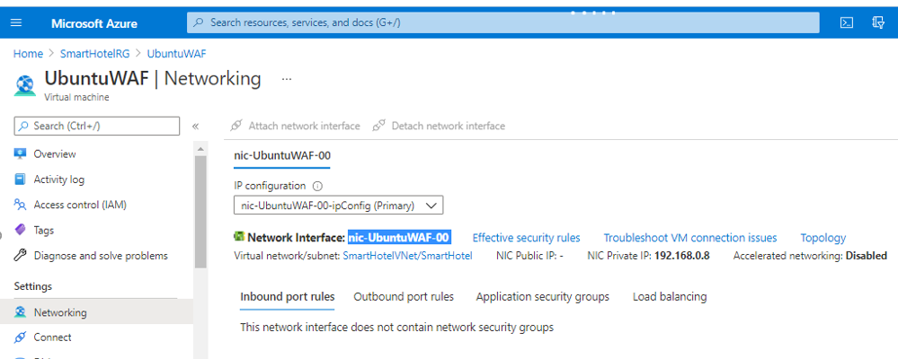

Select **IP configuration** under **Settings** on the left, then select the IP configuration listed.

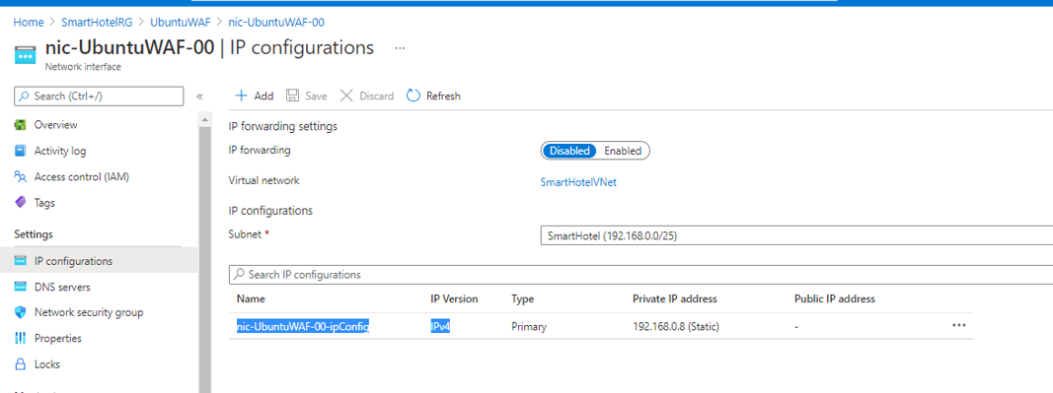

Set the **Public IP address** to **Associate**, and create a new public IP address named **UbuntuWAF-IP**. Choose a **Basic** tier IP address with **Dynamic** assignment. **Save** your changes.

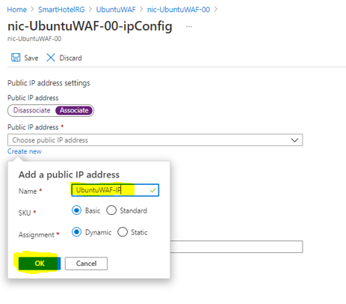

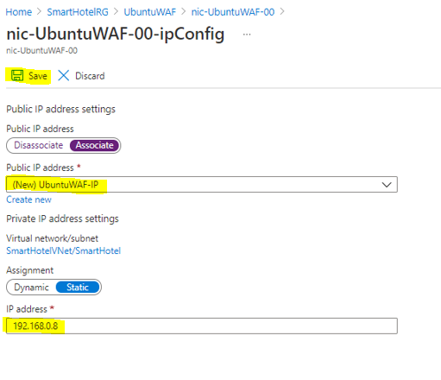

Return to the **UbuntuWAF** VM overview blade and copy the **Public IP address** value

Open a new browser tab and paste the IP address into the address bar. Verify that the SmartHotel360 application is now available in Azure.

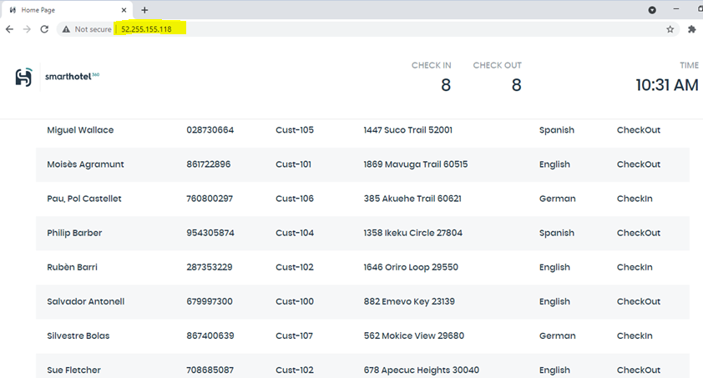

### Task 10: Post-migration steps

There are a number of post-migration steps that should be completed before the migrated services is ready for production use. These include:

* Installing the Azure VM Agent
* Cleaning up migration resources
* Enabling backup and disaster recovery
* Encrypting VM disks
* Ensuring the network is properly secured
* Ensuring proper subscription governance is in place, such as role-based access control and Azure Policy
* Reviewing recommendations from Azure Advisor and Security Center

In this task you will install the Azure Virtual Machine Agent (VM Agent) on your migrated Azure VMs and clean up any migration resources. The remaining steps are common for any Azure application, not just migrations, and are therefore out of scope for this hands-on lab.

**Note**: The Microsoft Azure Virtual Machine Agent (VM Agent) is a secure, lightweight process that manages virtual machine (VM) interaction with the Azure Fabric Controller. The VM Agent has a primary role in enabling and executing Azure virtual machine extensions. VM Extensions enable post-deployment configuration of VM, such as installing and configuring software. VM extensions also enable recovery features such as resetting the administrative password of a VM. Without the Azure VM Agent, VM extensions cannot be used.

In this lab, you will install the VM agent on the Azure VMs after migration. Alternatively, you could instead install the agent on the VMs in Hyper-V before migration.

In the Azure portal, locate the **smarthotelweb1** VM and open a remote desktop session using Azure Bastion. Log in to the **Administrator** account using password **demo!pass123** (use the 'eyeball' to check the password was entered correctly with your local keyboard mapping).

Open a web browser and download the VM Agent from: copy https://go.microsoft.com/fwlink/?LinkID=394789

1. . In the Azure portal, locate the **smarthotelweb1** VM and open a remote desktop session using Azure Bastion. Log in to the **Administrator** account using password **demo!pass123** (use the 'eyeball' to check the password was entered correctly with your local keyboard mapping).
2. Open a web browser and download the VM Agent from:

https://go.microsoft.com/fwlink/?LinkID=394789

**Note**: You may need to open the clipboard panel on the left-hand edge of the Bastion window, paste the URL, and then paste into the VM.

1. After the installer has downloaded, run it. Select **Next**, Select **I accept the terms in the License Agreement**, and then **Next** again. Select **Finish**.

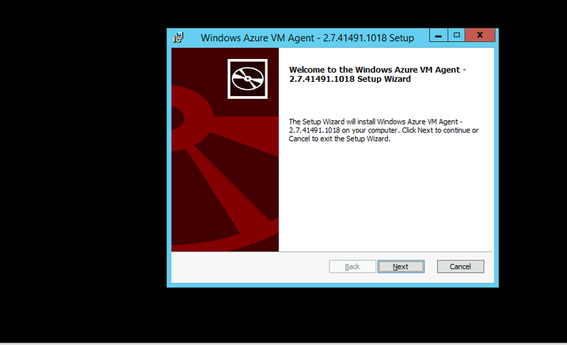

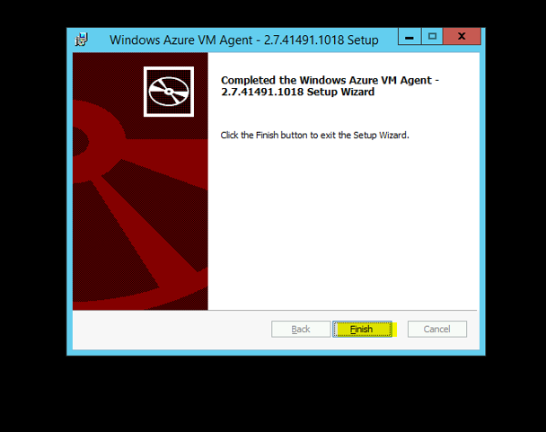

Close the smarthotelweb1 window. Repeat the Azure VM agent installation process on **smarthotelweb2**.



You will now install the Linux version of the Azure VM Agent on the Ubuntu VM. All Linux distributions supports by Azure have integrated the Azure VM Agent into their software repositories, making installation easy in most cases.

In the Azure portal, locate the **UbuntuWAF** VM and **Connect** to the VM using Azure Bastion, with the user name **demouser** and password **demo!pass123**. Since this is a Linux VM, Bastion will create an SSH session. You may need to enter the credentials again.

In the SSH session, enter the following command:

sudo apt-get install walinuxagent

When prompted, enter the password **demo!pass123**. At the *Do you want to continue?* prompt, type **Y** and press **Enter**.

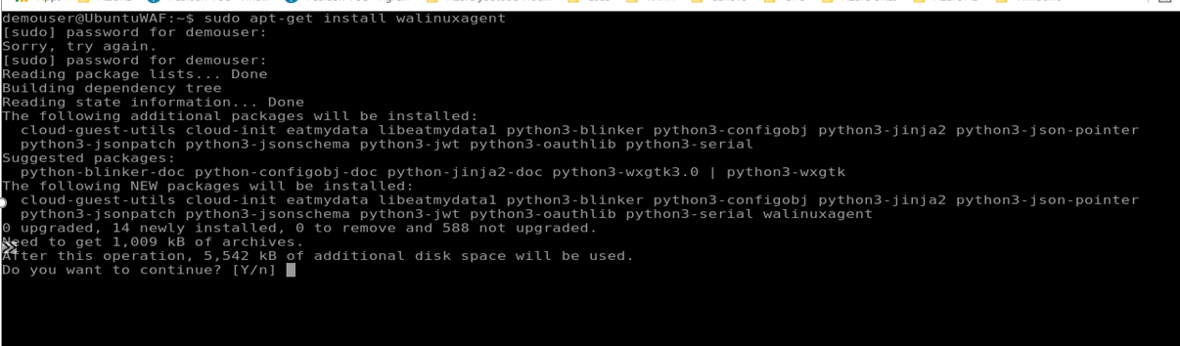

Wait for the installer to finish, then close the terminal window and the Ubuntu VM window.

To demonstrate that the VM Agent is installed, we will now execute the 'Run command' feature from the Azure portal.

Navigate to the **smarthotelweb1** blade. Under **Operations**, select **Run command**, followed by **IPConfig**, followed by **Run**. After a few seconds, you should see the output of the IPConfig command.

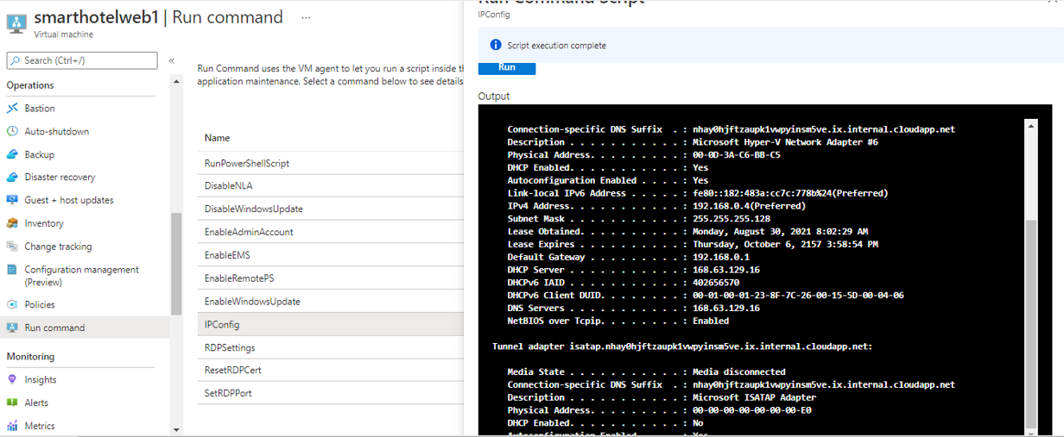

As a final step, you will now clean up the resources that were created to support the migration and are no longer needed. These include the Azure Migrate project, the Recovery Service Vault (Azure Site Recovery resource) used by Azure Migrate: Server Migration, and the Database Migration Service instance. Also included are various secondary resources such as the Log Analytics workspace used by the Dependency Visualization, the storage account used by Azure Migrate: Server Migration, and a Key Vault instance.

Because all of these temporary resources have been deployed to a separate **AzureMigrateRG** resource group, deleting them is as simple as deleting the resource group. Simply navigate to the resource group blade in the Azure portal, select **Delete resource group** and complete the confirmation prompts.

#### Task summary

In this task you installed the Azure Virtual Machine Agent (VM Agent) on your migrated VMs. You also cleaned up the temporary resources created during the migration process.

### Exercise summary

In this exercise I have migrated the web tier and application tiers of the application from on-premises to Azure using Azure Migrate: Server Migration. Having migrated the virtual machines, you reconfigured the application tier to use the migrated application database hosted in Azure SQL Database, and verified that the migrated application is working end-to-end. I also installed the VM Agent on the migrated virtual machines, and cleaned up migration resources.

### Clean up resources

You should complete all of these steps after attending the Hands-on lab. Failure to delete the resources created during the lab will result in continued billing.

1. Delete the **SmartHotelHostRG** resource group containing the SmartHotelHost.
2. Delete the **SmartHotelDBRG** resource group containing the Azure SQL Database.
3. Delete the **BastionRG** resource group containing the Azure Bastion.
4. Delete the **SmartHotelRG** resource group containing the migrated VMs and related infrastructure resources.
5. Delete the **AzureMigrateRG** resource group containing the Azure Migrate resources (if not done already at the end of Exercise 3).